Ravensburg, February 14, 2017
AKASOL at Energy Storage Europe 2017: Hall 8 B, booth D32
Premiere: GridSense-enabled PV battery
systems
neeoBASIX allows for intelligent, efficient electricity
management in the home
At this year’s Energy Storage Europe fair in Düsseldorf (March 14 to 16, 2017), AKASOL will be presenting the prototype of its new GridSense-enabled PV storage system, neeoBASIX, for the very first time. As an expert in stationary lithium-ion energy storage systems, the Ravensburg-based company has fitted its intelligent, highly scalable PV battery system with the GridSense home energy management system, which was developed by the Alpiq InTec Group in Zurich, Switzerland. Available in just a few months in two performance classes (6.5/13 kWh), the energy storage systems are designed to detect all PV systems and relevant power consumers in the household and optimize energy flows in a fully automated manner. “neeoBASIX combined with GridSense offers a range of benefits to owners of PV systems, as it means they will primarily consume electricity that they produce themselves. Any excess electricity is supplied to the grid, thus promoting grid-friendly behavior. This massively reduces energy costs and cuts the payback period by a significant margin,” states Markus Michelberger, Head of Stationary Battery Systems at AKASOL.
The prototype of neeoBASIX combined with GridSense that will be presented at the fair is ideal for photovoltaic (PV) systems in private households and smaller businesses with an output power of up to 10 kWp. The GridSense-enabled energy management system facilitates the management of all power producer and consumers in the home that are fitted with this technology – PV systems, heat pumps, boilers, home batteries, charging stations for electric cars, etc. – and enables energy loads to be optimized across all devices and units. Various parameters such as grid load and power consumption and production can be continuously measured based on an in-house-developed algorithm. Weather forecasts and electricity tariffs can also be included in the calculations. In addition, the intelligent algorithm is designed to learn the behavior of the power consumer. Markus Michelberger: “This smart energy management solution combines with integrated three-phase power electronics to form a high-performance lithium-ion storage system. On top of that, neeoBASIX also guarantees the safe, secure and long-term provision of energy. It is even able to manage energy volumes from a micro-cogeneration plant (1-5 kW of electricity) with no additional effort.”
neeoBASIX (GridSense) – technical data
Battery inverter | neeoBASIX 6.5 | neeoBASIX 13
AC values
System output AC max. | 3 kW
Mains connection | 400V, three-phase, 50 Hz
Electrical connection | 3L / N / PE
Nominal frequency/nominal frequency range | 50 Hz (47.5 ... 51.5 Hz)
Charge/discharge frequency | > 93.5 %
AC short-circuit protection | Yes
AC overload protection | Yes
Thermal cutoff protection | Yes
Power factor | 0.95 (capacitive) ... 1 ... 0.95 (inductive)
DC values
Max. discharge current | 50 A | 60 A
Max. charging current | 45 A | 45 A
DC voltage range | 40 V to 58.8 V
Max. charging capacity | 2.5 kW
Max. discharge capacity | 3 kW
Battery module
Battery capacity (nominal energy) | 6.5 kWh | 13 kWh
Usable energy | 5.9 kWh | 11.8 kWh
Cell technology +/- | NMC / graphite
Nominal voltage | 51.8 V
Voltage range (discharge/charging voltage) | 42 V to 58.8 V
Expected full cycles | 6,000
Replacement value guarantee | 10 years
Energy management and data
Communication for available network infrastructure | Ethernet
Visualization | Standard web browser, portal
Security | Authentication, hierarchy of access rights
Internal data memory | 4 GB
PV power inverter output reduction | 1 relay (turnkey, max. load 24V/5A)
General data
Ambient temperature between | +5°C and +30°C
Dimensions | 775 x 560 x 640 mm
Weight | 133 kg | 176 kg
Construction height above sea level | < 2,000 m
Protection class | Ip 21
Total consumption in standby mode | 27 W

Illustrations

AKA_neeoBASIX-01.jpg

A PV energy storage system to hold in high regard – neeoBASIX with GridSense guarantees intelligent and efficient energy consumption in private homes.
(Photo: AKASOL)
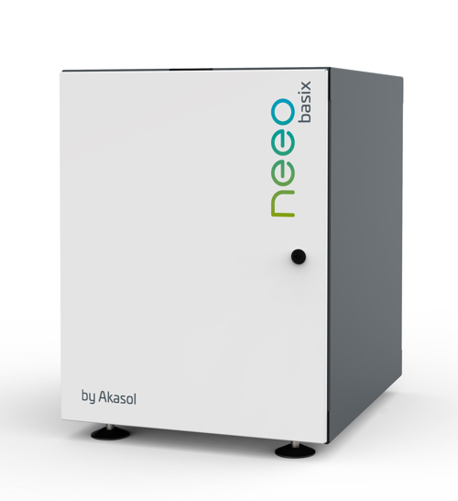

Further information  AKASOL GmbH, Katja Steinhauser  Landwehrstraße 55, 64293 Darmstadt, Germany  phone.: +49 6151 80 05 00-140  fax: +49 6151 80 08 00-129  katja.steinhauser@akasol.com  www.akasol.com | Press and public relations:  Press’n’Relations GmbH, Uwe Taeger  Magirusstraße 33, 89077 Ulm, Germany  phone.: +49 731 96 287-31  fax: +49 731 96 287-97  ut@press-n-relations.de  www.press-n-relations.de
About AKASOL
AKASOL GmbH has developed and manufactured mobile and stationary high-performance battery systems for the German and European market for 25 years. Its multi-award-winning storage solutions are used primarily in the automotive and commercial vehicle industries, the off-highway industry, and the solar power and wind power sectors.

