Darmstadt, 23 January, 2017
AKASOL supplies lithium-ion battery systems for series production of e-buses
Major contract in Scandinavia confirms company’s status as a technological leader
An internationally operating commercial vehicle manufacturer based in northern Europe has entrusted AKASOL with the serial production of lithium-ion battery systems for its entire fleet of e-buses. The contract, which represents hundreds of millions of euros and lasts until 2023, outlines a close, long-term partnership between both companies and involves the supply of up to 4,500 battery systems. “Thanks to our technological expertise and nearly 30 years of experience in the field of traction battery systems for the automotive industry, we made an impressive bid and were able to set ourselves apart from the competition,” says Sven Schulz, CEO of AKASOL.
The first serially produced e-buses equipped with AKASOL battery systems are due to be released starting in 2018. The sustainable public city e-buses can be fitted with either hybrid or battery electric drives, and boast a capacity of 150 to 300 kWh. AKASystem OEM’s modular nature allowed the Darmstadt pioneer in e-mobility battery solutions to provide the required level of energy performance and endurance while complying with specifications. “Thanks to our innovative and cost-effective fluid cooling system, AKASystem OEM maintains the optimum temperature conditions for operating batteries, making them particularly well-suited to long-term use in public transportation vehicles,” says Sven Schulz. Developed to comply with ISO 26262, these lithium-ion battery systems can be fast-charged with up to 500 kW and achieve more than 3,000 full cycles. They also meet Automotive Safety Integrity Level ASIL-C, as well as the EUCAR, GB/T, UN 38.3 and ECE R100 safety and performance requirements.

AKASystem OEM
The new battery storage system presented to the public for the first time at the IAA Commercial Vehicles is easily interchangeable and can be connected in any customer-specific variation, meaning it is completely scalable. “AKASystem OEM complies with the highest safety standards in the automotive sector. It is maintenance-free and possesses a high degree of technological maturity, making it an optimum basis for reliable and economical operation of hybrid and fully electric drive systems,” says Sven Schulz. AKASOL installs battery modules from major manufacturers in the compact, quick-charging battery solutions, resulting in an economically attractive price-performance ratio. According to Sven Schulz, “this means that AKASOL customers benefit thanks to the economies of scale that result from our series production to various OEMs for use in electric buses, trucks, construction vehicles and other commercial vehicles.”
The standard version of the AKASystem OEM has a battery storage capacity of 24.4 kWh at a voltage of 661 V (nominal), and can reach outputs of 150 kW (peak). Depending on system specifications, any number of the new solution’s battery boxes can, in theory, be connected in parallel or in series, and thus achieve energy quantities and outputs that can meet any given specification profile. A further benefit, according to the AKASOL CEO, is that “the water/glycol cooling system we've developed ensures that the battery modules maintain a uniform temperature, allowing even this compact, reduced-volume battery system to achieve impressive output values over a long service life.”

Images
KVB_E-Bus_am_Breslauer_Platz.jpg
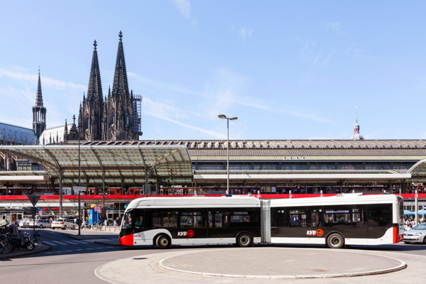
Sustainable passenger transportation without environmentally damaging emissions: one of eight battery-powered articulated buses with AKASOL battery systems operating as part of Cologne’s public transportation network.
(Photo: KVB Koelner Verkehrsbetriebe)
AKA_AKASystem_OEM_Expl.jpg
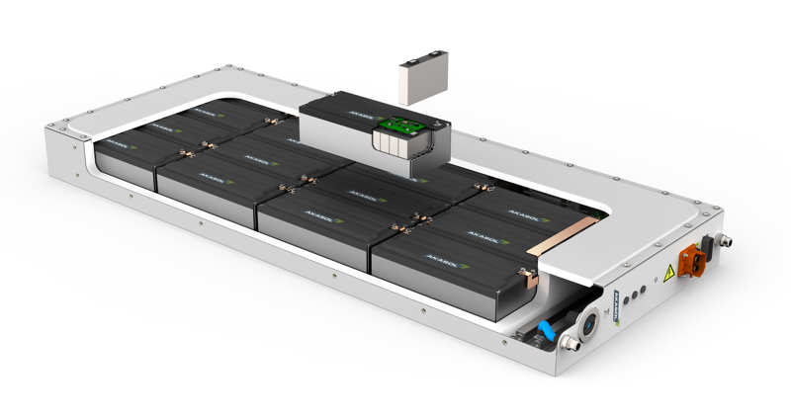
The compact and modular AKASystem OEM lithium-ion battery system is particularly well-suited for use in commercial vehicles such as buses, lorries, construction vehicles or other specialized vehicles. (photo: AKASOL)

AKA_Sven_Schulz_L_V.jpg

Sven Schulz, CEO of AKASOL GmbH, Darmstadt.
(photo: Schulz Group)


Further information:  AKASOL GmbH, Katja Steinhauser  Landwehrstrasse 55, 64293 Darmstadt, Germany  Tel.: +49 6151 80 05 00-140  Fax: +49 6151 80 08 00-129  katja.steinhauser@akasol.com  www.akasol.com | Press and public relations:  Press'n'Relations GmbH, Uwe Taeger  Magirusstrasse 33, 89077 Ulm, Germany  Tel.: +49 731 96 287-31  Fax: +49 731 96 287-97  ut@press-n-relations.de  www.press-n-relations.de
About AKASOL
AKASOL GmbH has developed and manufactured mobile and stationary high-performance battery systems for the German and European market for 25 years. Its multi-award-winning storage solutions are used primarily in the automotive and commercial vehicle industries, the off-highway industry, and the solar power and wind power sectors.

