Darmstadt, May 17, 2017
AKASOL founds two new production sites for
series production of battery systems
Large-scale expansion of production capacities thanks to
positive business development
With a new facility featuring over 3,000 m² of production halls and office space in Langen, as well as an additional 700 m² of halls at the headquarters in Darmstadt, lithium-ion battery system pioneer AKASOL is launching two further production sites at once. Starting in 2018, up to 150 members of staff will begin series assembly of lithium-ion battery systems for leading European bus manufacturers, in what will be the largest plant in Langen. By the end of 2017, the automated and automotive-focused series production line will be set up and put into operation. In a second new plant at the Darmstadt headquarters, small-scale series production for numerous orders in the commercial vehicle, railway and marine industries has already begun. “We are delighted to have found the ideal production and working conditions for series manufacturing in the direct vicinity of our Darmstadt headquarters thanks to the Multipark Langen. Our second plant in Darmstadt will allow us to add further capacity for small-scale series production. In short, our customers will benefit from the scalable and industry-specific production capacities of our new facilities. This move marks a new chapter in our company history,” says Sven Schulz, CEO of AKASOL GmbH.
As part of an initial expansion step in 2018, AKASOL will begin large-scale series production of battery systems for electric buses with a total capacity of up to 300 MWh at the new plant in Langen. This should be enough to equip about 1,500 e-buses annually. “In the second step, we plan on expanding the capacity to up to 600 MWh per year. We can also add further capacity by using additional halls on the premises,” says Schulz. In addition to large-scale series production at the Langen plant, the Darmstadt production halls will focus on small-scale series manufacturing, prototypes and samples for customers from the commercial and construction vehicle, railway, and marine fields. AKASOL will then have a total of over 5,000 m² of production and logistics halls as well as 1,200 m² of office space.

Multipark Langen
These facilities were designed to be sustainable, and were completed in 2016 in compliance with the latest standards for industrial production halls. The German Sustainable Building Council (DGNB – Deutsche Gesellschaft für Nachhaltiges Bauen e.V.) in Stuttgart certified the building according to the 40 DGNB Gold criteria, which represent the greatest possible level of transparency and quality with regard to sustainability, economy, socio-cultural and functional aspects, technology, processes, and location. According to Sven Schulz, “the new location in Langen not only meets our demands in terms of bright, well-lit and welcoming workstations, it can also be quickly and easily reached by employees and customers thanks to its location near the S-Bahn and direct connections to the A5 and A661 motorways.”
Images
AKA_Multipark_Langen_01.jpg, AKA_Multipark_Langen_02.jpg
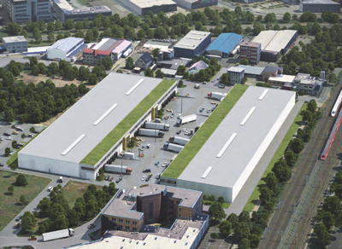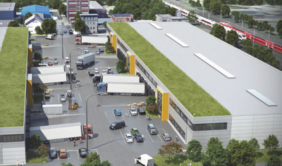
15 km north of Darmstadt: the new AKASOL production location in Langen. (Photos: MP Holding)

Sven Schulz, CEO of AKASOL GmbH, Darmstadt.
(Photo: Schulz Group)
AKA_Sven_Schulz_L_V.jpg
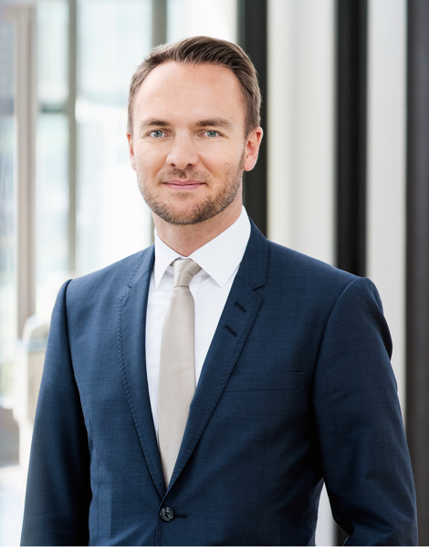

Further information  AKASOL GmbH, Katja Steinhauser  Landwehrstraße 55, 64293 Darmstadt, Germany  phone.: +49 6151 80 05 00-140  fax: +49 6151 80 08 00-129  katja.steinhauser@akasol.com  www.akasol.com | Press and public relations:  Press’n’Relations GmbH, Uwe Taeger  Magirusstraße 33, 89077 Ulm, Germany  phone.: +49 731 96 287-31  fax: +49 731 96 287-97  ut@press-n-relations.de  www.press-n-relations.de
About AKASOL
AKASOL GmbH has developed and manufactured mobile and stationary high-performance battery systems for the German and European market for 25 years. Its multi-award-winning storage solutions are used primarily in the automotive and commercial vehicle industries, the off-highway industry, and the solar power and wind power sectors.

