Darmstadt, May 12, 2017
AKASOL at Electric & Hybrid Marine World Expo:
Amsterdam, June 6 – 8, 2017, Stand E7090
Leading the way with clean energy
AKASYSTEM OEM lithium-ion battery system for electric yachts, boats and ships: robust, efficient and cost-effective
High-performance, customizable batteries for demanding applications in ships and yachts have traditionally been very costly. At this year's Electric & Hybrid Marine World Expo, AKASOL is presenting a promising solution: the AKASystem OEM. This compact, modular lithium-ion battery system is an ideal solution for yachts, offshore supply and drilling ships, excursion boats, tugs and ferries, as well as for mobile port equipment. E-mobility battery storage solutions experts have integrated standardized PHEV (plug-in hybrid electric vehicle) modules from large battery manufacturers into battery systems developed for the demanding requirements of the automotive sector. The result: the AKASystem OEM which meets very high output and lifecycle demands and can therefore be considered a very cost-effective solution. “Our customers benefit from our many years of expertise of using automotive technology in marine applications,” explains Sven Schulz, Managing Director at AKASOL.
The new battery storage system presented at Electric & Hybrid Marine World Expo is suitable for both low (from 50 kWh) as well as very high (MWh class) energy requirements. It is easily interchangeable and fully scalable as the connection on every variant can be adapted to match specific customer requirements. This opens up a wide range of applications, from fully electric or hybrid drives to cable winch, crane and pump operation through to on-board electronics. AKASOL battery storage systems can therefore be found not only on yachts, excursion boats and ferries but also on tugs and supply and drilling ships. The range encompasses luxury yachts such as the Adler Suprema HMS (Hybrid Machine Solutions) from Adler International as well as more robust applications in drilling ships and dredgers, such as those from De Keizer Marine Engineering.

Safety first
The AKASystem OEM meets the highest safety standards and degrees of protection in accordance with USABC, IEC, SAE, UN 38.3 and IP 6K9K. “Thanks to its maintenance-free use and high degree of technological maturity, it provides the ideal basis for reliable and economical operation of hybrid and fully electric drive systems,” says Markus Michelberger, Head of Stationary and Marine Energy Storage System (ESS). The battery storage experts from Darmstadt use proven technology from the automotive sector in the compact, quick-charging battery storage systems, which guarantees an attractive, cost-effective price-performance ratio.
The standard version of the AKASystem OEM has a battery storage capacity of 24.4 kWh at a voltage of 661 V (nominal), and can reach outputs of 150 kW (peak). Depending on system requirements, an unlimited number of battery boxes can theoretically be connected in parallel or in series, and thus achieve energy levels and outputs capable of meeting any given specification profile. According to Markus Michelberger, a further benefit is that “the water/glycol cooling system we’ve developed ensures that the battery modules maintain a uniform temperature, allowing the battery system to achieve impressive output values over a long service life, all in a range of compact, reduced sizes.”
Up to 50 percent longer service life
AKASOL experts have recently subjected the latest generation of the AKAMODULE 46Ah and 53Ah battery modules to an eighteen-month endurance test, generating an impressive set of data. The most significant result is that, due to the module’s liquid-cooled design (developed in-house) and extremely homogeneous conditions for the battery cells, the service life of the batteries can be extended by up to 50 percent when compared to the cell manufacturer’s specifications. This is due to the in-house design of the liquid-cooled module and the homogeneous integration of the cells.
This new solution supplements the AKASystem AKM product range, which includes battery modules manufactured by AKASOL. These will continue to be used for applications where even greater outputs are required.

Images
ADL_Adler_Suprema_HMS.jpg, AKA_AKASystem_AKR_6P12AKM.jpg, ADL_Adler_Yacht_Suprema.jpg
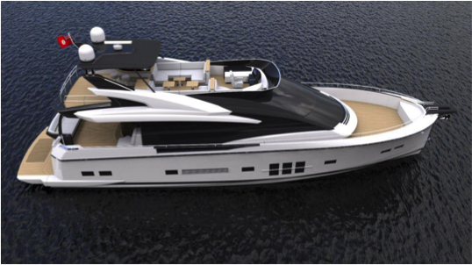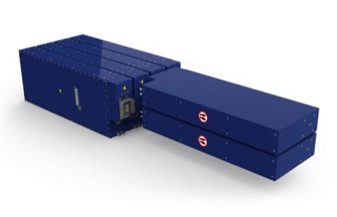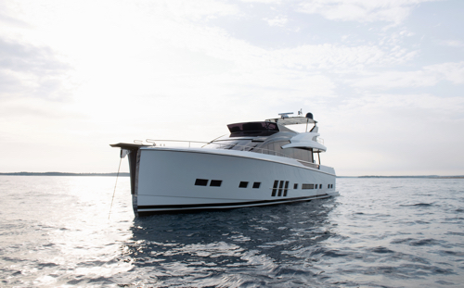
Lithium-ion battery systems meet the energy requirements on the Adler Suprema HMS electric yacht, amongst other things. (Photos: Adler Yacht, AKASOL)
AKA_Baggerschiff_Shutterstock_Franco Nadalin.jpg, KEZ_Marine_SmartGrid.jpg
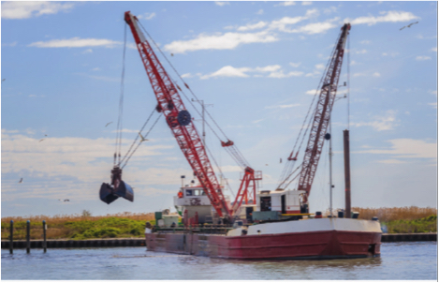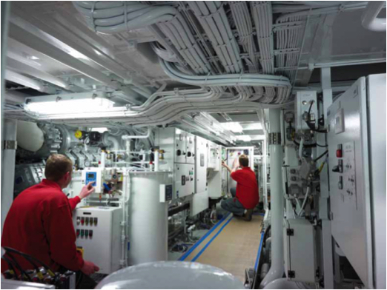
AKASOL battery systems are also suitable for more robust applications on the water: dredgers and Smart Grid equipment from De Keizer Marine Engineering.
(Photos: AKASOL [Shutterstock, Franco Nadalin], De Keizer Marine Engineering)
AKA_Versorgungsschiff_Shutterstock_claffra.jpg, AKA_Ferry_Shutterstock.jpg
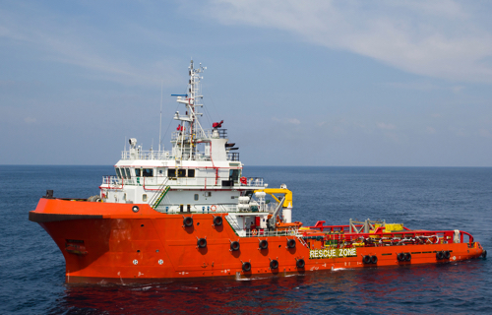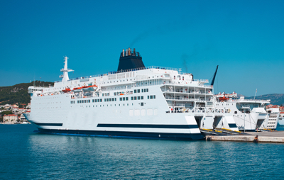
The AKASystem OEM's scalability makes it highly suitable for a wide range of marine applications. (Photos: AKASOL [Shutterstock, claffra])

AKA_Markus_Michelberger_01_C.jpg

Markus Michelberger, Head of Stationary and Marine Energy Storage System (ESS), AKASOL GmbH. (Photo: AKASOL)
AKA_Sven_Schulz_L_V.jpg

Sven Schulz, CEO of AKASOL GmbH. (Photo: Schulz Group)

Further information  AKASOL GmbH, Katja Steinhauser  Landwehrstraße 55, 64293 Darmstadt, Germany  phone.: +49 6151 80 05 00-140  fax: +49 6151 80 08 00-129  katja.steinhauser@akasol.com  www.akasol.com | Press and public relations:  Press’n’Relations GmbH, Uwe Taeger  Magirusstraße 33, 89077 Ulm, Germany  phone.: +49 731 96 287-31  fax: +49 731 96 287-97  ut@press-n-relations.de  www.press-n-relations.de
About AKASOL
AKASOL GmbH has developed and manufactured mobile and stationary high-performance battery systems for the German and European market for 25 years. Its multi-award-winning storage solutions are used primarily in the automotive and commercial vehicle industries, the off-highway industry, and the solar power and wind power sectors.

