Darmstadt/Høvik/NO, 2 June 2017
Two battery pioneers set sail together
AKASOL and ZEM announce partnership to develop
lithium ion batteries for maritime use
AKASOL, the German expert for lithium-ion battery systems, and ZEM, the Norwegian pioneer of maritime energy storage solutions, have worked together on the development of AKAZEM. The result is a unique autonomous IP 67-compliant liquid cooled modular system that can be combined in a “lego-like” fashion to meet smaller vessels’ space and power requirements up to a 2C power range at costs that opens many new applications. The first joint product, AKAZEM 15 OEM, is a self-contained modular battery unit specifically designed for work boats in the aquaculture industry, fishing boats and smaller passenger ferries. This self-contained 24kWh IP 67 system is likely to become a game changer, as its quality, safety and price are based on the large-series-production of the AKASystem OEM designed for buses.
Sven Schulz, CEO of AKASOL, and Jan-Olaf Willums, chairman and co-founder of ZEM, announced the results of this cooperation at the international shipping exhibition Nor-Shipping in Oslo this week. Together the two companies will develop, produce and distribute AKAZEM worldwide. AKAZEM is a modular, turnkey, high performance battery system. Thanks to its fully self-contained nature and IP 67 rating, it can find many applications in yachts, service vessels, lifeboats, fishing vessels and small passenger and tourist vessels. The project was initiated when ZEM was looking for a solution for free-fall lifeboats in the offshore industry, where reliability, safety and space were paramount requirements. In parallel, the strong growth in the aquaculture sector created the need for a modular IP 67-compliant solution, where customers need compact, reliable energy storage with up to 2C power at competitive prices.
AKAZEM can be put together to meet small (from 25 kWh) to larger energy requirements. It is thus very scalable and easily replaceable and can be customized to connect to many applications. „The unique modularity opened a wide range of applications, from use for the all-electric or plug-in hybrid operation by winches, cranes and pumps“, says Sven Schulz. AKASOL has developed modular solution for buses and trains, and will produce a rapidly increasing number for several large customers. "The quality and good engineering expertise, which we found in the AKASystem OEM is in our opinion the best basis for a first-class maritime energy storage system for smaller vessels" said Jan-Olaf Willums. ”Therefore, we decided to work with AKASOL and develop a fully self-contained modular system that can pass all maritime certification tests and, thanks to its IP67 rating, can be placed in all kinds of vessels.”
The AKAZEM modular systems will be used in the world's first battery-driven freefall lifeboats, a joint project with the company Norsafe, which had its world premiere at Nor-Shipping. Moen Marine will also announce a partnership agreement to use the AKAZEM solutions in its new series of aquaculture and fishing vessels. ZEM adapts the AKASystem OEM - to be produced at a new factory in large quantities for international bus manufacturers – to maritime requirements, including validation and certification of the classification society DNV-GL and the Norwegian Maritime Authority. The Norwegian specialist will be responsible for the final assembly, electrical integration and customer acceptance test in its production facilities in Karmøy on the west coast of Norway.
AKAZEM opens up a whole new modular market as batteries show increasingly higher capacities while the cell prices are falling. The system will be on display on stand E7090 at the Electric and Hybrid Marine World Expo in Amsterdam.

Pictures:
ZEM_freefall_lifeboats.jpg, NRS_lifeboat_fall.jpg, ZEM_lifeboat_on_sea.jpg
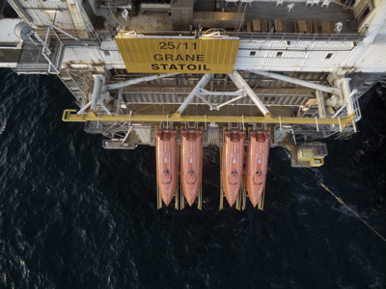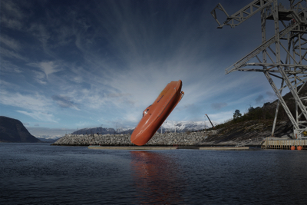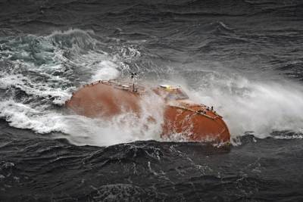
The first AKASOL and ZEM project: ZEM: freefall lifeboats for Norsafe.
(photos: ZEM)

AKA_ZEM_SVS_JOW.jpg
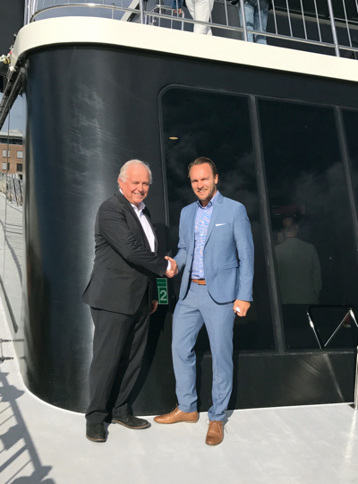

Jan-Olaf Willums, chairman and co-founder of ZEM (left), and Sven Schulz, CEO of AKASOL (right), after signing the contract. (Photo: ZEM)

Further information:  AKASOL GmbH, Katja Steinhauser  Landwehrstraße 55, D-64293 Darmstadt  phone: +49 6151 80 05 00-140  fax: +49 6151 80 08 00-129  katja.steinhauser@akasol.com  www.akasol.com  ZEM AS  Veritasveien 2, 1323 Høvik/Norwegen  contact@zemenergy.com | Press and public relations:  Press’n’Relations GmbH, Uwe Taeger  Magirusstraße 33, D-89077 Ulm  phone: +49 731 96 287-31  fax: +49 731 96 287-97  ut@press-n-relations.de  www.press-n-relations.de
About AKASOL
AKASOL GmbH has developed and manufactured mobile and stationary high-performance battery systems for the German and European market for 25 years. Its multi-award-winning storage solutions are used primarily in the automotive and commercial vehicle industries, the off-highway industry, and the solar power and wind power sectors.

