Press RELEASE
Ludwigsfelde, 11th September 2015

TÜV Rheinland confirms GDP-compliant logistics processes:
pharmaceutical logistics company Transco Berlin passes its first re-audit with flying colours

Successful re-certification at the end of the first year: Transco Berlin Brandenburg's GDP-compliant processes for transportation logistics on the roads

The EU guidelines on "Good Distribution Practice" (GDP), amended in 2013, impose significantly greater obligations on manufacturers and freight forwarding companies dealing with pharmaceuticals. Transco Berlin Brandenburg GmbH was the first pharmaceutical logistics company to be awarded the coveted new GDP certificate from TÜV Rheinland in the autumn of 2014. Exactly one year after certification, Transco has now successfully passed the testing institute's demanding re-audit. In this way the freight forwarding company from Ludwigsfelde has underscored its pioneering role in the sector for the design and implementation of modern, GDP-compliant pharmaceutical logistics processes. "Passing the re-audit with flying colours confirms that our whole team is conscious of GDP every day. It also shows that our investments in training, safety and vehicle technology and process optimisation are paying off in the long term," says Transco's Managing Director, Thomas Schleife. "We intend to continue in this way, and are currently in the process of involving our subcontractors more closely in our quality management processes. We can only achieve maximum safety in our transportation of pharmaceuticals if we have employees and subcontractors who are aware of the issues and through transparent processes," Schleife states with conviction. Over the summer TÜV-Rheinland tested Transco's qualified vehicles, its logistics processes and its quality management system in a demanding audit process.

In order to ensure that it can continue to guarantee and develop still further its GDP-compliant logistics processes, Transco has also increased its staff capacity. In spring 2015 the company appointed a Quality Management Officer so that two full-time employees from the 12-man team now deal exclusively with quality management (QM), quality assurance and the comprehensive documentation associated with GDP. The QM team is supported by an external "Qualified Person" with expertise in the field of pharmaceuticals, who is responsible for training and who supervises the self-audits and Transco's supplier audits. He also supports the development of documentation and participates in all important meetings relating to GDP.

The TÜV certificate enables the freight forwarding company to prove that its processes are GDP-compliant. It also facilitates comparisons between pharmaceutical transportation processes and services, which is beneficial for pharmaceutical manufacturers as contract givers. Quite independently from the TÜV certification, Transco had already started to prepare for the anticipated tightening up of the EU guidelines two years before the amended GDP guidelines came into force. As part of its "Safe Cold Chain" project the freight forwarder with considerable experience in Eastern Europe devised a holistic pharmaceutical transportation concept. The company had its cooling trailers qualified, undertook GDP training and documented its internal processes. Transco also carried out a comprehensive risk analysis and devised worst case scenarios and intervention plans based on this. In a demanding audit process TÜV Rheinland's auditors then tested the vehicles, the driver documentation and the cleaning facilities, the SOPs and the entire quality management system for GDP compliance. At Transco the latter is based on the ISO 9001 certification and was supplemented by the necessary QM processes specifically for pharmaceuticals in order to meet the EU guidelines.

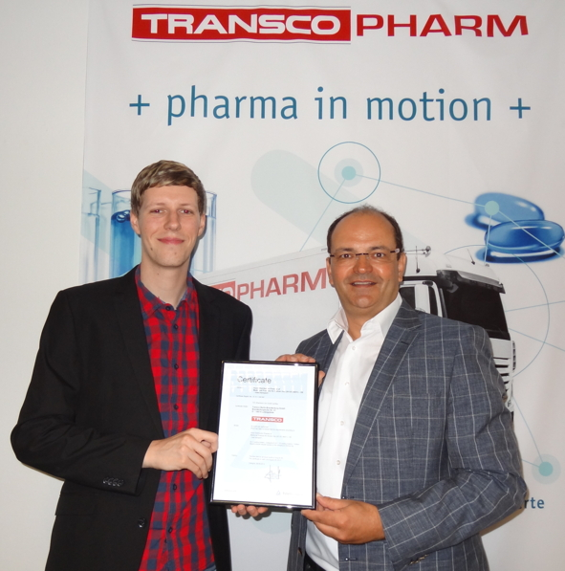
Images:
Proud of having passed the re-audit: Sören Bankrath (left, Quality Management Officer) and Thomas Schleife (right, Managing Director) with the GDP certificate issued by TÜV Rheinland for Transco Berlin Brandenburg GmbH

Further information available from:  Transco Berlin Brandenburg GmbH  Thomas Schleife, Managing Director  Brandenburgische Straße 51/53 - 14974 Ludwigsfelde  Telephone: +49 3378 - 519 30-15  Telefax: +49 3378 - 519 30-19  Thomas.Schleife@de.transco.eu  www.transco.eu | Press relations:  Press’n’Relations GmbH Berlin Office  Bruno Lukas  Boyenstraße 41 - 10115 Berlin-Mitte  Telephone: +49 30 - 577 00-325  Telefax: +49 30 - 577 00-324  blu@press-n-relations.de  www.press-n-relations.de

Transco Berlin Brandenburg GmbH

Founded in Ludwigsfelde, Transco Berlin Brandenburg GmbH specialises in the GDP-compliant transportation of pharmaceuticals. The logistics service provider, which is part of the Singener Transco Group, specialises in providing services for routes between Germany and Eastern Europe. The team under Managing Director Thomas Schleife, which has worked together for many years, develops and implements holistic pharmaceutical concepts to ensure the highest possible standards in process quality, safety, qualification and documentation. The company-owned, qualified refrigerated vehicles and the internal processes at Transco Berlin Brandenburg GmbH meet the requirements of the EU's GDP guidelines. The company was awarded certification to this effect by TÜV Rheinland in September 2014. Transco Berlin Brandenburg GmbH's quality management is also certified to ISO 9001. The company's environmental management is validated to ISO 14001.

