The new Schaerer Coffee Skye
For tailor-made coffee concepts in areas with mid-level demand

Zuchwil, 5. May 2022 – At the Internorga in Hamburg, Swiss coffee machine manufacturer Schaerer presented its latest machine development for the first time: The Schaerer Coffee Skye. The newest member of the family from the Schaerer product range is designed for mid-level demand, which is why it’s the perfect fit between the Schaerer Coffee Club and the Schaerer Coffee Soul 10 and 12. The Schaerer Coffee Skye features numerous equipment options as well as three different operating modes that allow it to be ideally configured to fit individualised customer requirements, for example in restaurants, convenience stores, bakeries, for coffee service in companies or catering at events. The machine’s look impresses with the aesthetic design typical for Schaerer: The display, which is deliberately set off from the housing, the coloured design elements and the accentuated lighting give the machine an elegant yet light feel. When designing the machine, Schaerer kept not only the appearance but also the functionality in mind. Thanks to the slim dimensions of 524 x 330 x 576 mm (h body/w/d) and the integrated 4.9 litre water tank, the Schaerer Coffee Skye can be set up practically anywhere a power connection is available. The option of placing a milk cooling unit on the right, left or under the counter makes its configuration even more flexible. Another advantage of the sophisticated design: All connections required for installation are directly accessible through the front panel, which makes machine handling much easier. In addition, the side openings simplify the connection of milk cooling units, and the closing mechanism for the bean hoppers also ensures convenient handling.

Individualised machine equipment
The Schaerer Coffee Skye stands for a large degree of freedom in configuration and can be ideally equipped for the area of use and the customer requirements — the “Select” concept familiar from the Schaerer Coffee Soul is also the basis for this machine and offers a selection adapted to the mid-range price segment. For instance, those who want to offer a wide range of beverages can choose a second grinder combined with espresso grinding discs, the Twin Topping container for stocking two different toppings, and an additional water spout integrated into the central spout for preparing americanos. A key locking mechanism is also available for the optional lockable bean and topping hoppers, which securely fastens them and prevents them from being removed. In areas with a high volume of guests, a mains water supply instead of a water tank and an under-counter grounds disposal unit are recommended equipment options. Of course, the Schaerer Coffee Link digital platform is also available for the Schaerer Coffee Skye. This powerful solution paves the way for various digital evaluations and applications and also allows the machine to be integrated into innovative business concepts, including so-called unmanned stores, to name just one example.

New Pure Foam milk system and Powersteam steam wand
For high beverage quality and a wide variety of milk-based coffee specialities, the Schaerer Coffee Skye can be equipped with the new Pure Foam milk system. It prepares hot and cold milk as well as creamy, fine-pored hot milk foam. The dispensing temperature of hot milk and milk foam ranges from 50 °C to 70 °C. A focus during the development of the Pure Foam was the sustainable use of water. The milk system has a very small internal volume, meaning it requires very little water for rinsing and cleaning. In addition, no pre- or post-rinsing is necessary when preparing beverages. For manual milk foaming — for example, for vegan coffee specialities made with plant-based drinks — you can also opt for the “Powersteam” steam wand.

Operation made fun
Preparing beverages is child’s play on the high-resolution 8-inch touch screen of the Schaerer Coffee Skye. Large icons combined with user-friendly, process-reliable and guided operation ensure a positive customer experience. A special feature of this display size: The screen can play videos, meaning it can be used for animations and promotions. Like the Schaerer Coffee Soul 10 and 12 with the “Select” concept, the new machine also offers three different operating modes: The “Guest” mode is ideal for self-service, for example in bakeries, convenience stores or self-service restaurants. The “Favourites” mode developed for dispensing coffee in offices scores points with short commands for quick beverage configuration, and the “Staff” mode is geared precisely to the requirements of areas where the coffee specialities are prepared by staff.

Optimised installation plan and service processes
The service concept also plays a key role when deciding on a coffee machine. The Schaerer Coffee Skye scores points here with its uncomplicated commissioning, as all connections required for installation (main power, secondary devices, mains water supply, waste water drain) are accessible from the front and the connection piece for the waste water hose can also be removed without tools. A special feature that really simplifies daily service by staff is the functional lighting on both sides of the central beverage outlet. It provides information on the current status of the machine with the colours white (ready for operation), yellow (action required soon), and red (action required now). The service staff can see from far away if anything needs doing.

Image material

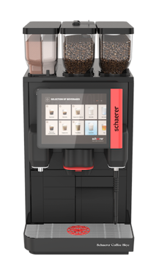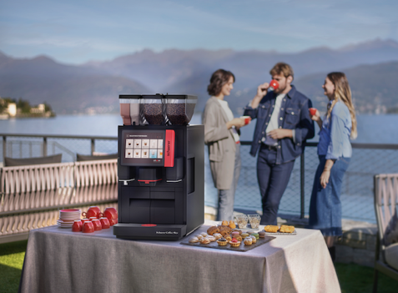
The new Schaerer Coffee Skye was presented to the public for the first time in Hamburg.

Image availability
You can find downloadable image material in our media portal press-n-relations.amid-pr.com (search term “Schaerer Coffee Skye”). I would of course be happy to email you the files as well. Contact: nfo@press-n-relations.de

Further information:
Schaerer AG
Matthias Lübke, Head of Marketing & Coffee Competence Centre Allmendweg 8, 4528 Zuchwil, Switzerland
Tel.: +41 32 681 64 99
MLuebke@schaerer.com
www.schaerer.com

Schaerer Press Office
c/o Press'n'Relations GmbH,
Nataša Forstner
Magirusstrasse 33, D-89077 Ulm, Germany
Tel.: +49 731 96 287-17
Fax: +49 731 96 287-97
nfo@press-n-relations.de
www.press-n-relations.de

Schaerer AG
Founded in 1892 and headquartered in Zuchwil, Switzerland, Schaerer AG is one of the world’s leading manufacturers of fully automated professional coffee machines. As a traditional company with many years of history, the Schaerer brand stands for Swiss values combined with an in-depth knowledge of coffee. The company expresses these brand attributes with the company logo “swiss coffee competence” and experiences them equally in its product development and in the Coffee Competence Centre, Schaerer’s own coffee expertise and training centre in Zuchwil. Moreover, Schaerer is characterised by extreme flexibility with the guiding principle “We love it your way” — be it in reference to customer requests, customer-specific products and large orders or the product range which offers the customer a wide range of customised configuration options. Customer-oriented and with extensive coffee knowledge, Schaerer supports customers of any size all over the world in offering their guests the highest level of coffee enjoyment.

Schaerer has been part of WMF since 2006 and of the French consortium Groupe SEB since the end of 2016. All B2B brands of the Group are bundled in the “SEB PROFESSIONAL” consolidated sales organisation. In addition to Schaerer, it includes the WMF and Wilbur Curtis coffee machine brands as well as the Professional Hotel Equipment division with the WMF Professional and HEPP brands.

