ProCom at EMO trade fair (September 16-21, 2019, Hanover, Germany) in Hall 9, Booth F32 in the Industry 4.0 area
High-speed laser cutting with the new CNC300PRO controller
Aachen, Germany, July 23, 2019 – The CNC300PRO is ProCom’s most powerful controller of the CNC300 product family for maximum speed and precise laser cutting. The new, ultra-modern IPC can be scaled as needed in terms of memory and processor performance, offering the best possible configuration for any application. The associated CNC software “ergoCNC” was also improved. This software supports flying cuts, among other things, for which the laser is switched with microsecond response time during movements. The fast cut mode and ping-pong positioning also offer significant time savings thanks to optimized tool paths. To achieve the highest cutting quality, the distance to the workpiece is dynamically adapted by adjusting the height in real time. Other technological features, such as tool radius correction or 5-stage puncturing strategies, offer precise results. Due to its ergonomically designed touch interface and task-oriented screens, ergoCNC can also be conveniently operated by machine operators without extensive prior experience.
The ergoCAM software is the perfect addition for optimizing cutting programs to achieve higher cutting quality, more throughput, or better material utilization. The CNC300PRO controller is also ready for the Clouver Industry 4.0 application from ProCom. This solution links production and business operations and provides management, factory managers, and machine operators with information that can assist in uncovering hidden costs or minimize downtime.
Features of the CNC300PRO
- Intel Core i3, i5, or i7 – longlife cycle
- RAM: 4GB, 8GB or 16 GB
- SSD: 126 GB or 256 GB
- Long-term industry PC mainboard
- Industry 4.0 ready
- EtherCAT interface
- OPC UA interfaces
- Electrical connection 24 VDC
- Windows 10 LTSB
More information under
https://procom-automation.de/en/cnc-cam/cnc300/hardware/
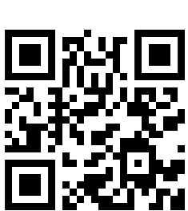
Video: flying cut, managed by ProCom’s software ergoCNC:
https://youtu.be/vMcVcL-kjbo
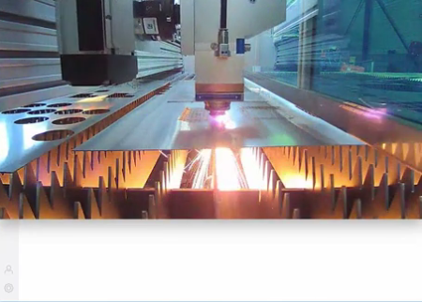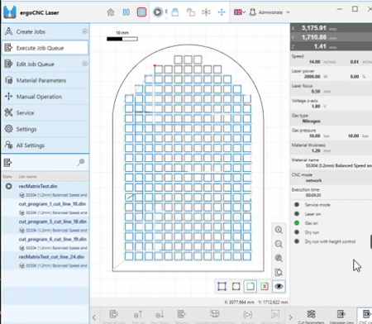
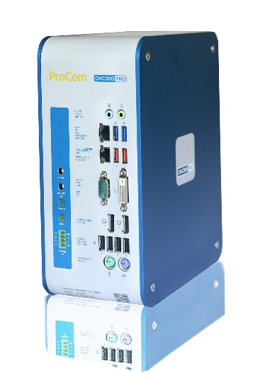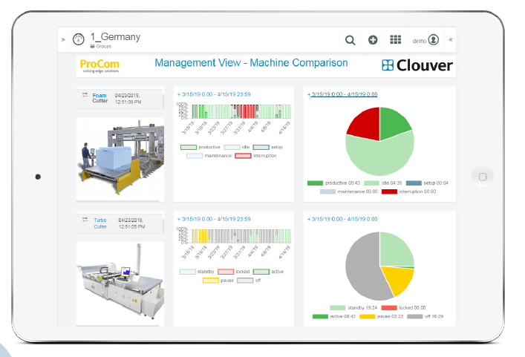
Printable image data can be downloaded under this link.
Press and Public Relations Offices:

ProCom GmbH
Stefanie Lakemper
Luisenstrasse 41
52070 Aachen (Germany)
Phone +49 241 51804-200
Fax +49 241 51804-30
Stefanie.Lakemper@procom.de
www.procom.eu
Press’n’Relations II GmbH
Ralf Dunker
Graefstrasse 66
81241 Munich (Germany)
Phone +49 89 5404722-11
Fax +49 89 5404722-29
du@press-n-relations.de
www.press-n-relations.com

Please provide two copies of publications.
ProCom has been developing custom automation solutions for machine manufacturers in the cutting and separating industry for over 35 years.
The development specialists at ProCom equip machine series with advanced CNC software and hardware, as well as CAM solutions and provide appropriate drive technology from world-renowned manufacturers. In-depth expertise in many different of processes, such as water jet cutting, laser cutting, plasma cutting, foam contour cutting and the cutting of textiles, combined with creativity and passion result in decisively better automation solutions.
The family-owned company is investing as well in its established, expandable market offerings in the European and Asian markets as in future-oriented services in the field of Industry 4.0.

