Stuttgart/Germany, January 20, 2020
160 years of comfort air technology: LTG with a new sales partner in the Netherlands
At the end of 2019, the Dutch company Interland Techniek BV from Waalwijk and LTG Aktiengesellschaft with headquarters in Stuttgart/Germany signed a distribution partnership. Interland Techniek, part of the SIG group of companies, is one of the leading Dutch suppliers of products for sustainable indoor air solutions. With decades of industry experience on both sides, with a focus on customer-oriented system solutions, the future collaboration with Interland offers an ideal basis for processing the Dutch market with air-water and air outlet systems from LTG.
During the international trade fair for heating, sanitary and comfort air technology VSK in Utrecht from February 4th to 7th, 2020, Interland will present the new cooperation and LTG products like the unique and award-winning concept for decentralized air conditioning "PulseVentilation", which has already been installed in numerous office buildings across Europe. These comfort air solutions are available as a floor, sill and ceiling unit and since 2019 with the integrated, bus-compatible control system "Connected Intelligence”, which will be presented in the Dutch market for the first time.

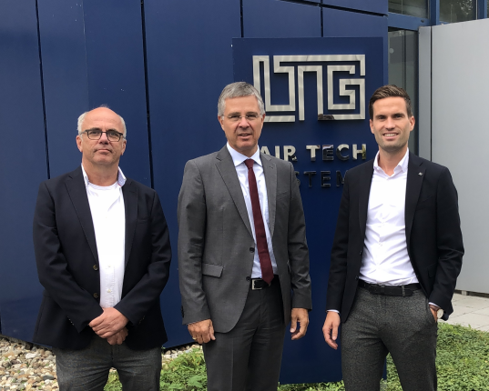
Peter van der Velde, Sales Director Interland; Wolf Hartmann, CEO LTG; Sander van der Hoven, Managing Director Interland (from left to right)
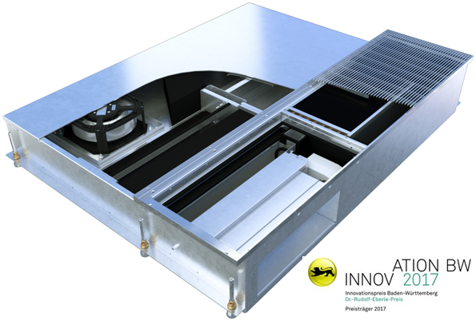
Facade ventilation unit for installation in double floors

Printable pictures are available here.
About LTG Aktiengesellschaft:
LTG was founded in 1924 by Dr. Albert Klein. The first company specialized in HVAC products in Europe is still representing innovation, quality and dependability in all areas of air related technology.
Press contact:

LTG Aktiengesellschaft
Mr. Tobias Kullnig
Grenzstrasse 7
70435 Stuttgart
Germany
Phone +49 711 8201-149
kullnig@LTG.de
www.LTG.de
Press’n’Relations II GmbH
Mr. Ralf Dunker
Graefstrasse 66
81241 Munich
Germany
Phone +49 89 5404 722-11
du@press-n-relations.de
www.press-n-relations.com

