PRESS RELEASE
Additional areas of application for BAUR’s liona and iPD devices
Online partial discharge testing optimised
Sulz (Austria), October 2020 – BAUR GmbH (Sulz/Austria) has improved its liona and iPD devices for online partial discharge testing on medium-voltage cables. The devices allow distribution network operators to examine important cables during operation, e.g., for damage to the insulation or defective joints, without the cables having to be de-energised first. Online partial discharge testing can be used to perform temporary diagnostics on a cable route or even stationary, regular measurement in the case of system-critical cables. Thanks to the latest optimisation, PD location now delivers good results even in the event of very strong noise signals.
For online diagnostics concerning partial discharge (PD), only the liona device is initially required. HFCT sensors that surround the cable sheath and are connected at the cable end are used to couple the signals in and out. If liona registers partial discharges, the new DeCIFer® algorithm works them out so that they can be clearly identified on screen on the evaluation computer. In addition to the magnitude and quantity of partial discharges, the phase-resolved PD pattern is also shown.
Determining the location of partial discharges requires the additional use of the iPD device, as reflections often do not occur at the far end in the case of online partial discharge testing. This then means that “traditional” location using reflection images cannot be performed. For this reason, the iPD is connected at the other cable end – also contact-free, using HFCT sensors – where it generates artificial reflections. liona then evaluates these for location purposes. Measurement and evaluation each take just a few minutes to complete.
Online partial discharge testing is now easier and improved due to two new features. Firstly, the automatic sensitivity adjustment of the iPD device makes it easier to identify both high and low partial discharge levels. Secondly, the new mapping app for the evaluation software successfully suppresses noise signals. This allows the software to accurately work out the location of partial discharges in the result diagram. Thanks to these optimisations, it is now also possible to detect and locate partial discharges on live cables under conditions where previous devices failed to do so due to high noise levels.
You can find further information at www.baur.eu/liona
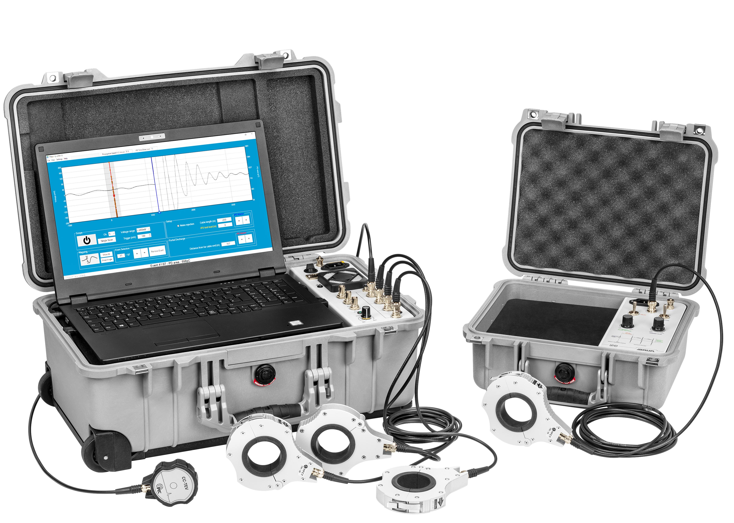
The measurement case with liona as well as the iPD device required for the location of partial discharges can be used to detect and locate partial discharges without cable routes having to be switched off. (Picture: BAUR GmbH)
You can find the print-ready image under this link.
Further information / press contact person
BAUR GmbH
Christina Plank
Raiffeisenstraße 8
6832 Sulz (Austria)
Tel.: +43 5522 4941-180
c.plank@baur.at
www.baur.eu
Press’n’Relations II GmbH
Ralf Dunker
Gräfstraße 66
81241 Munich (Germany)
Tel.: +49 89 5404722-11
du@press-n-relations.de
www.press-n-relations.com

