Bochum, August 16th, 2018
InnoTrans, 18 to 21 September, Messe Berlin / Hall 21, Stand 410
BVV wheels and wheelsets guarantee competitive advantages in all market segments
BVV with three highlights: light aluminum hybrid wheel, innovative 13.5-ton low-floor axle design and efficient high-speed wheel
This year’s InnoTrans appearance of the Bochumer Verein Verkehrstechnik GmbH takes place entirely under the theme “Competitive advantages guaranteed - meet the experts. Meet the future“. The internationally leading manufacturer of wheels and wheelset systems for local, long-distance and freight traffic on rails shows numerous innovations of its product portfolio 2018 from the areas Light Rail Vehicle (LRV), high-speed and material development. One highlight is the latest version of the resilient aluminum hybrid wheel Bo2000. The wheel, which is 30 percent lighter compared to steel wheels, provides a lot of economic advantages, such as enormous weight savings, less axle load and higher load increases. Additional highlights: Exhibition visitors are not only able to examine thoroughly the new 13.5-ton low-floor axledesign of the BVV but also the stress-balanced BVV high-speed wheel with a high mechanical load tolerance. This wheel, specifically developed for use within the Chinese high-speed network meets all of the demanding and strict specifications of the Chinese State Railway as one of the strongest running and most balanced high-speed wheels worldwide.
At the central industrial event for international railway transportation, BVV experts show the entire range of their quality wheels and wheelsets as well as current projects relating to wheels, wheelset systems and wheelset spare parts. “This year, we present as many as three new developments, by means of which BVV proves its technological pioneering role as a specialist for local and high-speed traffic. With this lead in performance, we ensure our customers competitive advantages in your market environment“, explains Karlheinz Springer, BVV-CEO. “In addition to these highlights, our experts advise on the entire BVV range for new vehicles, stock optimization and services across the entire vehicles service life.“

Quiet, durable and now even lighter – aluminum hybrid wheel Bo2000
Less weight sometimes leads to greater gain. This is proven by BVV with its latest development of the resilient aluminum hybrid wheel Bo2000. In these wheels, the monobloc wheel body and the wheel rim ring of this development do not consist of steel but of forged aluminum. A thin, torsion-proof rubber-cushion mounting is located between the wheel tire made from steel and the aluminum components. Therefore, its weight is up to 30 percent less compared to conventional wheels, which have been manufactured completely of steel. The advantages: enormous weight savings, less axle load, room for load increases as well as a lower load on the travel distance and at the vehicle. A six-axled light rail vehicle travelling on these quiet light-weight wheels, means 600 kilogram of weight less per vehicle, a 100 kilogram lower axle load as well as a lower load on the travel distance and the vehicle. Extrapolated to the service life of the vehicle with three million kilometers total performance means that approx. 195,000 kilowatt hours of energy are saved or 98,000 kilogram of CO2 emissions less. Likewise, the transport capacity per vehicle could be increased by eight persons or 600 kilogram for additional technical equipment.
Proven marathon strengths for low-noise long-distance traffic:
the BVV high-speed wheel
At InnoTrans, the exhibition visitors are able to inspect the latest version of one of the strongest running and most balanced high-speed wheels worldwide from close up: the BVV high-speed wheel developed in Bochum and manufactured in a stress-balanced manner meets the strict specifications of the Chinese State Railway equipping its long-distance trains with it. On extremely long distances (1,300–2,264 kilometers) designed for the Chinese high-speed railway network for up to 380 km/h, the BVV wheels set new standards with regard to smooth running and long distance culture. The straight and weight-saving design developed by the BVV GmbH itself of the stress-balanced wheel disks reduces natural vibrations and noise emissions significant during travel. Furthermore, this facilitates maintenance and service work. A significantly higher material hardness was achieved by an optimized thermal treatment and restricted analysis technique.

13.5-ton low-floor axle design increases the weight capacity
As an additional highlight the BVV presents an innovative low-floor wheelset in standard gauge design (1,435 millimeter) with monobloc drop-forged idle gear axle and resilient loose-wheels of the type of design Bo2000. On the steering knuckles of this idle gear axle, an own wheel bearing (tapered roller bearing) is installed for each wheel. The low-floor wheelset is ready to receive the braking systems, grounding and primary spring system. Based on the new design, the low-floor wheelset with its static axle load of 12,500 kilogram and the operational top speed of 106 km/h (+10 percent) designed for the use in light rail vehicles S70 of the Metropolitan Transit System (MTS) in San Diego (US) meets all required interface and weight specifications. Likewise, it meets the fire protection requirements according to DIN EN 45545: HL3.
Figures:
(BVV_Gummi_Radtypen.jpg)
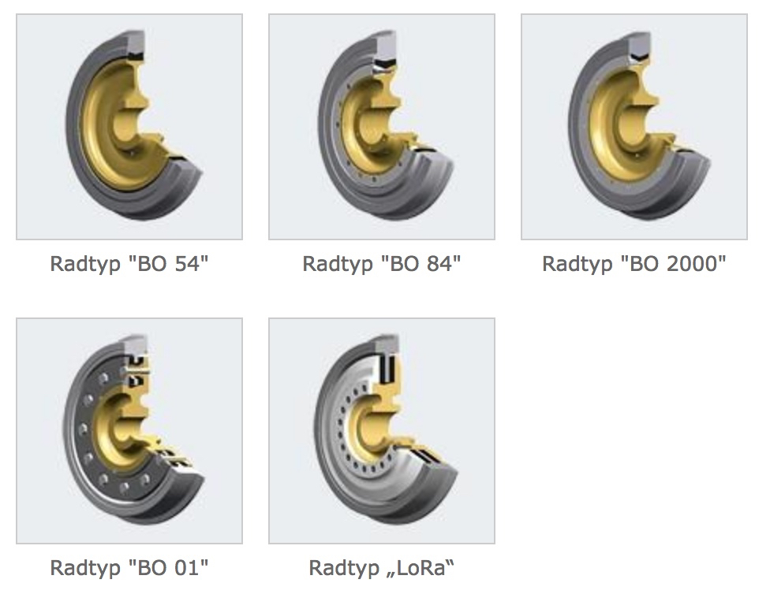
Since the 1950ies, the Bochumer Verein develops and manufactures a wide range of resilient wheels for rail vehicles. (Graphic: BVV)

(BVV_VGF_Hybridrad.jpg)

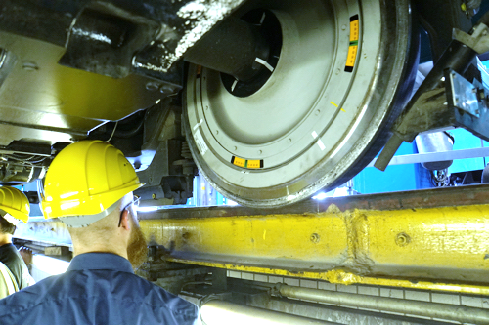
Aluminum instead of steel – The new BVV hybrid wheel BO 2000 achieves 50 kilogram
in weight reductions. (Photo: Stadtwerke Verkehrsgesellschaft Frankfurt am Main mbH)

(CRW_Website_01.jpg)
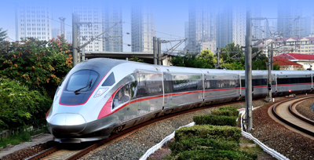
Over the distance exceeding 2,000 kilometers in the high-speed trains up to 350 km/h fast, the BVV wheels provide a maximum of safety, smooth running and durability.
(Photo: China Railway Group)

Further information:  Bochumer Verein Verkehrsbetriebe GmbH  Sabine Bühlbecker  Alleestraße 70, 44793 Bochum (Germany)  Phone.: +49 234 6891-547  Fax: +49 234 6891-60  buehlbecker@bochumer-verein.de  www.bochumer-verein.de | Press and Public Relations:  Press’n’Relations GmbH  Uwe Taeger  Magirusstraße 33, 89077 Ulm (Germany)  Tel.: +49 731 96 287-31  Fax: +49 731 96 287-97  ut@press-n-relations.de  www.press-n-relations.de

Bochumer Verein Verkehrstechnik (BVV) GmbH
The Bochumer Verein Verkehrstechnik GmbH is an internationally leading manufacturer of quality wheels and wheelsets for local, long-distance and freight traffic. From the concept to the finished product, BVV develops, designs, inspects and manufactures complete wheelset systems and individual wheelset parts according to customer requests. One of the technically most advanced developments within 175 years of company development are resilient, light and quiet wheels as well as different designs of single-piece forged axles for modern low-floor streetcars. Wheelset systems of the Bochumer Verein are used in city railways, street cars and subways, metros and suburban trains or regional trains as well as in high-speed trains, long-distance trains, engines, regional railcars as well as freight cars.
The more than 300 customers of the BVV include renowned rail vehicle manufacturers such as ALSTOM Transport, Bombardier Transportation, China CNR Corporation, CSR Corporation, Kirow Ardelt, Skoda Transportation, Siemens Transportation Systems, Stadler Rail, TRANSWAGGON and VTG. Also, rail vehicle operators - such as the Deutsche Bahn, as well as European state railways, private railways, and operators of public regional passenger transport with city railways, street cars and subways - benefit from the comprehensive range of products and services regarding spare parts and repairs. Since 2017, the Chinese investment group Full Hill Enterprise Ltd, Hong Kong is shareholder of the innovation-promoting traditional company. A total of 620 employees are working at both BVV locations Bochum (470) and Ilsenburg (150).

