The customary premium quality with double the volume
Curtis G4 ThermoProX and Curtis G4 GemX Gemini now available as a twin version

Geislingen (Germany), 11. May 2022 – High-performance machine technology is what is needed to meet the high requirements in terms of coffee quality and quantity in the catering trade or high-frequency gastronomic concepts. With the Curtis G4 ThermoProX Twin and the Curtis G4 GemX Gemini Twin, US manufacturer Wilbur Curtis presents two further professional coffee machines which offer elegant design, premium coffee quality and impressive brewing quantities. Compared to the single versions, the Curtis G4 ThermoProX Twin and the Curtis G4 GemX Gemini Twin are equipped with two independent brewing heads which give them an output of up to 80 litres per hour – ideal for self-service restaurants, petrol stations, hospitals and nursing homes or bakeries in high-frequency locations. And the twin models can not only serve a large number of guests – they also allow you to offer those guests variety with two different types of coffee bean. The filter coffee is brewed directly in two thermo containers which keep it at temperature and can then be set up separate from the brewing unit wherever you want to serve the coffee. The Curtis G4 ThermoProX Twin has a capacity of 3.8 litres per container, while each container of the Curtis G4 GemX Gemini Twin holds 5.7 litres. And thanks to FreshTrac and IntelliFresh technologies for monitoring the freshness and filling level of the coffee, the containers not only keep the prepared filter coffee at the perfect temperature for extended periods, but also guarantee premium quality.

Coffee quality and variety
The Curtis G4 ThermoProX Twin and the Curtis G4 GemX Gemini Twin offer sophisticated technical features which guarantee premium coffee quality, variety and efficiency. A digital fourth-generation G4 CPU means intuitive operation of the machines and process reliability during preparation of the coffee and also allows operators to individualise their range of filter coffee with a variety of recipes. The settings for extraction time, brewing temperature and the quantity of ground coffee can be changed to suit the specific roasting blend and the desired taste profile, and further details can also be defined. In this way, operators can offer a variety of coffees from one machine. The preset One Touch Global Recipes facilitate the profile settings and ensure consistent quality, cup after cup.

Intelligent technology for consistently good taste
The filter coffee variations prepared with the machines can then be positioned as required in the room in the respective stainless steel containers. The vacuum-insulated containers of the Curtis G4 ThermoProX Twin keep the coffee at the perfect serving temperature for up to four hours, and, thanks to FreshTrac technology, inform service personnel of the volume and quality of their content via an LED display. The satellite containers of the Curtis G4 GemX Gemini Twin are placed on a special thermo system. In addition to FreshTrac, the containers are also equipped with IntelliFresh technology – a special heating system which keeps the coffee in the satellite containers at the ideal temperature independent of the quantity. Via an integrated sensor, IntelliFresh measures the coffee temperature and triggers automatic fine adjustment of the heating function to prevent deterioration in the quality of the filter coffee caused by over- or underheating. In addition, the satellite containers of the Curtis G4 GemX Gemini allow simple scaling and decentralisation of the coffee supply: with the various thermo stations available, several satellite containers of a Curtis G4 GemX Gemini Twin filter coffee machine can be filled and placed next to each other – perfect for peak times at heavily frequented locations or in order to offer guests a choice of taste profiles. Both the Curtis G4 ThermoProX Twin and the Curtis G4 GemX Gemini Twin have a constant water supply and are equipped with an attractively designed hot water tap for the preparation of tea, soups or other instant products.

Image material
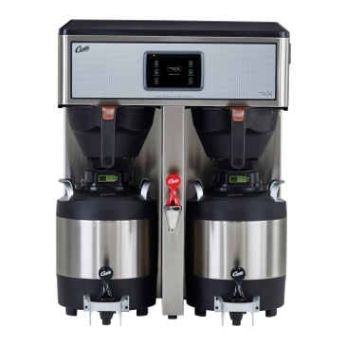 | 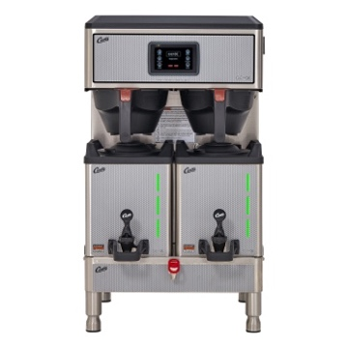
Curtis G4 ThermoProX Twin | Curtis G4 GemX Gemini Twin

Image availability
You can find downloadable image material on our media portal press-n-relations.amid-pr.com (search term “Twin-Modelle_ThermoProX_GemX-Gemini”). I would of course be happy to email you the files as well. Contact: nfo@press-n-relations.de

Further information
WMF GmbH, Altan Emci
General Manager Business Development Wilbur Curtis Global
WMF Platz 1, 73312 Geislingen/Steige, Germany
Phone.: +49 7331 25 7452
aemci@seb-professional.com
www.wilburcurtis.com

Curtis Press Office
c/o Press'n'Relations GmbH,
Nataša Forstner
Magirusstraße 33, 89077 Ulm, Germany
Phone.: +49 731 96 287-17
nfo@press-n-relations.de
www.press-n-relations.de

Wilbur Curtis
US company Wilbur Curtis has been developing professional filter coffee machines, tea brewing systems and speciality beverage machines since its founding in 1941. Thanks to its distinctive culture of innovation with foresight for the demands of the market, the family-owned company is currently the second largest American manufacturer in this sector, and also one of the leading players in this industry worldwide. Since 2019, Wilbur Curtis has been part of the Group SEB Professional Coffee Machines Division.

Curtis has been developing new technologies for a special coffee experience since the very beginning. It supports operators in offering consistent coffee quality while simplifying service processes. Innovative technology offers customers maximum flexibility and process reliability. Sustainable action for the environment and the responsible use of resources are also deeply rooted in the corporate philosophy. Curtis has been living in line with the three R’s: “Reduce, Reuse & Recycle” in all areas of business — from manufacturing and warehousing to administration — since 1941.

About WMF
WMF, which is short for Württembergische Metallwarenfabrik, is a leading premium supplier of household products, professional coffee machines and hotel equipment. WMF stands for innovation based on tradition and convinces with development and design “Made in Germany“. Under the brand names WMF, Silit and Kaiser, the company offers products for preparation, cooking, food, beverages and baking for home use, while business customers, in particular from the restaurant and hotel industry, can choose from product lines for the preparation of coffee, the perfectly laid table and buffet under the brand names WMF, Schaerer, Curtis and Hepp.

WMF products are available in more than 120 countries, and the company has over 6000 employees. In Germany, Austria and Switzerland, but also in the rest of Europe and worldwide, for example in China, WMF operates a total of around 350 own stores. The company was founded in Geislingen an der Steige in 1853 and became part of the French SEB Group at the end of 2016. For further information, see www.wmf.com

