ENEXIO Water Technologies GmbH
Karin Henning
Marketing Manager
Tel: +49 2233 39828-0
Fax: +49 2233 39828-20
Karin.Henning@ENEXIO.com
www.ENEXIO-water-technologies.com
Press Release
Brentwood Acquires Enexio Water Technologies
An Integration of Products, Capabilities, & People
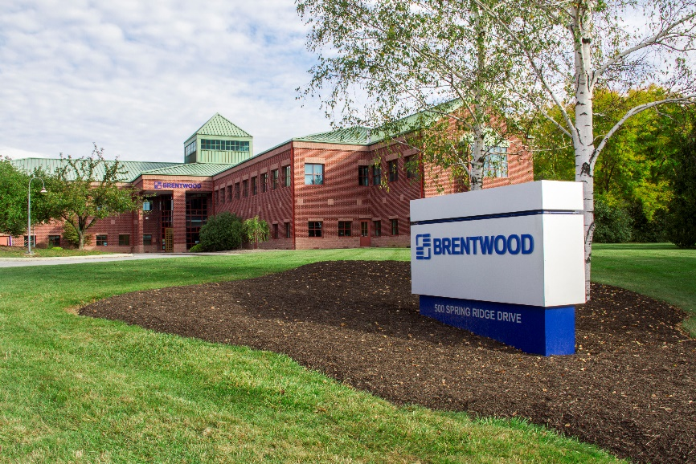

Reading, PA – January 3, 2022 – Brentwood is proud to announce its acquisition of Enexio’s Water Technologies business unit. Purchased from Kelvion, this grouping of companies consists of Enexio Water Technologies GmbH, Enexio Water Technologies s.r.o., Enexio UK Ltd., and Shandong Xinde Water Treatment Technology Co. Ltd.
Made official on January 3, 2022, the acquisition provides added capabilities, increased worldwide sales and engineering presence, and new areas of expertise for Brentwood. “This is exciting news, both for Brentwood and Enexio Water Technologies,” says Peter Rye, Brentwood’s President and CEO. “The synergies of products and staff will better position us to serve our customers around the globe.”
Enexio Water Technologies brings the competency of polypropylene processing to Brentwood, provides a platform for introducing Brentwood stormwater management products to the European market and cooling tower products to the Chinese market, and enables Brentwood to enter the mass transfer industry. The integration of these two plastics producers will also enable the growth of Brentwood’s existing products. Combined, Brentwood and Enexio Water Technologies employees have hundreds of years of experience in cooling tower technology and water/wastewater treatment.
Geographically, Brentwood will maintain its existing sites, and acquire from Enexio Water Technologies a manufacturing plant and sales office in Germany, a sales office in England, an assembly operation in the Czech Republic, and a joint venture manufacturing plant in China.

About Brentwood
Brentwood Industries, Inc., is a family-owned, family-run business, operating in the U.S., India, Thailand, Mexico, and the Czech Republic. For over 50 years Brentwood has applied plastic technologies to solve unique customer challenges and fostered a culture of innovation, entrepreneurship, and sustainability.
Today, Brentwood is an industry leader in the development, engineering, and production of plastic solutions for cooling tower, medical, water treatment, transportation, stormwater management, construction, and battery applications.

About ENEXIO Water Technologies
Within the ENEXIO group ENEXIO Water Technologies is the expert for water, wastewater and air treatment and for cooling tower components. For more than 40 years, we have been planning, developing and manufacturing structured packings and lamella packs for biological and chemical/physical processes in water and wastewater plants, bio and gas scrubbers, cooling towers and for air humidifying and cooling of stables. We see ourselves as a global service provider, who advises and supports industrial and municipal customers in the process design, engineering and optimization of their plants in above-mentioned applications. Learn more at www.enexio-water-technologies.com.
In case of publication, please send us a file copy of the published articles for our archive. If you do not want to receive information from ENEXIO Water Technologies any longer, please send us an email (marketing@enexio-water-technologies.com) or contact us by phone (+49 2233 29828 25).

