Medtec LIVE with T4M, May 23-25, 2022
Hall 1, Booth 1-321d (VDMA Community Booth)

ZAHORANSKY at Medtec LIVE:
A comprehensive range of solutions for primary packaging made of plastic and secondary packaging for the Personal Care industry

Freiburg, May 17, 2023. From May 23-25, 2023, the medical technology industry will meet at MedtecLIVE with T4M in Nuremberg. ZAHORANSKY AG’S Medical Unit will also be on site at the community booth of the VDMA Medical Technology Working Group (Hall 1, Booth 1-321d), where they will showcase their extensive solutions and manufacturing expertise in the field of plastic-based primary pharmaceutical packaging. Medtec LIVE is the ideal platform for ZAHORANSKY to present its high-performance solution portfolio and manufacturing expertise to meet the needs of the pharmaceutical industry. In addition to many years of experience in the development and implementation of automated production facilities, the “One Stop Shopping” concept in particular represents clear added value for customers. Customers receive a turnkey, fully-automated production line from ZAHORANSKY from a single source. ZAHORANSKY will also be presenting its manufacturing solutions for the production of secondary pharmaceutical packaging in Nuremberg.

Hygiene, quality and process safety are essential in the production of in-mold and multi-component products. ZAHORANSKY meets these requirements of the pharmaceutical industry with pioneering state-of-the-art technologies, as well as advanced injection molding and automation solutions. In this way, it covers the entire manufacturing cycle for primary pharmaceutical packaging for laboratory analysis and the administration of medicines. With an overall equipment effectiveness of over 85%, tried-and-tested glass-substitute products made from plastic, manufacturing processes in accordance with GMP specifications with no-human touch, all the way to a packaging selection, the solutions offered by this Black Forest-based company speak for themselves. The PRIMA Z syringe for staked needle syringes, for example, is the first production line on the market featuring a 16-cavity mold for manufacturing syringes as primary pharmaceutical packaging for liquid medicines. Drug delivery systems such as micropumps, pen injectors and inhalers are manufactured using the LIVA Z, which always enables safe and reliable dispensing of contents. With the VITRO Z models, the high global demand for in-vitro diagnostics (IVD) – such as dialyzers, pipette tips, cuvettes, laboratory consumables and blood collection tubes – can be met.

In the field of secondary pharmaceutical packaging, ZAHORANSKY continues to rely on the technical and sales cooperation with KOCH Pac-Systeme GmbH, which was launched in 2022. Together, the partners provide a broad portfolio of sustainable, environmentally friendly packaging solutions in the area of personal care – including the KOCH model series KDT and KBS, as well as the ZAHORANSKY machines Z.PACK 4 and 5. This joint portfolio will provide comprehensive market coverage for the demand for plastic and, in particular, mono-material cardboard blisters in the personal care sector.

More information about the Medical Unit of ZAHORANSKY AG can be found here:
https://www.zahoransky.com/de/medizintechnik.html

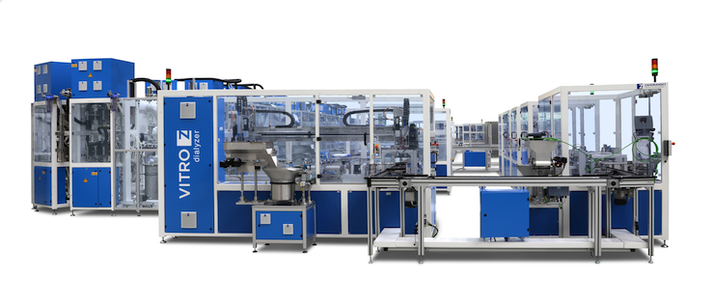
The VITRO Z models enable the high global demand for in-vitro diagnostics (IVD) to be met.

Image material
Image material can be found in our media portal press-n-relations.amid-pr.com (search term “Medtec LIVE 2023”). Of course, we would also be happy to send you the files by email.

Further information:  ZAHORANSKY AG  Robert Dous, Managing Director of ZAHORANSKY Automation & Molds and Chief Sales Officer of ZAHORANSKY GROUP  Anton-Zahoransky-Strasse 1  79674 Todtnau-Geschwend  Phone: +49 (0) 7671 997-0  Email: robert.dous@zahoransky.com  www.zahoransky.com | Press and public relations:  Press'n'Relations GmbH  Nataša Forstner  Magirusstr. 33, 89077 Ulm  Phone: +49 (0) 731 96287-17  Email: nfo@press-n-relations.de,  www.press-n-relations.de

Background information
The name ZAHORANSKY has stood for reliability, precision, and sophisticated technology since 1902. The foundation for this was laid by Anton Zahoransky in his small workshop in Todtnau, where he manufactured the first devices and machines for automated brush production.

Thanks to the experience and expertise gained since then, ZAHORANSKY is now a full-range supplier and technology partner for companies in the brush industry, medical technology, and other sectors. With injection molds, mechanical engineering, automation technology, and packaging systems, ZAHORANSKY can provide comprehensive services for individual requirements. Approximately 900 employees, including 70 trainees, work to achieve this every day at ten locations in Germany, Spain, China, India, Japan, Brazil, and the United States.

ZAHORANSKY’s multi-system solutions cover the entire process chain: from integrating packaging technology and handling, to programming and robotics in the manufacture of fully automated production and assembly systems. ZAHORANSKY's technologies and services are widely used in the following industries: household and industrial brushes, oral care, medical technology, cosmetics, consumer goods, and packaging.

