Geislingen, 6 July 2023

170 Years of German Innovation

Grown experience and passion for innovation

WMF celebrates 170 years! Since its foundation in Geislingen, Baden-Württemberg, WMF has stood for metal craftsmanship, outstanding quality, sophisticated design and decades of experience with professional tools. From pure metal processing at the beginning, a comprehensive portfolio has developed in the three business areas of consumer products, coffee machines for the professional sector and hotel equipment. In doing so, WMF maintains its values and traditions, but always keeps its finger on the pulse of the times and focuses on groundbreaking innovations. Over the years, this has resulted in a considerable number of milestones, patents and design icons.

In 1853, mill owner Daniel Straub and the Schweizer brothers founded the Straub & Schweizer metal goods factory in Geislingen. In 1880, the company merged with the Ritter & Co metal goods factory to form the Württembergische Metallwarenfabrik. Today the brand can look back on
170 years of change and success and is proud to still bear its roots and heritage in its name: WMF - Württembergische Metallwarenfabrik.

WMF offers cooking, drinking and eating culture at the highest level. More than 100 million people worldwide use WMF products every day. They use them in their kitchens at home, enjoy freshly prepared coffee specialities or stylishly served dishes in restaurants and hotels. In every case, award-winning design, perfect functionality and premium quality ensure a culinary experience. In the professional segment of the catering and hotel industry, WMF Professional Coffee Machines and WMF Professional Hotel Equipment are the leading global players.

The topic of design determines all areas of the WMF brand. Design is not a mere formality, but is seen as a whole that combines aesthetics, function and utility. In this way, many years of expertise and a passion for metal as a material lead to high-quality aesthetics that are particularly durable.
The traditional origin from Germany, iconic design, metal craftsmanship as well as expert know-how in the production of coffee machines and equipment for the professional sector form the four pillars for every creative idea and product development.

WMF uses its anniversary as an opportunity to celebrate its origins in Geislingen and its wealth of experience. Typical for WMF: It does not remain a mere retrospective, but spans the arc to groundbreaking developments of today.
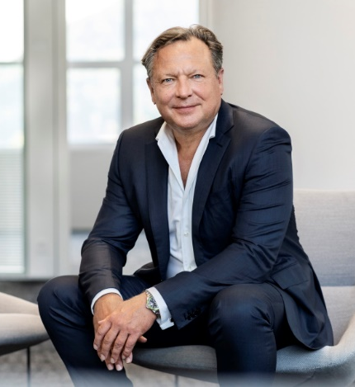
“170 years full of innovative spirit and fantastic milestones - that is a special achievement. Happy Birthday WMF! I am very happy to be able to work for a company with this history," says a delighted Oliver Kastalio, CEO at WMF. "And I am equally proud that we continue to develop the values of the founder, the demand for design and high quality with our products in a contemporary way. We are aware of our precious heritage and yet we are always looking ahead. Because - we still have a lot ahead of us."

WMF at a glance:

Three business units
A subsidiary of Groupe SEB
Quality
Approximately 800 patents
Production sites in Germany
Design as brand essence

Three business units
Refined tableware and products for the kitchen at home or coffee machines in upmarket restaurants and hotel equipment – for WMF, as a premium brand, in its three business units, only the best is good enough. With the promise “Designed to Perform,” WMF Professional Coffee Machines emphasises the technically outstanding and reliable performance of every WMF coffee machine, from fully automatic machines to automatic portafilter solutions right through to fully automatic filter machines. A distinguishing feature of the products for the B2B segment is quality “Made in Germany”. Besides, with more than 320 technicians, WMF has the largest in-house service organisation in Europe.
WMF Professional Hotel Equipment has a range which meets even the highest requirements and offers products for hotels and restaurants in premium quality and numerous design variants. From cutlery and glassware to serving equipment or table decoration right through to a flexible modular system for buffets, the product range includes all you could wish for optimum guest service.
Right from the beginning, the range for end consumers stood for special moments of indulgence and for design “Made in Germany”. From hand-forged knives to premium cookware or state-of-the-art electrical appliances for almost any application. The products are designed to make every moment of their use special – from preparation to cooking to eating and drinking.

A subsidiary of Groupe SEB
Since 2016, as a subsidiary of the French Groupe SEB, WMF has been part of an international teams of 33,000 employees in over 150 countries, who are responsible for 31 brands from the consumer and the professional segment. With its successful blend of accumulated experience and passion for innovation, WMF not only has a similar corporate history, but also shares many key
values. At the same time, WMF remains true to its roots as a premium brand with headquarters in Geislingen and 170 years of experience.

Quality
Outstanding quality is one of the cornerstones of the company, which places high demands both on its products and on itself, from the selection of materials, craftsmanship and design through to consulting expertise. The internationally renowned quality seal and designation of origin “Made in Germany” applies to a large proportion of the value chain. WMF manufacturers at sites in Germany, in Europe, and works with hand-picked suppliers and partners worldwide. The company has a global quality organisation which inspects all goods, tests them in accordance with statutory requirements and ensures compliance with its own consistently high standards.

Production sites in Germany
Since its founding, WMF has been closely connected with the region Baden-Wuerttemberg. With three of its sites, WMF has made a clear commitment to Germany as a production location. In Hayingen, Riedlingen, Geislingen and Birkenfeld, cutting edge technology and traditional craftsmanship come together. At the company’s headquarters in Geislingen, WMF Professional Coffee Machines manufactures a wide range of coffee solutions – for hotels, restaurants and catering companies or offices and bakeries and for all business ideas in which premium coffee concepts play an important role.
WMF Professional Hotel Equipment, the premium supplier of products for the perfectly laid table and the buffet, is based in Birkenfeld.
In Hayingen, WMF manufactures knives whose key feature is the exclusive Performance Cut technology, while the Riedlingen site is the competence centre for glass ceramics and the WMF Fusiontec series.

Approximately 800 patents
From the very beginning, WMF had a special feeling for the combination of tradition and innovation – and as a result, it has developed many unique materials and technologies over time. To date, WMF holds approximately 800 patents and is a pioneer both in the area of products for end consumers and professional coffee machines. The portafilter concept “WMF espresso,” for example, raises barista-made coffee to a completely new level when it comes to process reliability. As the first machine of its kind, the WMF espresso combines the flair of Italian portafilter concepts with the consistently high coffee quality of a WMF fully automatic coffee machine, while the “WMF AutoClean” system revolutionises and simplifies machine cleaning. Both the coffee and the milk system of the WMF fully automatic coffee machines are cleaned automatically, reliably and hygienically, at preset times and with no intervention needed. This brings a real time-saving, because it frees all employees from unpopular cleaning tasks. At WMF, new hardware components or software solutions are always developed with the aim of generating real added value for operators and end consumers – an aim which dovetails perfectly with the values of “Made in Germany”.

Design as brand essence
Exceptional design was an integral part of the company’s history right from the start. Clear silhouettes, a love of detail, hand-picked materials and harmonious surfaces are the characteristic features of WMF design. And the focus is always on the user. The intention is for the products to offer an emotional experience while preparing and cooking food and beverages.

Today, WMF’s internal design team works on products in all product categories. Dialogue with specialists from widely ranging fields plays a key role here.
Around 600 prestigious national and international design awards are evidence of the high standard and great importance of design at WMF.

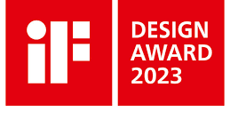
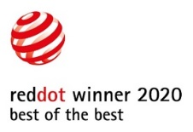
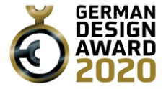

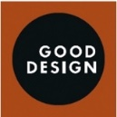
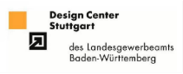


For more information, see www.wmf.com.

Image request
You can download image material here: https://aboutwmf.com/en/download/wmf-170-years-of-german-innovation/

Press contacts:

WMF Corporate
Corinna Spahn
WMF Platz 1
73312 Geislingen a.d. Steige
presse@wmf.de

WMF Professional Coffee Machines
Mirjam Sauter
Global Communication & Content Manager
GBU Professional Coffee Machines
WMF Platz 1 – D-73312 Geislingen
Tel.: +49 73 31 25 7314
presse.pcm@wmf.com – https://www.wmf.com

WMF Pressebüro
c/o Press’n’Relations GmbH
Monika Nyendick
Magirusstraße 33 – 89077 Ulm, Germany
Tel.: +49 731 96287-30
wmf@press-n-relations.de
https://www.press-n-relations.de

