INTERNORGA – Leading trade show for the catering and hospitality market, 13 to 17 March 2020, Hamburg, Hall B1 (ground floor), Stand 207

Zuchwil – 27 February 2020

Coffee expertise meets individuality
Schaerer combines technical finesse with maximum configurability

At Internorga 2020, the Schaerer exhibition stand will focus fully on individuality coupled with coffee expertise. The professional coffee machine manufacturer’s exhibits on display in Hamburg will demonstrate to visitors the options available with individually configurable solutions for operators of a wide range of hotel and catering concepts. A particularly eye-catching feature of the stand is the Schaerer Barista. It unites the craftsmanship of a portafilter machine with the simple operation of a fully automatic coffee machine, and is now being launched onto the market with new technical features. A further highlight is the presentation of the new Schaerer Coffee Soul Select. Thanks to the “Select” principle, it is even easier for customers to put together the perfect solution from the latest developments of the tried and trusted Schaerer Coffee Soul to suit their business model.

A new dimension of barista expertise
From coffee bars to Italian restaurants, the Schaerer Barista helps restaurant owners create the perfect environment for coffee culture, both visually and technically, whilst also providing consistent quality. To unite customised requirements and efficiency even more closely, the features of the Schaerer Barista have been expanded to include extension and adaptation options. Whilst the grinding level and brewing time are automatically monitored and adjusted as needed, the second optional Supersteam prepares consistently high quality milk foam creations even more quickly with its fully-automated technology. The new external bean hoppers are of particular interest to locations with a high beverage output. A capacity of over one kilogram per hopper ensures consistent operation without constant refilling, even with a high volume of guests.

Schaerer Coffee Soul: the new generation
With the new Schaerer Coffee Soul Select, the company is clearly demonstrating how the “We love it your way” market positioning is reflected in the development of new machine concepts. The ingenious “Mix & Match” principle of the new Schaerer Coffee Soul Select stands for maximum configurability and individuality: customers can select the equipment level they need from a variety of options – from the milk system to the outlet type or the number of bean hoppers, and other features such as the “Hot & Cold” technology or a syrup station. Regardless of this, they have the choice between two design options: the Schaerer Coffee Soul 10 with 10.4 inch display or the Schaerer Coffee Soul 12 with 12.1 inch display. Both versions feature design elements in different colourways.

www.schaerer.com

Image material
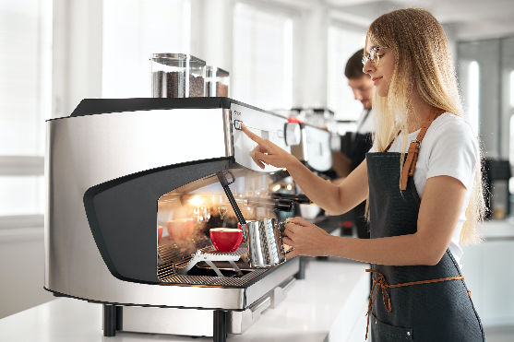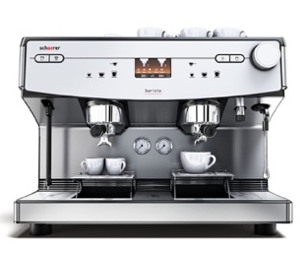 | 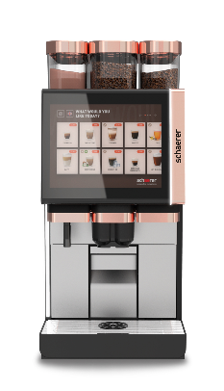
The Schaerer Barista combines the craftsmanship of a portafilter machine with the simple operation of a fully-automatic coffee machine. | The new Schaerer Coffee Soul 12 has a generously sized 12-inch display.

Image availability
You can find downloadable image material on our media portal press-n-relations.amid-pr.com (search term “Schaerer-Internorga-2020”). Naturally I would also be happy to send you the file via email. Contact: nfo@press-n-relations.de

Further information:
Schaerer AG
Matthias Lübke, Head of Marketing & Coffee Competence Centre Allmendweg 8, 4528 Zuchwil, Switzerland
Tel.: +41 32 681 64 99
MLuebke@schaerer.com
www.schaerer.com

Schaerer Press Office
c/o Press'n'Relations GmbH, Nataša Forstner
Magirusstrasse 33, D-89077 Ulm, Germany
Tel.: +49 731 96 287-17
Fax: +49 731 96 287-97
nfo@press-n-relations.de
www.press-n-relations.de

About Schaerer AG
Founded in 1892 and headquartered in Zuchwil, Switzerland, Schaerer AG is one of the world's leading manufacturers of fully automated professional coffee machines. As a well-established company with a long history, the Schaerer brand stands for Swiss values combined with in-depth knowledge on coffee. The company emphasizes these brand attributes in its logo “swiss coffee competence” and lives them equally in its product development and the Coffee Competence Centre, Schaerer’s coffee expertise and training centre in Zuchwil. Moreover, Schaerer is characterised by extreme flexibility adhering to the guiding principle of “We love it your way” - whether it concerns customer requests, customer-specific products bulk orders or the product range which offers the customer a wide collection of customised configuration options. Customer-oriented and equipped with comprehensive knowledge on coffee, Schaerer supports any customer of any size all over the world in offering guests delicious coffee of the highest quality.

Schaerer has been part of the WMF Group since 2006 and of the French consortium Groupe SEB since the end of 2016. All B2B brands of the Groupe are bundled under the consolidated sales organisation “SEB PROFESSIONAL”. In addition to Schaerer, it also includes WMF and Wilbur Curtis coffee machine brands as well as the Professional Hotel Equipment division of WMF Professional and HEPP brands.

