PRESS RELEASE

Zuchwil – 20. October 2020

Mix & match to fit any individual needs
Schaerer Coffee Soul with the “Select” concept: New design, two models and three user interfaces offer customers countless configuration options

Whether internationally active coffee chain or regional vendor: The desire for individuality is increasing, and not only when it comes to the technical equipment of a coffee machine. The look should also fit seamlessly into the design concept of the company. With the new Schaerer Coffee Soul featuring the flexible “Select” concept, the Swiss coffee machine manufacturer is setting new benchmarks in the individual configuration of its machine technologies to fit customer requirements. The concept is based on the underlying idea of combining technical equipment, user guidance as well as colours and other design elements to meet the specific needs of customers, therefore giving them the ultimate flexibility to adapt the machine perfectly to their business model. When it comes to configuration, two models offer a quick start. While the Schaerer Coffee Soul 10, with its 10.4 inch display, scores points with staff operation, the Schaerer Coffee Soul 12 with the 12.1 inch display, which can play videos, shines when it comes to self-service operation by guests. The operating concept of the two models is rounded out by the brilliant user interface, whose appearance and menu guidance have been completely redesigned. The GUI (Graphical User Interface) not only features large beverage icons, but the processes and display can also be adapted to the three most common application situations — self-service, preparation by staff and office use.

More freedom thanks to the “Select” concept
"Hot & Cold” technology for cold coffee specialities? Automatic height-adjustable “touchless” outlet? “Flavour Point” syrup station? One, two or even three grinders? Thanks to the “Select” concept, the technical features of the new Schaerer Coffee Soul are perfectly aligned to the needs of customers and their business models — no matter whether it is used in a restaurant, café, petrol station, convenience store or office. The Schaerer Coffee Soul 12 model is equipped with a touch screen which can play videos, for example for promotions, making it the ideal choice for operators who place the highest demands on the design of their coffee machines and set them up in self-service areas or anywhere customers can see them. The Schaerer Coffee Soul 10 model, on the other hand, is ideal for use by staff in restaurants, bars and hotels. No matter which model the customer chooses, the Schaerer Coffee Soul 10 or 12, design elements in different colours such as copper, red, brown or green, the optional stainless steel front and the illumination concept make it possible to adjust the appearance to individual preferences and harmonise it with the furnishing concept of the specific business.

New operating concept improves user experience
The operating concept was the focus when developing the new Schaerer Coffee Soul. The goal was to design the user interface so that it would perfectly fulfil the requirements of the respective area of application and improve the user experience thanks to its simple operation. For this purpose, the GUI (Graphical User Interface) was completely redesigned and the presentation of beverages and the menu guidance was adapted to the most common operating situations — self-service, offices, and preparation by staff. The “guest mode” operating mode makes self-service particularly user-friendly, for example in the breakfast area of a hotel, a cafeteria, a petrol station or a convenience store: Similar to using a tablet or a smartphone, guests can swipe through the menu and are guided intuitively though the options when creating their favourite coffee beverage. In addition, the “favourite mode” offers short commands which regular users can take advantage of to quickly create their favourite beverages. This operating mode is perfect for office environments, for example. Operation of the Schaerer Coffee Soul in “staff mode” is based on the requirements of areas in which coffee specialities are prepared by staff. Popular beverages can be preset for quick, reliable brewing and other coffee specialities can be prepared in a flash in just a few steps on the GUI. This means even employees with little experience can work efficiently with a Schaerer Coffee Soul 10 or 12 after just a brief introduction.

www.schaerer.com

Image material
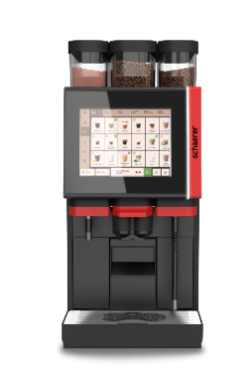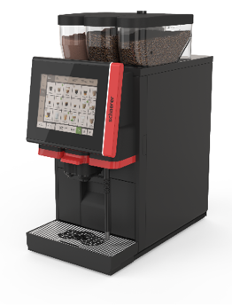 | 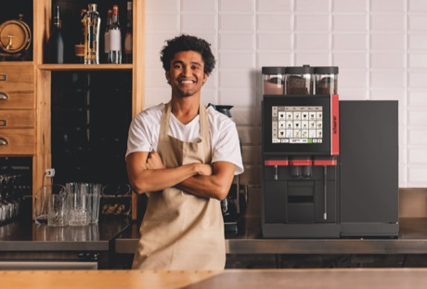
The workhorse: The Schaerer Coffee Soul 10 with the “Select” concept features a 10.4 inch screen.
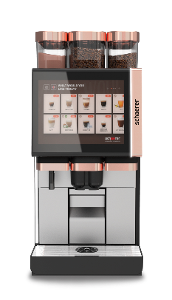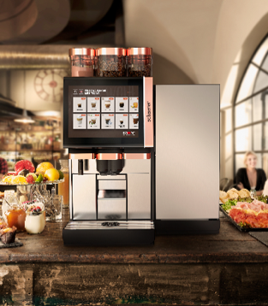 | 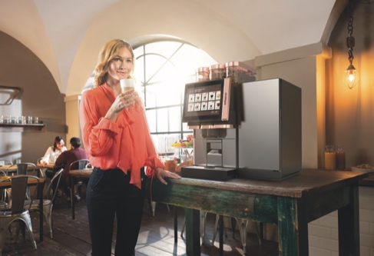
The Schaerer Coffee Soul 12 with the “Select” concept stands out with its large 12.1 screen display which can play videos.

Image availability
You can find downloadable image material in our media portal press-n-relations.amid-pr.com (search term “Schaerer-Coffee-Soul-Select”). I would of course be happy to email you the files as well. Contact: nfo@press-n-relations.de

Further information:
Schaerer AG
Matthias Lübke, Head of Marketing & Coffee Competence Centre Allmendweg 8, 4528 Zuchwil, Switzerland
Tel.: +41 32 681 64 99
MLuebke@schaerer.com
www.schaerer.com

Schaerer Press Office
c/o Press'n'Relations GmbH, Nataša Forstner
Magirusstrasse 33, D-89077 Ulm, Germany
Tel.: +49 731 96 287-17
Fax: +49 731 96 287-97
nfo@press-n-relations.de
www.press-n-relations.de

Schaerer AG
Founded in 1892 and headquartered in Zuchwil, Switzerland, Schaerer AG is one of the world’s leading manufacturers of fully automated professional coffee machines. As a traditional company with many years of history, the Schaerer brand stands for Swiss values combined with an in-depth knowledge of coffee. The company expresses these brand attributes with the company logo “swiss coffee competence” and experiences them equally in its product development and in the Coffee Competence Centre, Schaerer’s own coffee expertise and training centre in Zuchwil. Moreover, Schaerer is characterised by extreme flexibility with the guiding principle “We love it your way” — be it in reference to customer requests, customer-specific products and large orders or the product range which offers the customer a wide range of customised configuration options. Customer-oriented and with extensive coffee knowledge, Schaerer supports customers of any size all over the world in offering their guests the highest level of coffee enjoyment.

Schaerer has been part of the WMF Group since 2006 and of the French consortium Groupe SEB since the end of 2016. All B2B brands of the Group are bundled in the “SEB PROFESSIONAL” consolidated sales organisation. In addition to Schaerer, it includes the WMF and Wilbur Curtis coffee machine brands as well as the Professional Hotel Equipment division with the WMF Professional and HEPP brands.

