New optional accessories for the Schaerer Coffee Soul
Cup & Cool optional accessories, cup warmers and under-machine cooling unit increase flexibility in counter design

Zuchwil, 23/08/18 – Now available from Swiss coffee machine manufacturer Schaerer is an even greater selection of perfectly matched optional accessories for the Schaerer Coffee Soul. The new optional accessories are designed to be the perfect complement to the narrow design Coffee Soul and to offer restaurateurs maximum flexibility for the best possible organisation of their work and supply processes, even in the smallest of spaces. The product range includes a Cup & Cool System as well as a cup warmer in wide and narrow models, and an under-machine milk cooling unit with a capacity of 9.5 litres. The Cup & Cool solution combines a cup warmer and a milk cooler in one, offering even greater space savings and efficiency. The Cup & Cool as well as the cup warmers also provide a striking visual highlight: with integrated lighting – in a choice of various different colours – they enhance any individual restaurant styling. At the end of the year, Schaerer customers will be able to enjoy a new innovation for the preparation of cold coffee specialities: "Hot & Cold" technology for the Coffee Soul.

Cup & Cool System
Cup & Cool combines a cup warmer with a milk cooling unit, saving valuable space on the countertop. The narrow version (286 x 587 x 566 mm) offers a capacity of 4.0 litres, and the wide model (368 x 587x 569 mm) can store 9.5 litres of milk. When a level of around 0.5 litres is reached on either unit, the integrated fill level sensor sends a message to the machine. The wide version is also available as a Cup & Cool Centre Milk – meaning the optional accessory can be perfectly positioned between two machines for the central supply. In addition, the integrated lighting in the colours of white, red, blue and green provide further stylish options on the countertop.

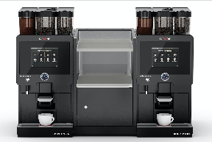
Schaerer Coffee Soul with Cup & Cool Centermilk.

Cup warmers and under-machine cooling unit
The new cup warmers for the Coffee Soul, with the same lighting options, bring cups and glasses to the ideal temperature to serve the prepared coffee specialities with the perfect taste and temperature during daily operations. Available as wide (368 x 585 x 547 mm) and narrow (286 x 587 x 542 mm) versions, they can be optimally integrated into any counter design concept. With the new under-machine cooling unit, Schaerer also offers a space-saving option to supply 9.5 litres of milk underneath the Coffee Soul – thanks to the optimum milk temperature, the perfect milk foam is easy to achieve for all types of speciality coffee beverage.

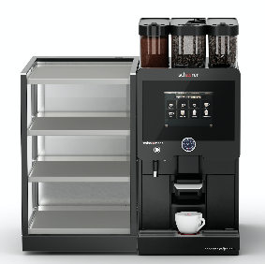 | 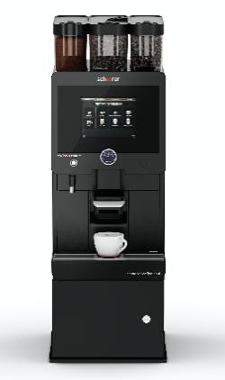
Schaerer Coffee Soul with illuminated cup warmers in narrow and wide design. | Schaerer Coffee Soul with under-machine cooling unit for a capacity of 9.5 litres of milk.

"Hot & Cold": Higher quality for cold coffee specialities
At the end of the year, Schaerer will be taking the quality of cold coffee specialities to a whole new level with the "Hot & Cold" technology for the Coffee Soul: Under the motto of "brewed hot and served cold", the coffee-based beverage will be brewed conventionally at 90 °C and cooled to 30-35 °C during the dispensing process using a special beverage cooling system. This allows refreshing summer specialities such as ice coffees with ice cubes or ice cream to be prepared rapidly and with an intense flavour – the ice cream or ice cubes keep their shape for longer, the beverage stays cool and dilution is reduced. Hot & Cold opens up new options for composing coffee creations to restaurateurs.

Image requirements
You can find downloadable image material in our media portal press-n-relations.amid-pr.com (search terms "Coffee Soul Optional Accessories"). Naturally I would also be happy to send you the file via email. Contact: nfo@press-n-relations.de

Further information:  Schaerer AG, Sarah Ogenibeni  Head of Marketing & Coffee Competence Centre, Allmendweg 8, 4528 Zuchwil  Tel.: +41 32 681 64 02  Fax: +41 32 681 64 04  sarah.ognibeni@schaerer.com  www.schaerer.com | Press and public relations:  Schaerer Press Office  c/o Press'n'Relations GmbH, Nataša Forstner  Magirusstrasse 33, D-89077 Ulm, Germany  Tel.: +49 731 96 287-17  Fax: +49 731 96 287-97  nfo@press-n-relations.de  www.press-n-relations.de

Schaerer AG
Schaerer AG, headquartered in Zuchwil near Solothurn, Switzerland, was founded in 1892 and is one of the world's leading manufacturers of fully automatic professional coffee machines, offering the perfect solution for every need and service requirement. Schaerer AG is represented internationally with subsidiaries in Germany, Belgium and the US and over 70 partner companies on all five continents. Schaerer has been part of the WMF Group since 2006 and of the French consortium Groupe SEB since the end of 2016.

Customers all over the world value Schaerer products for their ease of use, the large selection of coffee types available at the touch of a button and the excellent quality of their coffee. Numerous innovations, including the revolutionary, patented Best Foam milk system, highlight the company's pioneering approach. The company's claim of offering "Swiss coffee expertise" is founded on the Swiss engineering skills on which it draws and its far-reaching coffee expertise. The "Barista inside" strapline plays with the idea of the company's coffee machine technology and many years of coffee expertise being equal to the skills of a barista: On the inside of the coffee machines, all the details are perfectly coordinated to prepare beverages that are equal in taste and appearance to the coffee creations handcrafted by baristas.

