Zuchwil, 22. September 2020

Enjoying espresso on a whole new level
The Schaerer Barista scores with new functions and individualisation options

Combining the craftsmanship and aesthetics of a portafilter machine with the simple operation and process reliability of a fully-automated coffee machine — the Schaerer Barista has been living up to this standard since it was launched. Whether for quick-service restaurants, system catering, coffee bars or Italian restaurants — the Schaerer Barista helps restaurateurs celebrate the craft, technology and optics of espresso culture. The Schaerer Barista stands for consistently high beverage quality with minimal required training for the staff, making it the ideal alternative to the classic semi-automatic machine. To better unite customised requirements and efficiency, the Schaerer Barista is now undergoing various technical and design upgrades. The automatic grinding level monitoring function and corresponding adjustment when the level deviates from the target value result in a real plus for beverage quality. The new external bean hoppers are of particular interest to locations with a high beverage output. A capacity of over one kilogram per hopper ensures consistent operation without constant refilling, even with a high volume of guests. The second optional Supersteam also lends more power to the preparation process — milk foam creations can be created even faster while preserving the high level of quality. Various external parts can be wrapped in colourful foil to better harmonise the machine appearance with the existing furnishing concepts.

Software intelligence for high beverage quality
If a coffee machine is often in use, regular readjustment of the grinders ensures a consistent flavour profile and therefore high espresso quality. In order to minimise service processes and guarantee the flavour experience which comes as a matter of course for Schaerer machines, the Schaerer Barista will from now on feature automatic grinding adjustment and brewing time monitoring. Together with an intelligent software solution, the grinding level and brewing time are constantly monitored and automatically adjusted if there are deviations from the defined standard to ensure optimal results.

Perfect milk foam at the press of a button
Milk foam is essential for many espresso specialities. However, a great deal of know-how and practice is needed to achieve high quality with a traditional steam wand. The standard Schaerer Barista features a Supersteam system for fully-automated preparation of milk foam in up to three different consistencies. For areas with high beverage output, it can now be equipped with a second system as an option. Properties such as temperature and consistency are stored in the system and automatically implemented after selection. This means even inexperienced employees can make perfect milk foam and also use the time saved for other service work.

Extra portion of beans
It’s not only milk foam which pushes coffee machines to their limits; bean hoppers must also be refilled often if output is high. For the Schaerer Barista, there is therefore the option of selecting bean hoppers which are attached to the machine. A capacity of up to 1,100 grams each guarantees that large amounts of espresso can be prepared without constantly having to refill the hoppers with beans. However, the movable cup storage area and the cup heater have to be removed due to the large hoppers.

Working efficiently
All the operator has to do to prepare an espresso or a café crème with the Schaerer Barista is insert the portafilter and touch a drink to select it. All other quality-relevant steps such as measuring out and grinding the coffee as well as tamping with the optimal compression pressure are done by the machine. In addition, the Schaerer Barista “remembers” which of the three available portafilter sizes was inserted and automatically adjusts the dosage/filling level. As an additional advantage, the preset coffee quantity and the bean hoppers with integrated grinders which grind the coffee directly into the portafilter reduce the loss of coffee grounds and help keep the work area cleaner.

Exceptional colour accents
The Schaerer Barista is much more than an espresso machine. When put in the right setting, it really grabs the customer’s attention in any café or restaurant. There is now the option of attaching foil to different parts of the machine to better utilise this potential for restaurant owners. The side parts, rear wall and trim can be designed with special foils in any imaginable colour — there are no limits on creativity. Each order is made and processed separately so customers receive machines which completely fulfil their expectations in the shortest possible time.

www.schaerer.com

Image material
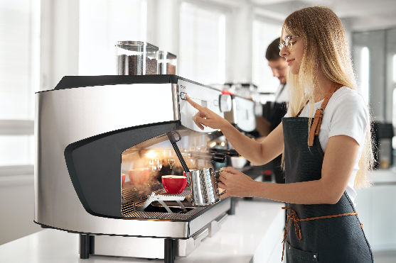 | 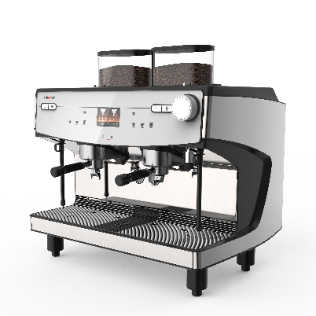
Starting now, the Schaerer Barista is offering more flexibility when adapting to individualised customer requirements.

Image availability
You can find downloadable image material in our media portal press-n-relations.amid-pr.com (search term “Schaerer-Barista-2020”). I would also be happy to send you the file via email. Contact: nfo@press-n-relations.de

Further information:
Schaerer AG
Matthias Lübke, Head of Marketing & Coffee Competence Centre Allmendweg 8, 4528 Zuchwil, Switzerland
Tel.: +41 32 681 64 99
MLuebke@schaerer.com
www.schaerer.com

Schaerer Press Office
c/o Press'n'Relations GmbH,
Nataša Forstner
Magirusstrasse 33, D-89077 Ulm, Germany
Tel.: +49 731 96 287-17
Fax: +49 731 96 287-97
nfo@press-n-relations.de
www.press-n-relations.de

Schaerer AG
Founded in 1892 and headquartered in Zuchwil, Switzerland, Schaerer AG is one of the world’s leading manufacturers of fully automated professional coffee machines. As a traditional company with many years of history, the Schaerer brand stands for Swiss values combined with an in-depth knowledge of coffee. The company expresses these brand attributes with the company logo “swiss coffee competence” and experiences them equally in its product development and in the Coffee Competence Centre, Schaerer’s own coffee expertise and training centre in Zuchwil. Moreover, Schaerer is characterised by extreme flexibility with the guiding principle “We love it your way” — be it in reference to customer requests, customer-specific products and large orders or the product range which offers the customer a wide range of customised configuration options. Customer-oriented and with extensive coffee knowledge, Schaerer supports customers of any size all over the world in offering their guests the highest level of coffee enjoyment.

Schaerer has been part of the WMF Group since 2006 and of the French consortium Groupe SEB since the end of 2016. All B2B brands of the Group are bundled in the “SEB PROFESSIONAL” consolidated sales organisation. In addition to Schaerer, it includes the WMF and Wilbur Curtis coffee machine brands as well as the Professional Hotel Equipment division with the WMF Professional and HEPP brands.

