Zuchwil – 28. September 2021

Experience coffee up close — in a digital space
Schaerer AG presents its machine portfolio and coffee expertise in its Virtual Showroom

As technology continues to evolve, many companies are asking themselves how customers can experience their products and services in a digital space. That is why Swiss coffee machine manufacturer Schaerer is now introducing a new Virtual Showroom in collaboration with German media agency Wurzel Digital - . The browser-based, three-dimensional showroom now allows visitors to view all machines and optional accessories in the Schaerer product range online. In addition to info texts, visitors will find detailed 3D models of the devices, which can be freely placed in real rooms using an augmented reality (AR) application. There’s more than just coffee machines on display in the Virtual Showroom, though: The unique coffee expertise of the Schaerer team also plays a central role in the innovative concept and is presented in an appealing manner. All visitors have the chance to experience and discover the comprehensive information on machine technology and coffee expertise for themselves, as the inviting presentation space can be explored with complete freedom, either with a mouse and keyboard or by touch control.

The idea of making trade show booths and exhibition spaces virtual is actually not new. However, the technology has enjoyed a decisive upsurge in interest due to the impact of the coronavirus pandemic, as Sebastian Walk, Digital Marketing Manager at Schaerer and project manager, explains: “In the last year and a half, trade shows all over world have either been cancelled or held digitally. Although the situation is slowly returning to normal, many manufacturers and event organizers are still looking for alternatives”.

Inviting appearance and detailed information
That is why Schaerer has also been working intensively on its own Virtual Showroom in recent weeks and months. The technical aspect of the development, meaning the programming of the website and creation of the three-dimensional machine models, was handled by Wurzel Digital GmbH from Esslingen in southern Germany. The experienced media agency transformed the expert input from the Schaerer machine and coffee experts into a visually appealing look. The final product impresses with the modern, feel-good ambience typical of Schaerer and invites guests to explore the space. Control of the room is intuitive and can be done with a mouse and keyboard or a touch screen. All machines from the Schaerer product range have been placed in the showroom as detailed models and can be examined more closely as desired. Different applications are shown as examples with various configurations and optional accessories. Accompanying informative texts for all devices also explain technical specifications and specific application options.

A special technical highlight of the Virtual Showroom is the option of placing the realistic 3D models of the coffee machines in real environments using an AR application. To do so, the software can access the camera of the smartphone or tablet and then realistically integrate the selected machine into the recorded image. This gives interested users the opportunity to test a potential purchase directly in their own space.

Digitalising coffee expertise and enjoyment
The Virtual Showroom features several stations on Schaerer coffee expertise to make sure that this topic gets the attention it deserves alongside the elaborate machine technology. Among other subjects, visitors will receive further information about the Schaerer Coffee Competence Centre. Interesting facts about the company itself, its service structures and other facets of Schaerer AG are also made available at certain points in the room.

The central objective of both Schaerer and Wurzel Digital when designing the showroom was to make the sensory impressions of coffee enjoyment tangible using digital tools. Matthias Lübke, Marketing Manager and Head of the Coffee Competence Centre at Schaerer, explains the central idea behind the project: “We are convinced that we can break new ground with the digital coffee experience in the Virtual Showroom. Of course, this will never completely replace interpersonal exchanges — but we will see digital forms of communication increasingly merging with the analogue world”. Sebastian Walk also underlines this approach and adds: “The showroom has many benefits. We now have a central hub for our multimedia content, regardless of time and place. On the one hand, this is extremely practical for our customers and partners all over the world, and on the other, it increases sustainability”.

Access to the Schaerer Virtual Showroom:
https://virtual-showroom.schaerer.com/?region=en

Image material

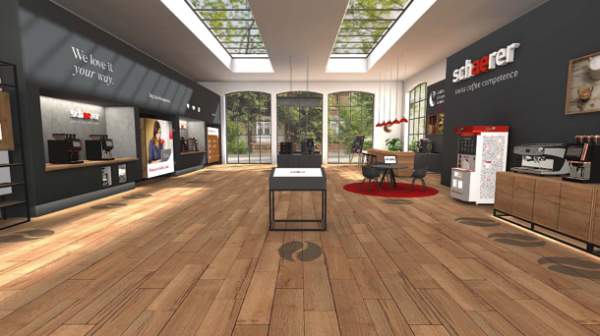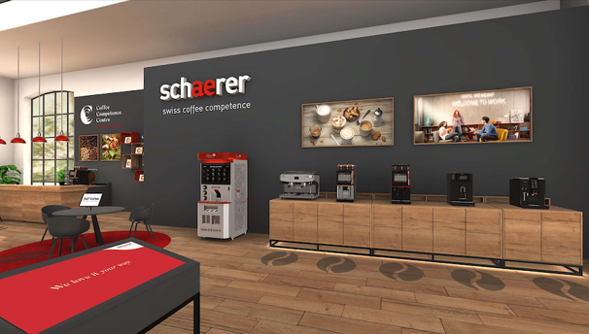

Image availability
You can find downloadable image material on our media portal press-n-relations.amid-pr.com (search term “Schaerer Virtual Showroom”). I would of course be happy to email you the files as well. Contact: nfo@press-n-relations.de

Further information:
Schaerer AG
Matthias Lübke, Head of Marketing & Coffee Competence Centre Allmendweg 8, 4528 Zuchwil, Switzerland
Tel.: +41 32 681 64 99
MLuebke@schaerer.com
www.schaerer.com

Schaerer Press Office
c/o Press'n'Relations GmbH,
Nataša Forstner
Magirusstrasse 33, D-89077 Ulm, Germany
Tel.: +49 731 96 287-17
Fax: +49 731 96 287-97
nfo@press-n-relations.de
www.press-n-relations.de

Schaerer AG
Founded in 1892 and headquartered in Zuchwil, Switzerland, Schaerer AG is one of the world’s leading manufacturers of fully automated professional coffee machines. As a traditional company with many years of history, the Schaerer brand stands for Swiss values combined with an in-depth knowledge of coffee. The company expresses these brand attributes with the company logo “swiss coffee competence” and experiences them equally in its product development and in the Coffee Competence Centre, Schaerer’s own coffee expertise and training centre in Zuchwil. Moreover, Schaerer is characterised by extreme flexibility with the guiding principle “We love it your way” — be it in reference to customer requests, customer-specific products and large orders or the product range which offers the customer a wide range of customised configuration options. Customer-oriented and with extensive coffee knowledge, Schaerer supports customers of any size all over the world in offering their guests the highest level of coffee enjoyment.

Schaerer has been part of WMF since 2006 and of the French consortium Groupe SEB since the end of 2016. All B2B brands of the Group are bundled in the “SEB PROFESSIONAL” consolidated sales organisation. In addition to Schaerer, it includes the WMF and Wilbur Curtis coffee machine brands as well as the Professional Hotel Equipment division with the WMF Professional and HEPP brands.

