Internorga, 10 to 14 March 2023, Hamburg, Hall A4, Booth 300

Schaerer at Internorga 2023
Schaerer ProCare cleaning system celebrates première in Hamburg

Zuchwil, 24. January 2023 – With its trade fair motto “We share, we care, we love it your way”, coffee machine manufacturer Schaerer is presenting at this year’s Internorga (Hall A4, Booth 300). The Schaerer ProCare cleaning system is celebrating its première in Hamburg: For up to three months, the compact add-on module supplies cleaning agents for up to 100 cycles and cleans the coffee and milk system fully automatically – without the involvement of service staff. “This has many practical advantages. A key point is how much it improves the coffee quality, because the Schaerer ProCare ensures consistent compliance with the recommended cleaning intervals. This also means that service staff doesn’t have to worry about cleaning. It makes their workday easier”, explains Hansjürg Marti, Managing Director of Schaerer Deutschland GmbH and Director Sales and Service DACH of Schaerer AG. The company will also focus on the coffee expertise and service portfolio of the Schaerer Coffee Competence Centre. The experts will transport visitors to the world of coffee and share their knowledge with them. In addition to its existing range of machines, Schaerer is also offering a self-service solution in the “Innovation Corner” that promotes minimalism, once again underlining its flair for innovative coffee concepts and its knowledge in the development of individualised customer solutions. The trade fair appearance will be rounded out by a presentation of the Wilbur Curtis filter coffee machine portfolio.

Schaerer ProCare – the star of the presentation
With the Schaerer ProCare cleaning system, Schaerer is completely rethinking everything we know about the system cleaning of professional coffee machines: The Schaerer ProCare add-on module stores acidic and alkaline cleaning agent in two bags and supplies it for one hundred cleaning cycles of the coffee and milk system. Thanks to the Schaerer ProCare, system cleaning can be carried out fully automatically for up to three months – this is one less task for service staff, and the desired cleaning time can be individually programmed by the operator. Marti adds: “The Schaerer ProCare not only makes handling easier and improves coffee quality. Consistent compliance with the recommended cleaning intervals also has a positive effect on the service life of the coffee machines and, thanks to the optimised supply of cleaning agents and less service work, the system also reduces operating costs”.

Machine expertise meets coffee expertise
Thanks to their flexibility and wide range of additional features, Schaerer coffee machines can be tailored individually to different customer requirements, no matter whether the machines are used in small or large coffee shops, for hotel breakfasts or in the office. At the Internorga, Schaerer will be presenting the multifaceted possibilities of their machines using different application scenarios and also providing information on the potential of networking the machines with the Schaerer Coffee Link. The Schaerer Coffee Competence Centre will also be in the spotlight at the Internorga. The experts will be sharing their in-depth knowledge about “the perfect setting” of all machine parameters for the perfect cup of coffee. Visitors will also get an impression of the extensive services, from customer consultation and recipe development to the comprehensive range of training courses, and will get the chance to taste a coffee speciality created especially for the Internorga.

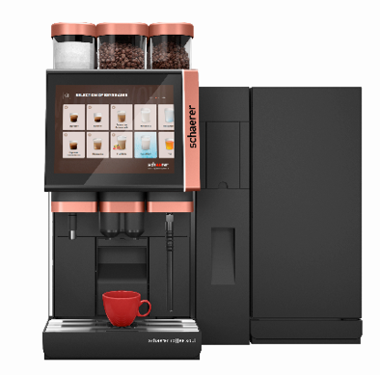 | 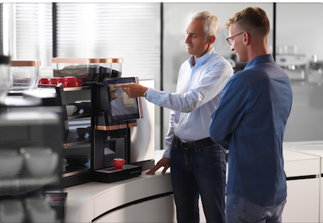
The cleaning system Schaerer ProCare can be integrated between the coffee machine and the milk system to save space. | The experts of the Schaerer Coffee Competence Centre will be sharing their in-depth knowledge about “the perfect setting” of all machine parameters for the perfect cup of coffee.

Image availability
You can find downloadable image material on our media portal press-n-relations.amid-pr.com (search term “Schaerer Internorga 2023”). I would of course be happy to email you the files as well.

Further information:
Schaerer AG
Monika Kammermann, Global Communications Manager
Allmendweg 8, 4528 Zuchwil
Tel.: +41 32 681 64 35
MKammermann@schaerer.com
www.schaerer.com
https://aboutwmf.com/de/news-media/newsroom/schaerer/

Schaerer Press Office
c/o Press'n'Relations GmbH,
Nataša Forstner
Magirusstrasse 33, D-89077 Ulm, Germany
Tel.: +49 731 96 287-17
Fax: +49 731 96 287-97
nfo@press-n-relations.de
www.press-n-relations.de

Schaerer AG
Founded in 1892 and headquartered in Zuchwil, Switzerland, Schaerer AG is one of the world’s leading manufacturers of fully automated professional coffee machines. As a traditional company with many years of history, the Schaerer brand stands for Swiss values combined with an in-depth knowledge of coffee. The company expresses these brand attributes with the company logo “swiss coffee competence” and experiences them equally in its product development and in the Coffee Competence Centre, Schaerer’s own coffee expertise and training centre in Zuchwil. Moreover, Schaerer is characterised by extreme flexibility with the guiding principle “We love it your way” — be it in reference to customer requests, customer-specific products and large orders or the product range which offers the customer a wide range of customised configuration options. Customer-oriented and with extensive coffee knowledge, Schaerer supports customers of any size all over the world in offering their guests the highest level of coffee enjoyment.

Schaerer has been part of WMF since 2006 and of the French consortium Groupe SEB since the end of 2016. All B2B brands of the Group are bundled in the “SEB PROFESSIONAL” consolidated sales organisation. In addition to Schaerer, it includes the WMF and Wilbur Curtis coffee machine brands as well as the Professional Hotel Equipment division with the WMF Professional and HEPP brands.

