New features and online configurator available for the Schaerer Coffee Soul 10 and 12
Autosteam and Supersteam steam wands automate the milk foaming process. Large under-counter cooling unit with two 10-litre containers reduces service times.

Zuchwil (Switzerland), 20. May 2022 – The Schaerer Coffee Soul 10 and 12 offer Schaerer customers the greatest possible freedom when configuring the machine to perfectly fit their individualised business model thanks to the “Select” concept. Other optional features are available starting now: The Schaerer Autosteam and Supersteam steam wands are the perfect additions for automated milk foaming: While the Autosteam features temperature monitoring, the Supersteam foams fully automatically until the desired milk temperature and milk foam consistency are achieved — a real plus for beverage quality and a relief for service staff. For machines used in busy locations, the large under-counter cooling unit with two 10-litre containers significantly simplifies the service process, ensuring reliable preparation of milk-based speciality coffees — and when the Twin Milk system is used, fully automatic preparation of beverages with plant-based milk alternatives is also possible. If you would like to discover the countless options for customising the Schaerer Coffee Soul 10 and 12 with the “Select” concept, you can create “your Soul” digitally with the new online configurator at https://soul-select.schaerer.com/en/. There you will also find inspiring content as well as comprehensive information about the Schaerer Coffee Soul 10 and 12.

Autosteam and Supersteam steam wands
The addition of a steam wand is always recommended when creating latte art or expanding the range of beverages to include lactose-free or vegan milk alternatives, for example. In addition to the Powersteam steam wand for manual foaming which has been available for some time, Schaerer is now also offering the two Autosteam and Supersteam steam wands for the Schaerer Coffee Soul 10 and 12. Both make foaming much easier: The Autosteam features a temperature monitoring function that automatically switches off the system once the set temperature has been reached, thereby preventing the milk from overheating. However, the foam consistency must be monitored manually. The Supersteam steam wand, the other hand, offers fully automatic milk foaming. The desired temperature and foam consistency can be adjusted individually and as soon as they are reached, the Supersteam simply stops foaming. The newly designed nozzle optimizes the foam quality for both steam wands.

Under-counter cooling unit with two 10-litre containers
The under-counter cooling unit with two 10-litre containers is perfect for stocking large quantities of milk and reduces the workload for service staff in countless applications, including hotel breakfasts, event catering and self-service concepts in convenience stores or bakeries. The under-counter cooling unit allows for all types of use: As a Twin Milk system, a vegan plant-based drink can be stored along with cow’s milk. When the coffee speciality is selected, the right type is automatically used and the beverage flows into the cup at the desired temperature and with the perfect foam consistency. If the under-counter cooling unit is configured as a backup milk solution, the machine automatically switches over to the second milk container when the first is empty. This gives the staff time to refill it. When used as a centre milk system, the cooling unit can be used for two machines at the same time.

Customise the Schaerer Coffee Soul online
Schaerer has developed an online configurator for the machine to show off the limitless possibilities of the Schaerer Coffee Soul 10 and 12 thanks to the “Select” concept. At https://soul-select.schaerer.com/en/configurator, visitors can digitally customise their individualised Schaerer Coffee Soul and also directly contact the Schaerer Sales Team. If you would like to learn more about the Schaerer Coffee Soul 10 and 12, check out the microsite https://soul-select.schaerer.com/en/ for application examples, videos and much more.

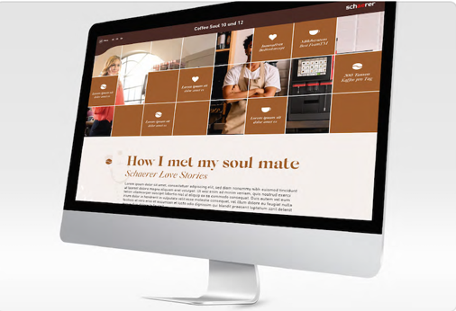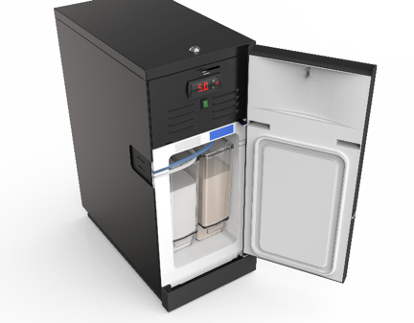

Image availability
You can find downloadable image material in our media portal press-n-relations.amid-pr.com (search term “Schaerer Coffee Soul 10 und 12”). I would of course be happy to email you the files as well. Contact: nfo@press-n-relations.de

Further information:
Schaerer AG
Matthias Lübke, Head of Marketing & Coffee Competence Centre Allmendweg 8, 4528 Zuchwil, Switzerland
Tel.: +41 32 681 64 99
MLuebke@schaerer.com
www.schaerer.com

Schaerer Press Office
c/o Press'n'Relations GmbH,
Nataša Forstner
Magirusstrasse 33, D-89077 Ulm, Germany
Tel.: +49 731 96 287-17
Fax: +49 731 96 287-97
nfo@press-n-relations.de
www.press-n-relations.de

Schaerer AG
Founded in 1892 and headquartered in Zuchwil, Switzerland, Schaerer AG is one of the world’s leading manufacturers of fully automated professional coffee machines. As a traditional company with many years of history, the Schaerer brand stands for Swiss values combined with an in-depth knowledge of coffee. The company expresses these brand attributes with the company logo “swiss coffee competence” and experiences them equally in its product development and in the Coffee Competence Centre, Schaerer’s own coffee expertise and training centre in Zuchwil. Moreover, Schaerer is characterised by extreme flexibility with the guiding principle “We love it your way” — be it in reference to customer requests, customer-specific products and large orders or the product range which offers the customer a wide range of customised configuration options. Customer-oriented and with extensive coffee knowledge, Schaerer supports customers of any size all over the world in offering their guests the highest level of coffee enjoyment.

Schaerer has been part of WMF since 2006 and of the French consortium Groupe SEB since the end of 2016. All B2B brands of the Group are bundled in the “SEB PROFESSIONAL” consolidated sales organisation. In addition to Schaerer, it includes the WMF and Wilbur Curtis coffee machine brands as well as the Professional Hotel Equipment division with the WMF Professional and HEPP brands.

