Zuchwil, 03.03.2021

Virtual product experiences with a personal touch
Schaerer is exhibiting at the “International Digital Food Services Expo 2021 powered by Internorga”

At the “International Digital Food Services Expo 2021 powered by Internorga”, coffee machine manufacturer Schaerer will be combining virtual product experiences with informative presentations and personal interactions. During the three-day digital event, booth visitors will be able to discover the Schaerer product range in many different ways: In the 3D showroom, for example, they will have the chance to explore the new Schaerer Coffee Soul with the “Select” concept as well as other machines all on their own. Those who want additional information can log into one of the corresponding product presentations in video format, download extensive information material or register for a live chat with a Schaerer employee. In addition, the coffee experts will be sharing their knowledge about the perfect cup of coffee with visitors in the virtual Schaerer Coffee Competence Centre.

“Digital trade fairs in times like these, which are characterised on the one hand by contact restrictions and on the other hand by advancing digitalisation, are a sensible and also interesting alternative to conventional trade fairs. That's why we decided to participate in the “International Digital Food Services Expo 2021 powered by Internorga”. We are looking forward to it and at the same time are curious to see how this new type of trade fair will be received by the industry and ultimately, of course, what success it will mean for us as exhibitors”, says Hansjürg Marti, Director of DACH Sales and Service at Schaerer AG and Managing Director of Schaerer Deutschland GmbH. On all three days of the trade fair, he and Jörg Schwartze, CEO of Schaerer AG, will focus on the company as well as the central topics of flexibility and customer orientation in the development of individual coffee concepts in their joint presentation and will be available to answer questions live afterwards.

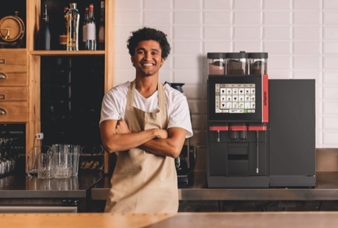
Schaerer Coffee Soul with the “Select” concept
Schaerer Coffee Soul 10 model variant with 10.4-inch screen

Image availability
You can find downloadable image material in our media portal press-n-relations.amid-pr.com (search term “Schaerer-Coffee-Soul-Select”). I would of course be happy to email you the files as well. Contact: nfo@press-n-relations.de

Further information:
Schaerer AG
Matthias Lübke, Head of Marketing & Coffee Competence Centre Allmendweg 8, 4528 Zuchwil, Switzerland
Tel.: +41 32 681 64 99
MLuebke@schaerer.com
www.schaerer.com

Schaerer Press Office
c/o Press'n'Relations GmbH, Nataša Forstner
Magirusstrasse 33, D-89077 Ulm, Germany
Tel.: +49 731 96 287-17
Fax: +49 731 96 287-97
nfo@press-n-relations.de
www.press-n-relations.de

Schaerer AG
Founded in 1892 and headquartered in Zuchwil, Switzerland, Schaerer AG is one of the world’s leading manufacturers of fully automated professional coffee machines. As a traditional company with many years of history, the Schaerer brand stands for Swiss values combined with an in-depth knowledge of coffee. The company expresses these brand attributes with the company logo “swiss coffee competence” and experiences them equally in its product development and in the Coffee Competence Centre, Schaerer’s own coffee expertise and training centre in Zuchwil. Moreover, Schaerer is characterised by extreme flexibility with the guiding principle “We love it your way” - be it in reference to customer requests, customer-specific products and large orders or the product range which offers the customer a wide range of customised configuration options. Customer-oriented and with extensive coffee knowledge, Schaerer supports customers of any size all over the world in offering their guests the highest level of coffee enjoyment.

Schaerer has been part of the WMF Group since 2006 and of the French consortium Groupe SEB since the end of 2016. All B2B brands of the Group are bundled in the “SEB PROFESSIONAL” consolidated sales organisation. In addition to Schaerer, it includes the WMF and Wilbur Curtis coffee machine brands as well as the Professional Hotel Equipment division with the WMF Professional and HEPP brands.

