Zuchwil – 25. March 2021

Schaerer introduces new features for contactless preparation and payment processes
The Schaerer Digital Payment Solution "2nd Screen" option and "Touchless Outlet” increase convenience and hygiene in self-service

Whether in hotels, convenience stores or petrol stations: In these times of the coronavirus, anyone preparing a self-service coffee speciality on a fully-automatic coffee machine is paying more attention than ever to preparation and payment processes that require as little contact as possible. Swiss coffee machine manufacturer Schaerer supports operators in the implementation of corresponding concepts with customised solutions. For the Schaerer Coffee Soul as well as its successor model, the Schaerer Coffee Soul with the "Select" concept, three powerful new features are available for the implementation of contactless preparation and payment processes: The "2nd Screen" option makes it possible to start beverage preparation from the smartphone of the guest after a QR code is scanned — touching the machine display is no longer necessary. If the machine is also equipped with the optional "Touchless Outlet," the outlet moves precisely to the optimal dispensing position after the respective beverage has been selected. Last but not least, integration of the Schaerer Digital Payment Solution also allows for contactless payment with a smartphone — an external terminal is no longer necessary for the payment process.

Schaerer Digital Payment Solution
The Schaerer Digital Payment Solution is now making it easy to enter the world of mobile app payment. The best part: The Schaerer Digital Payment Solution is an integral part of the coffee machine software, meaning an external terminal is no longer needed for the payment process. After selecting the beverage, a QR code appears on the coffee machine touch display, which the guest scans with a smartphone to initiate the payment process. The flexible framework of the Schaerer Digital Payment Solution enables connection to common payment solutions such as AliPay or WeChatPay (or Twint in Switzerland) as well as the integration of customised solutions. When payment is complete, the selected coffee speciality is prepared. "Especially when it comes to self-service, the Digital Payment Solution makes handling the payment process much easier — both for our customers and the consumers", reports Sandro Bianchi, Product Manager at Schaerer AG, and explains the operating principle: "Our framework offers operators a great deal of creative freedom in implementing their individualised mobile payment concept. For example, up to four solutions can be integrated at one time. Among others, interfaces to AliPay, WeChatPay and Twint, which is popular in Switzerland, are integrated as standard. Other providers or individual solutions are implemented at the customer's request". Another advantage: Since the coffee machine touch display is used to interact with the payment app, there is no need for additional costs and effort for connecting payment terminals and for contracts with third-party providers. If the operator uses his own app or a scanner is connected to the self-service coffee concept, the digital playing field is even larger — from beverage creation in apps by coffee connoisseurs to the implementation of customer loyalty programs based on bonus systems or vouchers.

Schaerer “2nd Screen” and “Touchless Outlet”
For low-contact preparation of speciality coffees with the Schaerer Coffee Soul model and its successor, the Schaerer Coffee Soul with the “Select” concept, Schaerer now offers the "2nd Screen" option as a new optional feature. The prerequisite is that the machines are networked with the Schaerer Coffee Link telemetry solution. The "2nd Screen" option allows beverages to be prepared from the smartphone of the guest. A QR code appears on the display of the coffee machine. The end customer scans it with their smartphone, then the available coffee specialities are displayed. Tapping on the smartphone starts the preparation process. Another plus for hygienic operation is the optional automatic height-adjustable "Touchless Outlet". Depending on the coffee speciality selected, it moves to the optimal dispensing height and does not need manual adjustment.

Image material

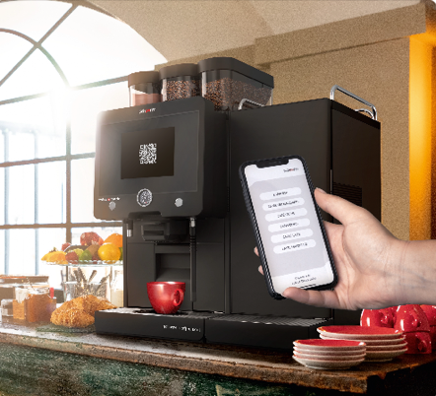

Image availability
You can find downloadable image material in our media portal press-n-relations.amid-pr.com (search term " Schaerer-Digital-Payment-2ndScreen "). I would of course be happy to email you the files as well. Contact: nfo@press-n-relations.de

Further information:
Schaerer AG
Matthias Lübke, Head of Marketing & Coffee Competence Centre Allmendweg 8, 4528 Zuchwil, Switzerland
Tel.: +41 32 681 64 99
MLuebke@schaerer.com
www.schaerer.com

Schaerer Press Office
c/o Press'n'Relations GmbH,
Nataša Forstner
Magirusstrasse 33, D-89077 Ulm, Germany
Tel.: +49 731 96 287-17
Fax: +49 731 96 287-97
nfo@press-n-relations.de
www.press-n-relations.de

Schaerer AG
Founded in 1892 and headquartered in Zuchwil, Switzerland, Schaerer AG is one of the world’s leading manufacturers of fully automated professional coffee machines. As a traditional company with many years of history, the Schaerer brand stands for Swiss values combined with an in-depth knowledge of coffee. The company expresses these brand attributes with the company logo “swiss coffee competence” and experiences them equally in its product development and in the Coffee Competence Centre, Schaerer’s own coffee expertise and training centre in Zuchwil. Moreover, Schaerer is characterised by extreme flexibility with the guiding principle “We love it your way” — be it in reference to customer requests, customer-specific products and large orders or the product range which offers the customer a wide range of customised configuration options. Customer-oriented and with extensive coffee knowledge, Schaerer supports customers of any size all over the world in offering their guests the highest level of coffee enjoyment.

Schaerer has been part of the WMF Group since 2006 and of the French consortium Groupe SEB since the end of 2016. All B2B brands of the Group are bundled in the “SEB PROFESSIONAL” consolidated sales organisation. In addition to Schaerer, it includes the WMF and Wilbur Curtis coffee machine brands as well as the Professional Hotel Equipment division with the WMF Professional and HEPP brands.

