Speciality coffees for the cold season
Schaerer coffee recipes help guests forget the winter blues

Zuchwil, 09. November 2022 – Winter is just around the corner. It is not only the cosiest time of the year, but also a season full of tempting scents and treats. Now is the perfect time to treat your guests to yummy seasonal coffee specialities. Monika Oeggerli, coffee expert and trainer at the Schaerer Coffee Competence Centre, has selected five special recipes that restaurant operators can use to open up new taste experiences to tempt their guests. The seasonal delicacies can be easily added to the menu and preparation is simple with the help of Schaerer coffee machines. This means restaurant operators can try out an almost endless number of creative ideas and boost their hot beverage sales. The Schaerer coffee machines are also perfect for preparing two vegan creations, the “espresso winter wonderland” and the “pumpkin spice latte”: With the combination of Best Foam and Twin Milk, vegan coffee specialities can also be prepared fully automatically with the highest level of quality. Thanks to the Best Foam milk system, the foam quality is sure to impress coffee lovers, regardless of whether their winter treat is prepared with cow’s milk or a vegan alternative. The Schaerer Twin Milk system allows a vegan plant-based drink to be stored in addition to cow’s milk. When selecting the desired coffee speciality, the correct variant is used automatically.

Schaerer’s recipe tips for enjoying speciality coffees in the cold season:

Honey-clove coffee
If you stick the small dried blossoms in an orange, it smells like Advent for weeks! But the spice also creates a wonderfully wintry aroma in coffee beverages.

Ingredients
• 3 tsp. liquid chocolate
• 1 tsp. honey
• 1 pinch clove powder
• 1 café crème
Some creamy milk foam

Preparation
Pour the liquid chocolate, honey and pinch of clove powder into a cup, brew the café crème over it and cover with milk foam.

Caffè borgia
Christmas biscuits wouldn’t be half as tasty without cinnamon and honey. In coffee, these ingredients bring back memories of grandma’s homemade gingerbread.

Ingredients
• 1 espresso
• 1 tsp. honey
• Chocolate shavings
• 1 pinch of cinnamon
• A little orange syrup (optional)
• Whipped cream or creamy milk foam

Preparation
Mix the espresso with honey, chocolate shavings, some cinnamon and optional syrup in a large espresso cup and decorate with milk foam or cream.

Baileys cappuccino
Irish cream liqueur and a bit of alcohol, combined with cinnamon, warm the soul even in freezing temperatures.

Ingredients (serves 2)
• 2 tsp. brown sugar
• 4 tbsp. Baileys (whiskey liqueur)
• 2 double espressos
• A bit of cinnamon powder

Preparation
Warm up sugar and Baileys, pour into two cups, then brew two espressos (in two cups). Sprinkle cinnamon on the top and serve.

Espresso winter wonderland (vegan)

The combination of dates and gingerbread spice make this coffee speciality the perfect companion on a cold winter’s day.

Ingredients
• 1 freshly-brewed cappuccino
• Some date syrup
• 1-2 tsp. gingerbread spice
• 1 pinch of cinnamon powder
• A vegan ginger biscuit
• Vegan whipped cream to taste

Preparation
Brew cappuccino in a cup. Add the gingerbread spice while serving the milk. Then pour in the date syrup and decorate with whipped cream, cinnamon powder and biscuit pieces.

Pumpkin spice latte (vegan)
The pumpkin harvest really rings in the cold season. The vegetable not only makes for delicious meals – it is just as good in coffee and almond drink.

Ingredients (serves 2)
• 1 – 2 freshly-brewed espressos
• 450 ml almond drink (heated)
• 4 tbsp. pumpkin purée (warm up)
• 1 tsp. pumpkin spice
• 1 tsp. cinnamon
• 1 tbsp. agave sugar
• 1 tbsp. natural vanilla extract
- Some almond milk foam (warm)

Preparation
Brew espresso and almond milk. Pour into a large preheated pitcher and add the remaining ingredients and mix well with a whisk. Then serve in two large cups and add some more milk foam to top it off.

Image material:

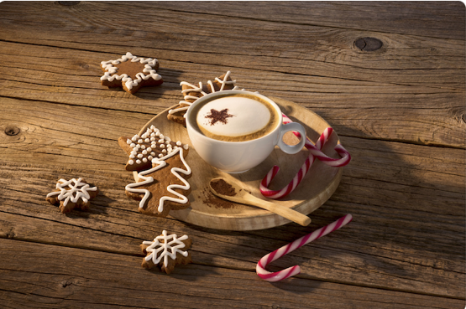

Image availability
You can find downloadable image material in our media portal press-n-relations.amid-pr.com (search term “Schaerer-recipe-tips-winter-2022”)Of course, I would also be happy to send you the files by e-mail. Contact: nfo@press-n-relations.de

Further information:
Schaerer AG
Monika Kammermann, Marketing Manager
Allmendweg 8, 4528 Zuchwil
Tel.: +41 32 681 64 35
MKammermann@schaerer.com
www.schaerer.com
https://aboutwmf.com/de/news-media/newsroom/schaerer/

Schaerer Press Office
c/o Press'n'Relations GmbH,
Nataša Forstner
Magirusstrasse 33, D-89077 Ulm, Germany
Tel.: +49 731 96 287-17
Fax: +49 731 96 287-97
nfo@press-n-relations.de
www.press-n-relations.de

Schaerer AG
Founded in 1892 and headquartered in Zuchwil, Switzerland, Schaerer AG is one of the world’s leading manufacturers of fully automated professional coffee machines. As a traditional company with many years of history, the Schaerer brand stands for Swiss values combined with an in-depth knowledge of coffee. The company expresses these brand attributes with the company logo “swiss coffee competence” and experiences them equally in its product development and in the Coffee Competence Centre, Schaerer’s own coffee expertise and training centre in Zuchwil. Moreover, Schaerer is characterised by extreme flexibility with the guiding principle “We love it your way” — be it in reference to customer requests, customer-specific products and large orders or the product range which offers the customer a wide range of customised configuration options. Customer-oriented and with extensive coffee knowledge, Schaerer supports customers of any size all over the world in offering their guests the highest level of coffee enjoyment.

Schaerer has been part of WMF since 2006 and of the French consortium Groupe SEB since the end of 2016. All B2B brands of the Group are bundled in the “SEB PROFESSIONAL” consolidated sales organisation. In addition to Schaerer, it includes the WMF and Wilbur Curtis coffee machine brands as well as the Professional Hotel Equipment division with the WMF Professional and HEPP brands.

