Zuchwil – October 06, 2020

Schaerer and Jetinno sign exclusive strategic partnership to continue business expansion in Asia
The focus is on the customisable Schaerer Premium Coffee Corner coffee-to-go concept

In order to satisfy the specific requirements of Asian customers and to optimise the overseas supply chain in the future, Schaerer is now starting an exclusive strategic partnership with Chinese company Jetinno in the field of free-standing vending machines. The goal is to further promote the Schaerer Premium Coffee Corner coffee-to-go-concept and to produce the customisable housing of the self-service machines locally for the Asian market. Schaerer CEO Jörg Schwartze: “With Jetinno, we have an experienced partner who can support us in expanding into this very important segment in a highly attractive market.”

Chinese company Jetinno, with headquarters in the port city of Guangzhou, was founded in 2013. It is specialised in the development and production of innovative commercial coffee machines, especially in the field of free-standing vending, and offers the highest level of digitalisation. This and the very good positioning of the company in the Chinese market make Jetinno the perfect partner for adapting the Schaerer Premium Coffee Corner to Asia. “Our self-service concept is based on modifying the coffee machine technology and the housing to the exact customer requirements. Customers can choose whether they only want the technology, which is the Schaerer Premium Coffee Engine and will make the shell themselves. They could also have the shell produced by a third party or they could purchase technology and shell as one solution. Together with Jetinno, we can do this locally in line with customer requirements ensuring speed and efficiency”, says Schwartze. In addition, Jetinno has sound experience in technologies which are standard or even required in coffee vending machines in China and other Asian countries, for example the integration of an automatic cup dispenser for fulfilling hygienic and safety requirements. Jetinno is also a well-versed partner when it comes to the implementation of mobile payment solutions, which are an absolute must for self-service concepts in Asia.

“We are happy that the cooperation with Schaerer comes to a new chapter, we believe we can satisfy Asian customers’ requirements better by combining the advantages of Schaerer and Jetinno”, says Eric Wu, CEO of Jetinno.

Promoting developments together
At the beginning of 2019, the partnership was tested at high speed on the basis of the European Premium Coffee Corner. In mid-2019, the first mutual project between Schaerer and Jetinno followed. The subject was a Chinese coffee shop chain. Since a product launch at the beginning of 2020, it has relied on the Schaerer Premium Coffee Engine for its coffee concept and the shell and automation components from Jetinno. “This has shown us that we have the same high standards on quality, technology and customer orientation and are able to promote and successfully implement tailor-made self-service concepts together”, confirms Schwartze. With the strategic partnership, exclusive on both sides, the partners want to build on this success and continue to strengthen their position in the Asian market. At the moment, Schaerer and Jetinno are working on further developing the Schaerer Premium Coffee Corner for other Chinese customers.

www.schaerer.com

Image material
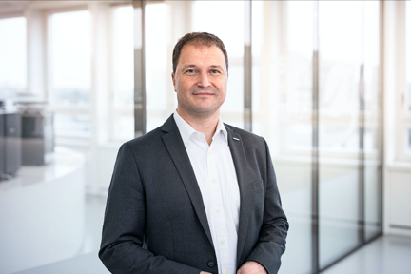 | 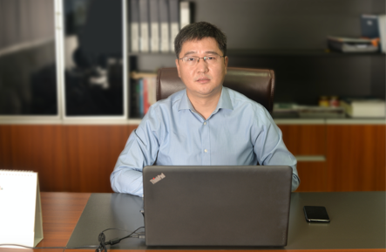
Jörg Schwartze, CEO Schaerer | Eric Wu (WU, Daoyu吴道玉), CEO Jetinno
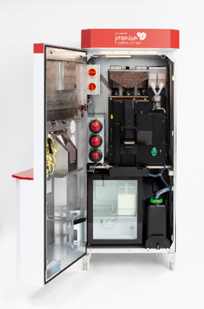 | 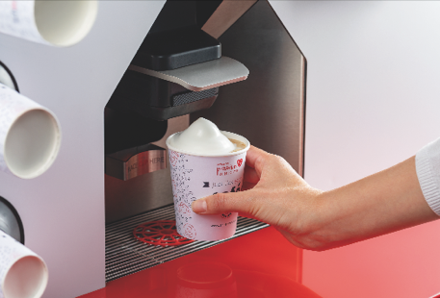
Schaerer and Jetinno sign exclusive strategic partnership to continue business expansion in Asia. The focus is on the customisable Schaerer Premium Coffee Corner coffee-to-go concept.

Image availability
You can find downloadable image material in our media portal press-n-relations.amid-pr.com (search term “Schaerer-Partnership-Jetinno”). I would also be happy to send you the file via email. Contact: nfo@press-n-relations.de

Further information:
Schaerer AG
Matthias Lübke, Head of Marketing & Coffee Competence Centre Allmendweg 8, 4528 Zuchwil, Switzerland
Tel.: +41 32 681 64 99
MLuebke@schaerer.com
www.schaerer.com

Schaerer Press Office
c/o Press'n'Relations GmbH,
Nataša Forstner
Magirusstrasse 33, D-89077 Ulm, Germany
Tel.: +49 731 96 287-17
Fax: +49 731 96 287-97
nfo@press-n-relations.de
www.press-n-relations.de

Schaerer AG
Founded in 1892 and headquartered in Zuchwil, Switzerland, Schaerer AG is one of the world’s leading manufacturers of fully automated professional coffee machines. As a traditional company with many years of history, the Schaerer brand stands for Swiss values combined with an in-depth knowledge of coffee. The company expresses these brand attributes with the company logo “swiss coffee competence” and experiences them equally in its product development and in the Coffee Competence Centre, Schaerer’s own coffee expertise and training centre in Zuchwil. Moreover, Schaerer is characterised by extreme flexibility with the guiding principle “We love it your way” — be it in reference to customer requests, customer-specific products and large orders or the product range which offers the customer a wide range of customised configuration options. Customer-oriented and with extensive coffee knowledge, Schaerer supports customers of any size all over the world in offering their guests the highest level of coffee enjoyment.

Schaerer has been part of the WMF Group since 2006 and of the French consortium Groupe SEB since the end of 2016. All B2B brands of the Group are bundled in the “SEB PROFESSIONAL” consolidated sales organisation. In addition to Schaerer, it includes the WMF and Wilbur Curtis coffee machine brands as well as the Professional Hotel Equipment division with the WMF Professional and HEPP brands.

