PRESS RELEASE

Ludwigsfelde (D), 26 April 2018

Transco Berlin appears at the “Iran Health” exhibition in Tehran:
GDP-compliant pharmaceutical transports to Iran

One year after establishing a branch office in the Iranian capital of Tehran, Transco Berlin Brandenburg GmbH presents their logistics services at the biggest healthcare exhibition in Iran. The pharma logistics specialist from Ludwigsfelde will be represented at “Iran Health”, 19-22 June 2018, with their own booth (Hall 5) and a German-Iranian team. Transco will be presenting their GDP-compliant logistics processes and transport services with various technical solutions. The main focus will be on temperature-controlled road transports and airfreight transports from Europe to Iran – plus warehouse logistics services. “We’re also currently checking the Iranian pharmaceutical market for demands for warehousing and distribution services, as well as value added service for pharmaceutical products”, explains Transco Director Thomas Schleife. “Iran Health is the perfect platform – both for our European business partners and for our regional network of partners”. Transco is targeting suppliers and pharmaceutical manufacturers active in Iran and in the region, as well as the Iranian pharmaceutical industry. “As an international logistics service provider, we also see ourselves as a go-between and a bridge builder between European shippers and the Iranian healthcare sector”. As such, Transco is also teaming up with their partners at the exhibition to offer a special workshop on pharmaceutical logistics needs in Iran.

In the second quarter of 2017, the Transco Group founded the subsidiary Transco Iran GmbH – with a branch office in the Iranian capital of Tehran. The new subsidiary company is primarily being used to arrange GDP-compliant transport of pharmaceuticals from Germany and all of Western Europe to Iran. The transports also include raw materials, machinery and system components. For Iranian imports, Transco offers road transport with complete and partial loads, as well as groupage. The shipping company also arranges airfreight transports. Transco Berlin Brandenburg GmbH is renowned as a company with decades of experience handling Eurasia transports.

According to Transco Director Thomas Schleife, having a local presence with their own business unit in Iran is a crucial condition for long-term development – for example, when it comes to issuing invoices in the local currency or processing orders in the local language, using the company’s own staff. The local office in Tehran works closely with Transco Berlin in sales and quality management.

Info box: GDP-compliant within Europe and to Eurasia
Transco arranges continuous road transports within Europe, as well as to Eurasia, and offers airfreight transports as an alternative on the main run. Depending on priority, Transco allows shippers to choose between road transportation or airfreight. The solo vehicles and trailers are GDP-certified for pharmaceutical transports. The staff is specially trained, and the logistics processes are demonstrably GDP-compliant. Compliance with “good distribution practice” as defined by the EU has been confirmed repeatedly by the EIPL European Institute for Pharma Logistics in Audits.

Visuals (Image source: Bruno Lukas)

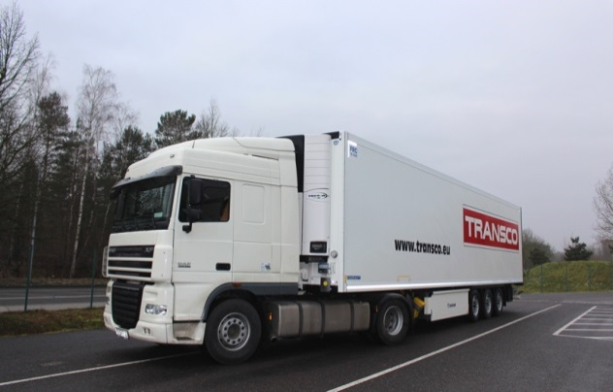

Articulated lorry with high-security pharma trailer by Krone
- for the temperature-controlled, GDP-compliant transport of pharmaceuticals to Iran

Further information:  Transco Berlin Brandenburg GmbH  Thomas Schleife, CEO  Brandenburgische Straße 51/53 - 14974 Ludwigsfelde  Phone: +49 3378 - 519 30-15  Fax: +49 3378 - 519 30-19  Thomas.Schleife@de.transco.eu  www.transco-logistik-berlin.com | Public relations:  Press’n’Relations GmbH, Berlin office  Bruno Lukas  Boyenstraße 41 - 10115 Berlin-Mitte  Phone: +49 30 - 577 00-325  Fax: +49 30 - 577 00-324  blu@press-n-relations.de  www.press-n-relations.de

Transco Berlin Brandenburg GmbH
Founded in Ludwigsfelde, Transco Berlin Brandenburg GmbH specialises in GDP-compliant pharmaceutical transports. As a shipper and freight carrier belonging to the Transco Group in Singen, they offer their services throughout all of Europe and are considered an expert on routes from Germany to Eastern Europe and Eurasia that pose special customs and safety-related challenges. The team surrounding CEO Thomas Schleife has been working together for many years, developing and implementing comprehensive pharma concepts for top process quality, safety, qualification and documentation. With their own certified refrigerated vehicles and internal processes, Transco Berlin Brandenburg GmbH is in full compliance with the requirements of the EU-GDP guideline. In August 2017, the company received their second GDP certificate from the EIPL and has thus been GDP-certified since 2014. Transco Berlin Brandenburg GmbH is also certified in quality management in accordance with ISO 9001. The company’s environmental management has been approved as per ISO 14001.

