Geislingen/Steige, 25th October 2017

Host - international hospitality exhibition - 20th to 24th October 2017, Fiera Milano,
Hall 22, Stand E 28/F27

WMF is leading the way for the coffee business 4.0

Digital high-end solution for business models of the future hits the mark for trade fair visitors

Whether we are talking about a sales increase in the food chain or increased efficiency in facility management, at host 2017, the digital WMF coffee pioneers Bob and Melanie gave a glimpse of tomorrow’s workplace. Lots of trade fair visitors were inspired by the possibilities offered by a systematic collection and analysis of professional coffee machines for the continuous optimisation of daily business. “A large number of restaurateurs and hoteliers are currently working on the question of how digitisation affects their business model. Regarding the coffee machine sector, we were able to answer a lot of questions in Milan and draw a clear path into the future of digital coffee concepts,” said Viola Linke, WMF Group’s Vice President of Global Marketing Coffee Machine Business. The range of information offered by the Geislingen-based premium manufacturer in the international expert audience hit the mark and this was also demonstrated by the great interest in the hourly live demos on the digital WMF stage. These demos showed how the use of digital solutions in the daily routines of Facility Manager Bob and Food Chain Manager Melanie can increase efficiency and profit in the coffee business.

The highlight of the fair and the basis for the live scenarios at Host is the WMF CoffeeConnect digital platform, which allows for comprehensive collection, analysis and graphical processing of performance and service data from the WMF machines. Thanks to this new technology, the trade visitors were able to learn all about intelligent handling of data in an informative and tangible way. After all, this is the basis for more efficient and more economic business models in the digital age.

The case of Melanie: Sales growth in food chain management
One example of WMF CoffeeConnect is the task performed by Food Chain Manager Melanie, who analyses last week’s coffee sales using a tailor-made dashboard. The field-tested scenario not only includes the detailed consideration of cup draws and resource consumption of different branches and even individual coffee machines, but also, for example, a root cause analysis of identified sales losses. The app’s dashboard provides an accurate overview of which coffee machines are generating particularly high sales at which locations and where there is a need for other machines and locations to catch up. If a coffee speciality is not in demand from the customers, a sales promotion is triggered to promote it. You can upload the special offer to the displays of selected devices and locations using an app.

The case of Bob: More efficient facility management
Protagonist Bob also gave the fair visitors an insight into his daily routine to do with facility management. His scenario: Through the WMF CoffeeConnect app, even before the working day starts, he can find out directly what the condition of all coffee machines in the building is and plan his work accordingly. Whilst one coffee machine reports an empty bean container, a different technical problem arises with another machine. Bob tries to solve this problem by using the knowledge base integrated in the app, which provides typical error sources and appropriate solutions.
If he can’t fix it himself, he creates a service ticket and then receives a call from the call centre, giving him concrete work instructions for his task on site. The Facility Manager therefore makes his work day much more efficient and also avoids unnecessary travel.

The films for the cases of Bob and Melanie can be found here:
https://www.wmf-coffeemachines.com/en_com/host2017.html

Image request
You can find images on our media portal http://press-n-relations.amid-pr.com (search term “WMF-CoffeeConnect”).

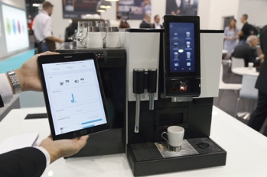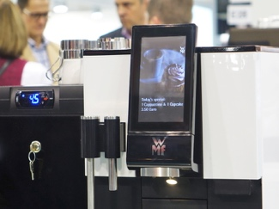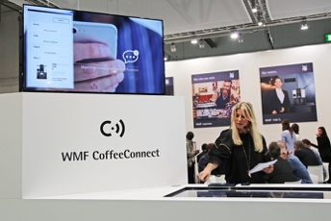

Further information:  WMF Group GmbH  Luise Glauert  Corporate Communications  Eberhardstraße 35 – D-73309 Geislingen  Phone: +49 73 31 25 8153  Fax: +49 73 31 25 8061  luise.glauert@wmf-group.com - www.wmf.de | Press and public relations:  WMF Pressebüro  c/o Press’n’Relations GmbH  Monika Nyendick  Magirusstraße 33 – D-89077 Ulm  Phone: +49 731 96287-30  Fax: +49 731 96287-97  wmf@press-n-relations.de - www.press-n-relations.de

About the WMF Group
For more than 160 years, the WMF Group brands have been synonymous with the best cooking, drinking and eating culture. Every day, several hundred million people worldwide use WMF, Silit and Kaiser products to prepare, cook, eat, drink and bake at home. Or they enjoy speciality coffees and dishes made with WMF, Schaerer and HEPP products in the gastronomy or hotel industry. Our employees are passionate about bringing people together – be it at home, on the road or in upscale restaurants – and providing them with precious and delicious moments to share. And they can do this with products that produce the best culinary experiences thanks to an excellent design, perfect functionality and best quality. Our traditional company was founded in 1853 in Geislingen an der Steige, Germany and has been a part of the French Groupe SEB consortium since the end of 2016.

