Birkenfeld, 31 January 2019

Internorga 2019 – 15 to 19 March, Messe Hamburg – Hall B7, Stand 409

Filigree hammering for timeless beauty
New “SITELLO” cutlery collection from WMF Professional with a hammered finish

With the new SITELLO cutlery collection, WMF Professional is showcasing for the first time, a design with a hammered finish. The delicately worked accents give each piece of cutlery its own characteristic, without disrupting the balanced lines of the traditional rounded handles. The gentle feathering of the contemporary finish establishes a connection between the spoon and the blade that is both harmonious and dynamic. Moreover, the user design experience is further enhanced through the additional tactile sensations delivered by the hammering structure on both sides. Thanks to its harmonious contrasts, the new collection extends the range of options available to hoteliers and restaurateurs through the addition of this extraordinary but exceptionally versatile model. Specialist visitors to Internorga 2019 will not only be able to take a look at the new cutlery collection. WMF Professional will also be showcasing its new exhibition booth design, which gives an extra emotional emphasis to the competence fields of Kitchen, Cooking and Serviced Apartments.

The SITELLO Collection from WMF Professional is a further development of the traditional SIGNUM Line. With a total of 21 pieces, the new creation provides the ideal accompaniment for culinary experiences of every taste. The hammered finish emphasises the clear lines whereby the long tines, the protruding spoon bowls and the large blades complement each other perfectly. Additionally, restaurateurs can choose between the highly polished, dishwasher-safe 18/10 stainless steel version and the silver-plated version, both of which guarantee a long working life thanks to the thickness of the materials used.

www.wmf-professional.com

Image request
You can find and download images from our media portal http://press-n-relations.amid-pr.com by searching for the term „WMF-Sitello“.

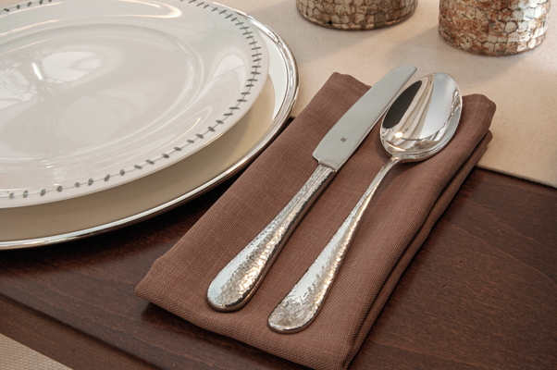

Further information:  proHeq GmbH  WMF Professional  Carl-Benz-Str. 10  75217 Birkenfeld  Tel. +49 7231 4885 0  Fax +49 7231 4885 83  wmf@press-n-relations.de  www.wmf-professional.de | Press and public relations:  WMF Press Office  c/o Press’n’Relations GmbH  Monika Nyendick  Magirusstraße 33 – D-89077 Ulm  Tel. +49 731 96287-30  Fax +49 731 96287-97  wmf@press-n-relations.de  www.press-n-relations.de

About the WMF Group
WMF Professional’s Hotel business unit is one of the leading providers of professional equipment for hotels and the catering industry. The key strength of this long-established brand is its innovative, painstakingly crafted and stylish all-in-one solutions covering every aspect of food and drink, from preparation to serving. The extensive product range includes cutlery and glassware, serving and buffet equipment and table decorations in every colour.

For more than 160 years, the brands that make up the WMF Group have stood for the best in cooking, drinking and dining. Every day, more than 100 million people around the world use products from WMF, Silit and Kaiser to prepare, cook, bake, eat and drink in their homes. And when they are not doing that, they are enjoying coffee specialties and foods prepared by the hotel and catering industry using WMF, Schaerer or HEPP products. Our employees are passionate about bringing people together, whether at home, on the move or at fine-dining establishments, in order to give them shared moments that are both precious and delicious. All this with products which have outstanding design, perfect functionality and excellent quality to make every culinary experience a real joy. Our business has a long tradition, having been founded in Geislingen an der Steige in 1853, and has been part of the French Groupe SEB since the end of 2016.

