WMF 1100 S: Great coffee moments in a compact package

The new member in WMF's professional coffee expertise range impresses with its drink quality, diversity and ergonomics

Whether in the office, at the airport lounge, hotel bar or in the bistros of petrol stations, convenience stores and many others – the WMF 1100 S speciality machine gives coffee lovers perfect moments of pleasure in almost any location. Thanks to the slim dimensions of 50 x 32.5 x 56.1 centimetres (HxWxD), the new entry-level model from the German-based premium manufacturer can fit in even very small spaces while guaranteeing a recommended delivery of up 80 cups. The proven professional technology such as the Basic Milk system accepts no compromises when it comes to the quality of individual fresh milk creations, while the associated Click & Clean process is characterised by its unlimited user-friendliness. The comfort features are not only complemented through a newly developed operating concept for the 7-inch touch display. The optional colour scheme of the machine housing, the creation of personalised favourite drinks and the wide range of services offered mean that it can be customised to suit WMF customers' individual tastes.

In addition, the inner values of the WMF 1100 S allow for the combined use of fresh milk and topping powder. Optionally equipped with a grinder, with a grinder and a powder hopper (choc dispenser) or with two grinders, the user can completely adapt the machine to their needs. Moreover, there is an optional steam wand – an indispensable helper when manually frothing milk or simply heating drinks. Depending on the configuration, the fully automatic machine offers maximum freedom in the selection of drinks – from espresso and café crème to cappuccino, café latte, latte macchiato and even milk choc and chociatto. A central hot water spout completes the drinks menu with tea specialities at just the right temperature.

Simplicity is key
Plug & Play – this is the best way to summarise the operating concept of the new member of the WMF family. No expensive expertise is called for – neither for the initial briefing nor when modifying the planned use, for example changing the water tank (4.5 litre) to a constant water supply or switching the classic coffee grounds container to an under-counter coffee grounds container. The machine impresses in daily use with its well-thought-out details. Thanks to their elongated design, the bean hoppers are easy to fill, even in small spaces. Decoupled grinders guarantee ultra-quiet grinding processes and the integrated eco mode ensures an effective reduction in energy consumption. If the user does not have a heated cup rack, then the integrated SteamJet brings glasses and cups to the ideal temperature. Presence and fill level sensors prevent the drip tray from annoyingly overflowing, while the cup rack integrated in the coffee grounds container offers space for porcelain and glasses with low fill levels. But it is not just because of its functional design that the WMF 1100 S is the first choice for small and medium requirements. In addition to this, the outer appearance can be personalised using an individual colour scheme in white (standard), sunflower yellow, bright orange, grass-green or strawberry red.

Intuitive and highly individual
The operating concept of the 7-inch touch display enables "vertical swiping" for the very first time and guides the user through the machine's menus. Therefore, saving your own recipes, images and background colours is just as easy as defining individual templates for different usage scenarios (such as the targeted hiding/displaying of function buttons). Animated illustrations inform the user of the preparation process status and provide support when carrying out the HACCP-compliant cleaning and care programs (Click & Clean). Even when it comes to self-service environments, the new entry-level model is the first choice thanks to its well-thought-out ergonomics.

The WMF 1100 S has the optional "My Coffee App" up its sleeve for completely personalised coffee moments. With the help of the smart software application, the user can create their favourite recipe on their smartphone in just a few steps and transfer the data to the machine by touch.

Team player with exceptional communication skills
WMF's solution portfolio is entirely based on the needs of its customers. As a result, the WMF 1100 S also offers a wide range of possibilities with regard to payment and billing systems. This includes classic methods such as card readers and coin checkers, as well as the integration of cashless and mobile payment systems (via an MDB interface). You also have freedom of choice with the add-on equipment – be it a cup rack, milk cooler or cup dispenser.
To request an image
Images can be found in our media portal at http://press-n-relations.amid-PR.com (search term ‘WMF1100S’).
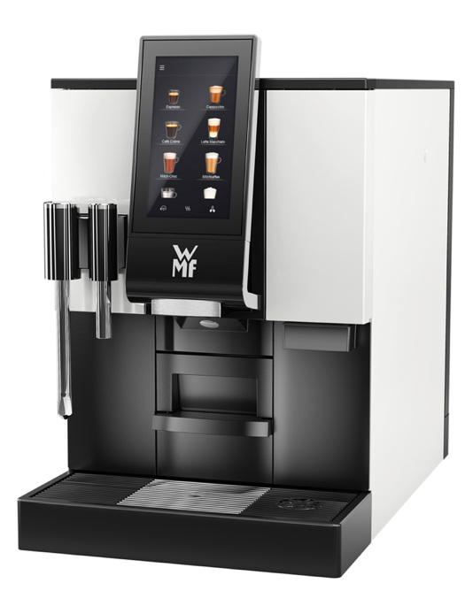

Additional information:  WMF Group GmbH  Luise Glauert  Corporate Communications  Eberhardstraße 35 – D-73309 Geislingen  Tel.: +49 73 31 25 8153  Fax: +49 73 31 25 8061  luise.glauert@wmf-group.com - www.wmf.de | Press and public relations  WMF press agency  c/o Press’n’Relations GmbH  Monika Nyendick  Magirusstrasse 33 – D-89077 Ulm, Germany  Tel.: +49 731 96287-30  Fax: +49 731 96287-97  wmf@press-n-relations.de  www.press-n-relations.de

About the WMF Group
For more than 160 years, the brands that make up the WMF Group have represented the best in cooking, drinking and dining. Every day, several 100 million people around the world use WMF, Silit and Kaiser products to prepare food, cook, bake, eat and drink in the comfort of their own home. And when they are not doing that, they are enjoying coffee specialities and dishes prepared in hotels and restaurants using products made by WMF, Schaerer and HEPP. Our employees are passionate about bringing people together, whether at home, on the move or at high-end restaurants, in order to give them shared moments that are both precious and tasty. This is all possible thanks to our products, whose exceptional design, perfect functionality and highest quality provide wonderful culinary experiences. Our company has a proud tradition, and was founded in Geislingen an der Steige in Germany back in 1853. Almost 6,000 employees provide culinary joy at more than 40 locations worldwide.

