Geislingen/Steige (Germany), 16th April 2018

Coffee experience meets technological sophistication

New automatic coffee machine WMF 1500 S+ matches every cup to your taste

The new bean-to-cup machine WMF 1500 S+ from the Geislingen-based coffee machine manufacturer combines the technological sophistication of a high-performance automatic machine with the requirements of a medium-sized coffee output. Designed for a recommended daily capacity of 180 cups and with a slimline footprint of just 32.5 cm x 59 cm (WxD), it features an impressive array of innovations in its interior: The new “Dynamic Coffee Assist” ensures guaranteed top quality of all espresso-based coffee specialities. The integrated Milk Excellence sensor raises milk management by the WMF 1500 S+ to a new quality level, while convenience is further enhanced by an automatically height adjustable spout and a new Choc mixer. The large 10-inch touch display has options for displaying handling videos, nutritional information or promotional offers. A range of templates ensures that the machine adapts individually to personal requirements. The highlight is the inclusion of “WMF CoffeeConnect” as standard – your route to coffee business 4.0.

10-inch touch display
Not just functional, but designed in perfect harmony with the working day: the 10-inch touch display of the WMF 1500 S+ has a clear structure, intuitive navigation using touch and swipe gestures, and enables rapid access to the main menu. It has a range of possible colour schemes to customise the appearance, rounded off by the ability to import your own beverage images and videos. Preset special functions can also be selected quickly from the toolbar in the display. This is easy for the user to configure, offering a number of additional intelligent customisation options including the new touch slider, which can be used to determine the cup volume of each beverage.

Innovations provide a helping hand
The revolutionary innovation “Dynamic Coffee Assist” provides a quality promise for all espresso-based coffee specialities. The principle: the extraction time is continuously measured by measuring the ground coffee quantity and the brew time of the purchased beverages and constantly optimised as necessary by the fully automatic grinding level adjustment. This ensures a consistent coffee quality. But even milk beverages present specific challenges. Milk management in catering involves more than just diligent, perfect hygiene: protecting the milk system is at least as important. The new Milk Excellence sensor from WMF plays a crucial role here; like the “empty” sensor in the cooler, it protects the mixer of the Dynamic Milk system. It measures the flow and the temperature of the milk without contact by means of ultrasound technology. Malfunctions due to air bubbles are also detected accurately. If deviating results occur, the system automatically adjusts the settings. The patented Choc mixer is another highlight of the WMF 1500 S+, impressing with its easy handling, cleaning and maintenance. Thanks to the magnetic lock, correct insertion of the mixing cup is guaranteed. An integrated sensor also monitors the perfect fit of the mixer wheel.

Visual appeal reinforces the taste
For a completely harmonious overall impression, the three bean/powder containers on the WMF 1500 S+ have a uniform appearance. In addition to attractive design aspects, the new speciality machine offers the greatest possible choice of coffee types: machines equipped with two grinders and powder containers also provide the option of using the manual insert for the use of
ground coffee.

WMF CoffeeConnect: real-time overview of status and consumption
One of the highlights of the WMF 1500 S+ is that the coffee machine is IoT-compatible as standard, and hence has uncomplicated access to the digital solution, WMF CoffeeConnect. As an integrated database for all product and process data, WMF CoffeeConnect lays the foundation for sustainable business models. Sales figures and sales volumes, as well as service information and error messages, can be viewed on a computer or mobile device at any time and from any location. Promotional offers can be sent from a central location directly to the display of a selected machine, for example, to increase sales in a targeted manner. This significantly optimises processes related to the management and operation of the coffee machines. Important basic applications are directly available as a Freemium package, with additional applications available as Premium packages. Business analysts at WMF additionally provide support for custom analyses and solutions, and advice relating to process improvements and maximising your coffee business.

Image request
You can find images on our media portal http://press-n-relations.amid-pr.com (search term “WMF1500S+”).
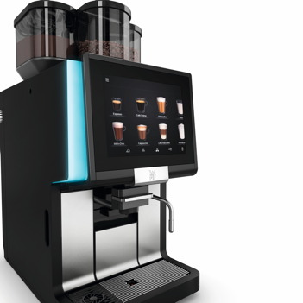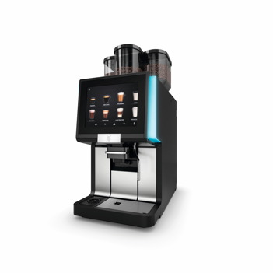
Further information:  WMF Group GmbH  Luise Glauert  Corporate Communications  Eberhardstraße 35 – 73309 Geislingen, Germany  Tel.: +49 73 31 25 8153  Fax: +49 73 31 25 8061  luise.glauert@wmf-group.com – www.wmf.de | Press and public relations:  WMF Pressebüro  c/o Press’n’Relations GmbH  Monika Nyendick  Magirusstraße 33 – 89077 Ulm, Germany  Tel.: +49 731 96287-30 – Fax: +49 731 96287-97  wmf@press-n-relations.de - www.press-n-relations.de

About the WMF Group
For more than 160 years, the WMF Group brands have been synonymous with the best cooking, drinking and eating culture. Every day, several hundred million people worldwide use WMF, Silit and Kaiser products to prepare, cook, eat, drink and bake at home. Or they enjoy specialty coffees and dishes made with WMF, Schaerer and HEPP products in the gastronomy or hotel industry. Our employees are passionate about bringing people together – be it at home, on the road or in upscale restaurants – and providing them with precious and delicious moments to share. And they can do this with products that produce the best culinary experiences thanks to an excellent design, perfect functionality and best quality. Our traditional company was founded in 1853 in Geislingen an der Steige, Germany and has been a part of the French Groupe SEB consortium since the end of 2016.

