The Symphony of Perfect Taste
WMF 9000 S+: Perfection in quality, flexibility and individuality

The WMF 9000 S+, the new flagship of the coffee machine manufacturer from Geislingen, introduces users and restaurant guests to entirely new experiences. Developed for high performance usage, the fully automatic coffee machine meets customers' expectations in every way – whether it's product quality, flexibility or beverage variety. The ten-inch touch screen can be fully customised in terms of its graphic, functional and linguistic settings. In addition, there are also pre- and post-select concepts, which align the operation of the device with a specific usage profile. High-performance grinders and brewers, precision grinding discs and an innovative chocolate mixer highlight the superior quality, as does the "Dynamic Milk" system. The latter offers four different consistencies for hot milk froth and up to three variations for adding a layer of cold milk froth, as well as hot and cold milk. Intelligent processes when it comes to telemetry, cashless payment and the "My Coffee" app complete the user experience.

Personalisation made easy
The touch screen of the WMF 9000 S+ offers the user all information at a glance. With horizontal swiping motions, the user can flick comfortably between the screens, whereby the operating system allows for the animation of drink images, as well as the flexible embedding of nutritional data (allergen labelling), promotional offers or explanatory videos (e.g. digital animation videos for cleaning processes). The machine proves to be no less flexible when it comes to the selecting the colours: Firstly, the user has the opportunity to choose their preferred colour scheme from six different design templates. Secondly, complete personalisation can be achieved with just a few hand movements in accordance with the company's CI/CD guidelines. The language is selected via a short tap on the corresponding country flag. In self-service mode, up to five additional different languages can be activated using the flag icons.

A new understanding of operating comfort
The touch screen display includes customisation options for the pre- or post-select. Whenever the WMF 9000 S+ is operated in waiter mode or recurring (professional) self-service mode, users who are familiar with pre-select have permanent access to special functions. These include, for example, drink sizes, coffee strengths and tea water temperatures. Switching between different types of milk (lactose-free milk, soya milk, reduced-fat milk etc.) is easy thanks to the optional 2 milk system. For extra efficiency during peak periods, a whole sequence of drinks can be pre-selected which are then prepared one after the other by the speciality machine. The recommended daily output is 350 cups.

When it comes to standard self-service, the WMF 9000 S+ is also simple for first-time users to operate. This is thanks to the "post-select" function. Here, you have the possibility to request beverage options via menu control. The machine will guide customers step-by-step through the individual variations in the preparation process (individual cup size, as well as the selection of the coffee and/or type of milk - depending on the machine) before the desired drink is automatically prepared.

Quality at its best
Like all machines in the new generation series, the WMF 9000 S+ benefits from the consistent development of the underlying technology platform. Solid components, such as the brewing unit with stainless steel brewing chamber and die-forged frame ensure robust reliability. New high-performance grinders with electrically adjustable grinding degrees are characterized by high speed and minimal noise. The new WMF grinding discs ensure lower dispersion and high precision for maximum durability and ease of maintenance. A newly developed chocolate mixer ensures easy handling, cleaning and maintenance, which in turn also extends the service life of the component. The WMF 9000 S+ also displays its intelligence through the revised dual spout, which is now cleaned daily via the automatic cleaning programme. The WMF 9000 S+ is equipped with the SteamJet so that delicious coffee specialities can be served at any time to perfection. Thanks to this function, cups and glasses can be brought back to the perfect temperature with a quick steam shower.

For added comfort, the new flagship offers a variety of auxiliary and vending devices, such as a heated cup cabinet, milk coolers and cup dispensers. The fully automatic coffee machine comes with a wide range of possibilities in terms of payment and billing systems. This includes classic methods such as card readers and coin checkers, as well as the integration of cashless and mobile payment systems (via an MDB interface) for credit cards, PayPal and the like.

Efficient processes when it comes to purchasing, sales and service
Thanks to the "WMF CoffeeConnect" bi-directional telemetry concept, the WMF 9000 S+ provides the operator with optional and effective controlling technology. The target: a centralised service and analysis platform that makes WMF coffee machines more efficient and more profitable when it comes to service, purchasing and sales. On the one hand, WMF CoffeeConnect allows you to collect a wide range of machine data (such as proactive service or status messages) across multiple locations and to analyse it in order to achieve optimal processes in inventory management and service planning. Added to this is performance data from daily operations. What are the favourite drinks among customers? At what time, price and location? - The answers to such questions are at your fingertips. On the other hand, the concept allows for a high degree of flexibility in terms of the product range: vendors can offer individual product specials along with accompanying pictures on the displays of their machines - at any location and time-controlled via web servers. "With WMF Digital Solutions, our customers have the opportunity to leverage the power of their data and to prepare themselves more efficiently in their coffee business", says Viola Linke, Vice President Global Marketing Coffee Machine Business WMF Group.

To request an image
Images can be found in our media portal at http://press-n-relations.amid-PR.com (search term ‘WMF9000S+’).
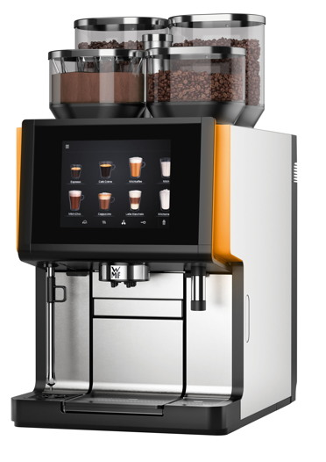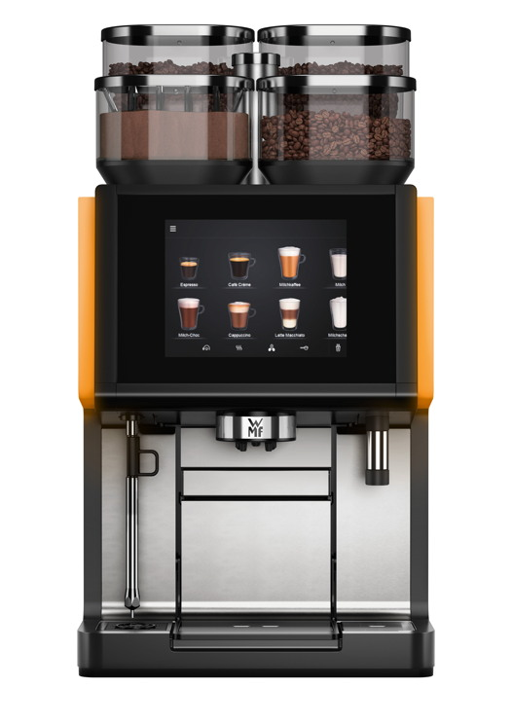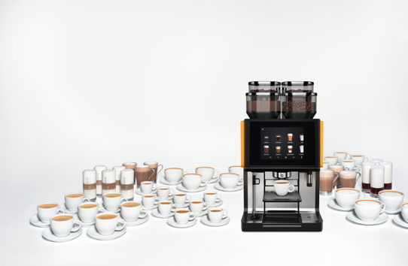

Additional information:  WMF Group GmbH  Luise Glauert  Corporate Communications  Eberhardstraße 35 – D-73309 Geislingen  Tel.: +49 73 31 25 8153  Fax: +49 73 31 25 8061  luise.glauert@wmf-group.com - www.wmf.de | Press and public relations  WMF press agency  c/o Press’n’Relations GmbH  Monika Nyendick  Magirusstrasse 33 – D-89077 Ulm, Germany  Tel.: +49 731 96287-30  Fax: +49 731 96287-97  wmf@press-n-relations.de  www.press-n-relations.de

About the WMF Group
For more than 160 years, the brands that make up the WMF Group have represented the best in cooking, drinking and dining. Every day, several 100 million people around the world use WMF, Silit and Kaiser products to prepare food, cook, bake, eat and drink in the comfort of their own home. And when they are not doing that, they are enjoying coffee specialities and dishes prepared in hotels and restaurants using products made by WMF, Schaerer and HEPP. Our employees are passionate about bringing people together, whether at home, on the move or at high-end restaurants, in order to give them shared moments that are both precious and tasty. This is all possible thanks to our products, whose exceptional design, perfect functionality and highest quality provide wonderful culinary experiences. Our company has a proud tradition, and was founded in Geislingen an der Steige in Germany back in 1853. Almost 6,000 employees provide culinary joy at more than 40 locations worldwide.

