Geislingen/Steige (Germany), 5th August 2020

A truly smart coffee machine adapts to every cup
Intelligent coffee service thanks to WMF Cup Sensor
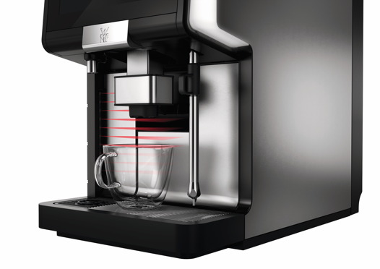
Available as an option with the fully automatic coffee machines
WMF 5000 S+ and WMF 1500 S+ the Cup Sensor recognises the cup placed on the drip tray, moving the automatic spout to precisely the right distance above it. The machine can even preselect specific beverages or sizes based on the cup used, eliminating the need for manual selection and minimising the risk of overfilling or damaging the cups. Moreover, no beverage will be dispensed without a cup, so waste and cleaning are reduced. Customers enjoy smooth service, and maximum operational efficiency.
With the Cup Sensor of WMF every drink travels the shortest distance to the cup, so it is served at the perfect temperature and in best quality. The sophisticated feature can be used in various ways, depending on the customers needs. In one mode, the selected beverage will only be served if the sensor detects a cup is in place – very handy in self-service venues. In a second mode, the machine detects the cup and then automatically adjusts the spout to the correct distance from the top of it – ideal for venues where the same beverage is dispensed into many different-sized cups, like offices. In the third mode, the sensor recognises the height of the cup being used and consequently the display menu only shows beverages corresponding to that size of cup. In this mode, the spout moves automatically to the optimal height for each recipe, saving time and effort.
Picture request
You can find image material in our media portal http://press-n-relations.amid-pr.com (search term "WMFCupSensor").
Further information:  WMF Group GmbH  Eva Gold  Senior Manager Global Brand & Communications  GBU Professional Coffee Machines  Eberhardstraße 35 – 73312 Geislingen, Germany  Tel.: +49 73 31 25 8589  EGold@wmf.com - www.wmf.com | Press and public relations:  WMF Pressebüro  c/o Press'n'Relations GmbH  Monika Nyendick  Magirusstraße 33 – 89077 Ulm, Germany  Tel.: +49 731 96287-30  wmf@press-n-relations.de  www.press-n-relations.de
About the WMF Group
For over 160 years, WMF has been dedicated to achieving the perfect balance of design, functionality and quality. The company, based in southern Germany, is a global market leader in the Professional Coffee Machines (PCM) sector. With the aim of being the first choice worldwide for professional coffee solutions, the "made in Germany" quality seal combines premium products and innovative strength with peak performance and reliability.
At the core of the WMF PCM solutions portfolio is a clear message: Designed to Perform. The business unit from Geislingen an der Steige has just the right concept for every business model in the coffee sector – from high-performance fully automatic machines for coffee specialities and filter machines right through to fully automatic portafilters and innovative digitalisation concepts. Moreover, national and international customers alike benefit from high-quality consulting and service, based on the largest in-house service organisation for professional coffee machines in Europe. Regular training courses in the WMF training centres ensure that this expertise is continuously passed on to the entire global WMF service network.
At the end of 2016, WMF Group became part of the French Groupe SEB consortium. In this context, all B2B brands of the Group were recently brought together under the umbrella "SEB PROFESSIONAL". In addition to WMF PCM, the umbrella brand also includes Schaerer and Wilbur Curtis coffee machines as well as the business division Professional Hotel Equipment with the brands WMF Professional and HEPP.

