Geislingen/Steige, 4th July 2019

Freshly brewed and super cool
Chilled coffee specialities at the touch of a button with WMF Chilled Coffee

The hottest cold drink around – chilled coffee beverages have evolved into one of the most enduring trends of recent years. Coffee machine manufacturer WMF is catering to this growing demand with the innovative Chilled Coffee system. An integrated counterflow cooler reduces the dispensing temperature of a freshly brewed coffee to below 50 degrees. Instead of having to brew or cool the coffee for hours on end, the Chilled Coffee technology delivers a coffee product within seconds which can then go on to be prepared further straight away. Refreshing classics such as iced coffee and caffè freddo as well as the latest on-trend beverages involving syrup and the like can be prepared faster and above all much more easily.

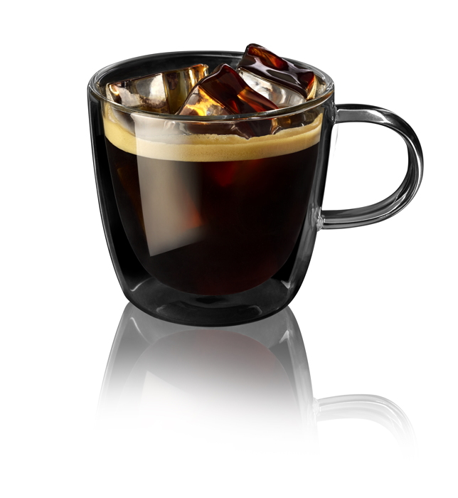
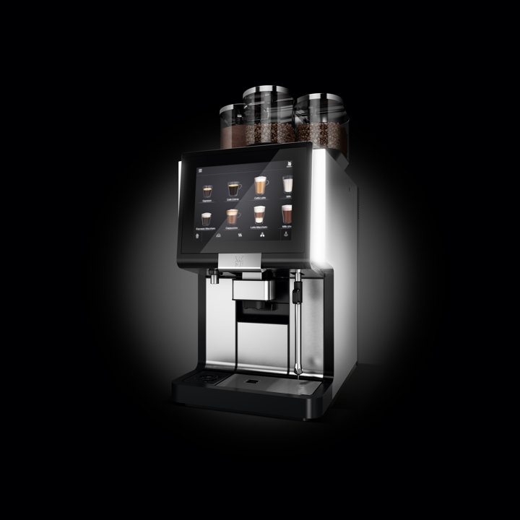
The new Chilled Coffee technology, which is available for the first time in the WMF 5000 S+ fully automatic machine, offers more than simply process reliability and efficiency – sustainability and economical energy usage are core principles of the system and are incorporated effectively with the aid of the counterflow cooler. Before the hot coffee from the brewing unit is conveyed to the spout, it first flows through the counterflow cooler. There, the cold fresh water flows to the boiler in the opposite direction for the next cup. This is the point where the energy exchange takes place – the coffee becomes cooler while the water gets warmer. As a result, the water doesn’t have to be heated as much in the boiler and no additional refrigeration units are needed to cool the coffee. Fully automatic coffee machines with Chilled Coffee technology therefore do not consume more energy than comparable machines which do not feature this innovative equipment. For restaurateurs and hoteliers, the system is a worthwhile investment in two respects: firstly, a greater variety of coffee specialities can be offered, and secondly, the machine can be used in a sustainable and energy-efficient manner – provided the Chilled Coffee system is used regularly.

Image request
You can find images on our media portal http://press-n-relations.amid-pr.com (search term “WMF-ChilledCoffee”).

Further information:  WMF Group GmbH  Corinna Lägeler  Corporate Communications  Eberhardstraße 35 – 73309 Geislingen, Germany  Tel.: +49 73 31 25 8833  Fax: +49 73 31 25 8061  corinna.laegeler@wmf-group.com – www.wmf.de | Press and public relations:  WMF Pressebüro  c/o Press’n’Relations GmbH  Monika Nyendick  Magirusstraße 33 – 89077 Ulm, Germany  Tel.: +49 731 96287-30  Fax: +49 731 96287-97  wmf@press-n-relations.de  www.press-n-relations.de

About the WMF Group
For more than 160 years, the WMF Group brands have been synonymous with the best cooking, drinking and eating culture. Every day, several hundred million people worldwide use WMF, Silit and Kaiser products to prepare, cook, eat, drink and bake at home. Or they enjoy specialty coffees and dishes made with WMF, Schaerer and HEPP products in the gastronomy or hotel industry. Our employees are passionate about bringing people together – be it at home, on the road or in upscale restaurants – and providing them with precious and delicious moments to share. And they can do this with products that produce the best culinary experiences thanks to an excellent design, perfect functionality and best quality. Our traditional company was founded in 1853 in Geislingen an der Steige, Germany and has been a part of the French Groupe SEB consortium since the end of 2016.

