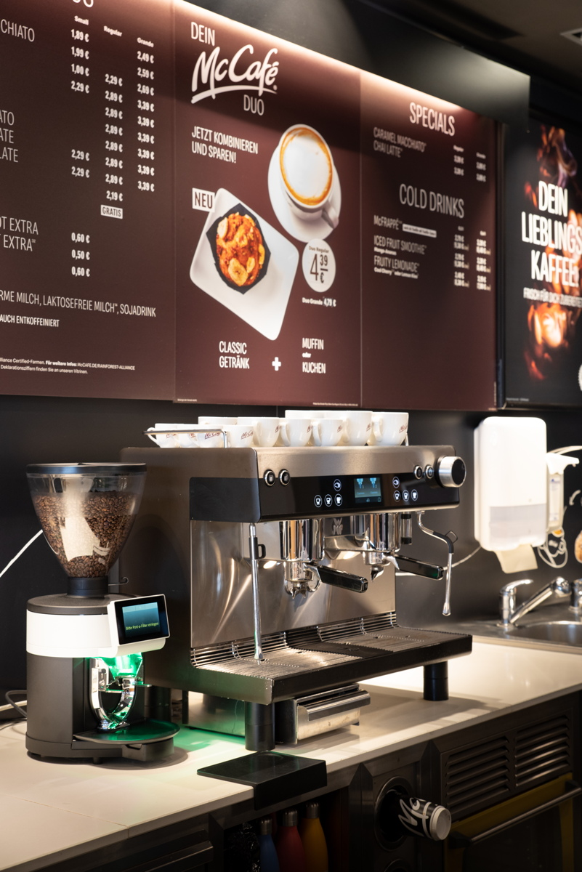
Geislingen/Steige, 12 January 2021

An exemplary approach to absolute customer focus
WMF is developing customised solutions for McDonald’s

For more than 25 years, visitors to McDonald’s restaurants in Germany have been enjoying the finest coffee specialities prepared in fully automatic machines supplied by WMF Professional Coffee Machines. The long-term partnership between the two market leaders is based on close collaboration. The fundamental task of the experienced Key Account Management team at WMF is to understand every detail of what the McDonald’s organisation and its franchisees in Germany want and need, then deliver end-to-end solution concepts that meet these requirements. WMF coffee machines have become a standard feature of many McDonald’s locations, serving millions of guests with premium quality coffee specialities every year. The market launch of automated portafilter machine WMF espresso in 2015 marked a crucial shared milestone in the partnership between the two companies. This heralded a new era of cooperation as part of the transformation of many McDonald’s locations into the “restaurant of the future” and an upgrading of the coffee concept under the motto “barista-made coffee”. To date, more than 700 WMF espresso machines have been installed in McDonald’s restaurants across Germany, with several thousand appliances in use in other locations worldwide.

Premium coffee concepts have been a familiar feature of the global fast food and food service industry for many years. Powerful and reliable appliances that are able to deliver consistently high coffee quality are crucial to their success. In the early 1990s, McDonald’s was one of the first companies in Germany to pick up on this trend, which is why it chose machines from WMF, the market and quality leader. Today, more than 30 years later, the number one in the food service industry and the number one in the field of professional coffee machines have developed an all-encompassing partnership. Right from the start, the national and international Key Account Management teams at WMF Professional Coffee Machines played a decisive role in this relationship, being there at every stage of the collaborative process – from the initial definition of requirements and needs to roll-out and beyond.

Working together for barista-made coffee
By the end of 2019, McDonald’s had converted the majority of its German locations to its “restaurant of the future” concept. WMF had been directly involved in this major project since the start of 2015. Adaptations were made to the WMF espresso automated portafilter machine as early as the development stage to meet the specific requirements of the modern McDonald’s restaurants and the McCafés they housed. Being able to prepare coffee specialities to barista standard and with the flair associated with a classic café without having to spend a lot of time and money on staff training was something which particularly impressed McDonald’s.

Understanding and responding to international requirements
On the basis of its positive experiences of working with WMF in Germany, McDonald’s was quick to expand the collaboration to other countries. The WMF espresso has enjoyed success in locations from the UK, France, Spain and the Netherlands via Poland and Eastern Europe and beyond to Taiwan, Indonesia and South Africa. The machine’s most recent highlight is its installation in all McCafé subsidiaries across Taiwan.

As a result of this extensive and long-term cooperation between the two companies, McDonald’s gets involved whenever WMF is considering adding new features to its WMF espresso machines or refining their existing scope. Specific pilot projects and the increasing relevance of digital platforms like WMF CoffeeConnect already suggest the direction in which the partnership might develop in the years to come.

Image requests
You can find images on our media portal http://press-n-relations.amid-pr.com (search term “McDonalds-WMF-Coffeemachines”).

Video clip
https://www.youtube.com/watch?v=mGvbBM36LVs&feature=youtu.be
Further information:  WMF Group GmbH  Eva Gold  Senior Manager Global Brand & Communications  GBU Professional Coffee Machines  Eberhardstraße 35 – 73312 Geislingen, Germany  Tel.: +49 73 31 25 8589  EGold@wmf.com - www.wmf.com | Press and public relations:  WMF Pressebüro  c/o Press’n’Relations GmbH  Monika Nyendick  Magirusstraße 33 – 89077 Ulm, Germany  Tel.: +49 731 96287-30  wmf@press-n-relations.de  www.press-n-relations.de

About the WMF Group
For over 160 years, WMF has been dedicated to achieving the perfect balance of design, functionality and quality. The company, based in southern Germany, is a global market leader in the Professional Coffee Machines (PCM) sector. With the aim of being the first choice worldwide for professional coffee solutions, the “made in Germany” quality seal combines premium products and innovative strength with peak performance and reliability.

At the core of the WMF PCM solutions portfolio is a clear message: Designed to Perform. The business unit from Geislingen an der Steige has just the right concept for every business model in the coffee sector – from high-performance fully automatic machines for coffee specialities and filter machines right through to fully automatic portafilters and innovative digitalisation concepts. Moreover, national and international customers alike benefit from high-quality consulting and service, based on the largest in-house service organisation for professional coffee machines in Europe. Regular training courses in the WMF training centres ensure that this expertise is continuously passed on to the entire global WMF service network.

At the end of 2016, the WMF Group became part of the French Groupe SEB consortium. In this context, all B2B brands of the Group were recently brought together under the umbrella “SEB PROFESSIONAL”. In addition to WMF PCM, the umbrella brand also includes Schaerer and Wilbur Curtis coffee machines as well as the business division Professional Hotel Equipment with the brands WMF Professional and HEPP.

