Geislingen an der Steige, 19th January 2021
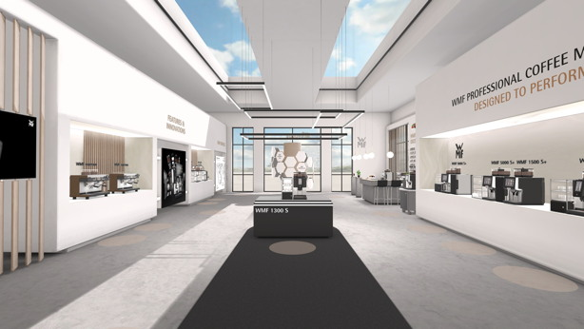
The new 3D customer experience
The virtual showroom created by WMF Professional Coffee Machines is bringing digital customer experiences to an unprecedented new level within the industry

With the launch of its virtual showroom, WMF Professional Coffee Machines is delivering an inspirational digital experience in a class of its own. The outstanding audiovisual presentations within it allow visitors to take a tour around WMF’s entire world of professional coffee machines. Creating a thrilling narrative in three dimensions, the showroom covers everything from the full product portfolio, accessories, various services and digital solutions through to a unique collection of taste experiences in the Coffee Excellence area. Click here to go to the showroom: https://www.wmf-coffeemachines.com/virtual-showroom/index.html?region=EN

By harnessing technological innovations and content that focuses on users’ needs, the new virtual showroom from WMF Professional Coffee Machines is creating an experience with an unparalleled personal touch – a space that is digital yet still feels hands-on. Visitors are greeted with a spectacular audiovisual exhibition as soon as they enter the digital showroom, with the platform for the new WMF 1300 S fully automatic machine providing a counter in the middle of the room that reveals highlights.
Guests approaching the counter already receive initial information about the exhibit. By clicking on the machine and its accessories, further details appear, with the 3D view of the fully automatic machine guaranteeing a holistic machine experience. A video about the WMF 1300 S not only illustrates its functions and outstanding flexibility, but also uses a concept and storytelling devices that are cleverly designed to awaken emotions and underline a sophisticated approach to technology, captivating customers and potential buyers.

All the other stations in the new virtual showroom are also controlled using an intuitive navigation concept. Users can move around the space by clicking on the brown areas on the floor or with the help of the three-dimensional map display. One can also use the keys "a,s,d and w" and the keyboard arrows to move forwards, backwards, to the right and to the left in the room.

The voyage of discovery takes them through a premium world that showcases a range of fully automatic coffee machines, plus filter and portafilter machines, with individual demonstration videos and animations creating a cinematic experience on a smaller scale. The innovation wall, presenting a whole variety of digital telemetry, self-service and web application solutions, is also aimed at delivering facts and creating an emotional connection with visitors in a way that reflects the premium-market standards of the solutions. Naturally, the showroom also tells visitors everything they need to know about WMF’s service team – Europe’s largest in-house network of this kind. The WMF Coffee Excellence Centre area, meanwhile, is there to provide delicious recipes for the latest coffee specialities plus exciting insights into the world of coffee – from the plants and how they are cultivated through to roasting and the final sensory experience. Last but not least, the sophisticated 3D space also houses a range of functions that include a product finder, designed to help visitors identify the perfect machine for their needs.

“In one respect, our new digital showroom is designed to compensate for the inability to hold upcoming trade fairs and events in person due to the coronavirus pandemic. However, it goes far beyond that: we have also developed it as a way to exploit the opportunities available in digitalisation and give our customers a whole new premium WMF experience. We are creating experiences that invite visitors to discover what we have to offer and provide inspiration for new business ideas”, says Renaud Gey, Vice President Strategic Marketing and Prodcut Management GBU Professional Coffee Machines at the WMF Group. The premium manufacturer, based in Geislingen an der Steige, is highly conscious of the need to maintain personal interactions too. In addition to providing contact opportunities available through e-mail, it also intends to enable direct interaction in real time, live presentations and a call-back button as a next step.

Image requests
You can find images on our media portal http://press-n-relations.amid-pr.com (search term “WMF-Virtual-Showroom”).
Further information:  WMF Group GmbH  Eva Gold  Senior Manager Global Brand & Communications  GBU Professional Coffee Machines  Eberhardstraße 35 – 73312 Geislingen, Germany  Tel.: +49 73 31 25 8589  EGold@wmf.com - www.wmf.com | Press and public relations:  WMF Pressebüro  c/o Press’n’Relations GmbH  Monika Nyendick  Magirusstraße 33 – 89077 Ulm, Germany  Tel.: +49 731 96287-30  wmf@press-n-relations.de  www.press-n-relations.de

About the WMF Group
For over 160 years, WMF has been dedicated to achieving the perfect balance of design, functionality and quality. The company, based in southern Germany, is a global market leader in the Professional Coffee Machines (PCM) sector. With the aim of being the first choice worldwide for professional coffee solutions, the “made in Germany” quality seal combines premium products and innovative strength with peak performance and reliability.

At the core of the WMF PCM solutions portfolio is a clear message: Designed to Perform. The business unit from Geislingen an der Steige has just the right concept for every business model in the coffee sector – from high-performance fully automatic machines for coffee specialities and filter machines right through to fully automatic portafilters and innovative digitalisation concepts. Moreover, national and international customers alike benefit from high-quality consulting and service, based on the largest in-house service organisation for professional coffee machines in Europe. Regular training courses in the WMF training centres ensure that this expertise is continuously passed on to the entire global WMF service network.

At the end of 2016, the WMF Group became part of the French Groupe SEB consortium. In this context, all B2B brands of the Group were recently brought together under the umbrella “SEB PROFESSIONAL”. In addition to WMF PCM, the umbrella brand also includes Schaerer and Wilbur Curtis coffee machines as well as the business division Professional Hotel Equipment with the brands WMF Professional and HEPP.

