Birkenfeld, 17th January 2019

WMF Quadro wins German Design Award in “Excellent Product Design” category
Buffet collection impresses with its boundless opportunities and elegant design

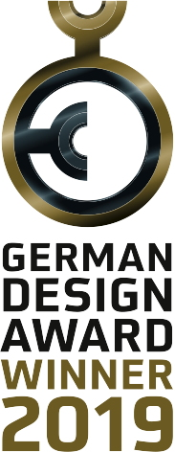
For the product managers at WMF Professional, self-explanatory, emotional, functional, long-lasting and high-quality attributes are among the key elements of successful design. The specialist jury of the German Design Award agreed with them and awarded the “WMF Quadro” modular buffet system in the “Excellent Product Design 2019” category. The German Design Council, which gave out the awards, was especially impressed by the intelligent arrangement in layers, significantly increasing the usable space at the buffet. The different modules in the comprehensive collection can be quickly and easily combined and customised for every occasion in a few simple moves. The jury also enjoyed the combination of stainless steel, glass, wood and porcelain and the clear lines of the design. “The design selected gives the multifunctional system an elegant, quality look and provides the perfect backdrop for the food presented on it,” explained the experts.

The German Design Council gives out its prestigious international premier prize “German Design Award” every year. The aim is to showcase and publicly honour unique design trends. As one of the most famous design competitions in the world, it rewards outstanding design quality in a number of categories. The prize-winners are decided during a two-day meeting of the jury made up of design connoisseurs from science, academia and business and the design industry.

A buffet perfect for the restaurant industry
Functionality and flexibility are key for WMF Quadro, as no two buffets are the same. Cooling, stacking, combining and serving on multiple levels, everything must be quick and seamless. In order to guarantee this, precision timing with perfect-fit transitions are essential. WMF Quadro fulfils this requirement with a range of inserts in GN format, such as porcelain bowls, plates made from different materials and woven-look baskets. Themed culinary islands can be set up with different attachments, bridges and serving stands. The LEDlight adapters provide an additional optical highlight. These can be fitted on the frames of the modules and provide the desired mood with LEDlight units in various dimmable light colours.

www.wmf-professional.com

Image request
You can find and download images from our media portal http://press-n-relations.amid-pr.com by searching for the term „WMF-Quadro“.
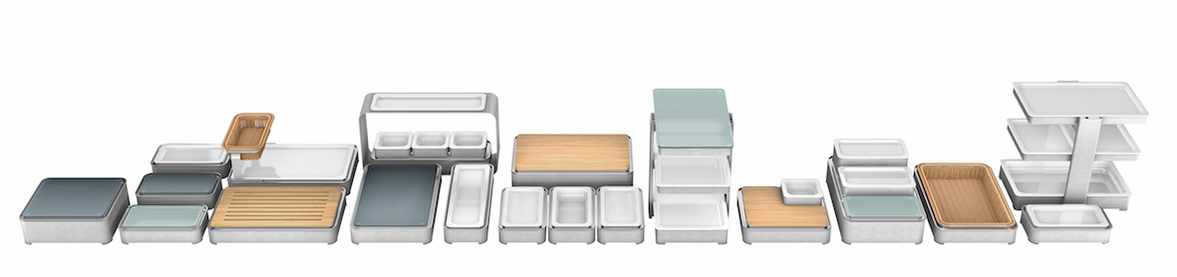
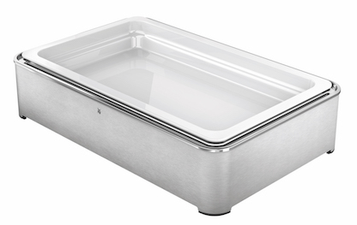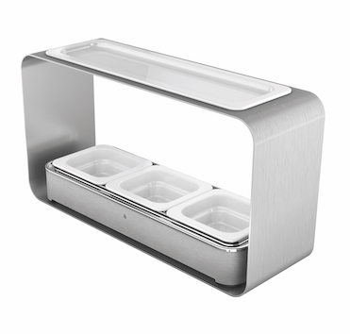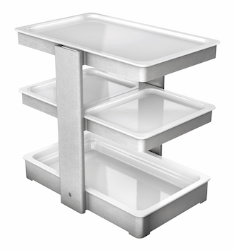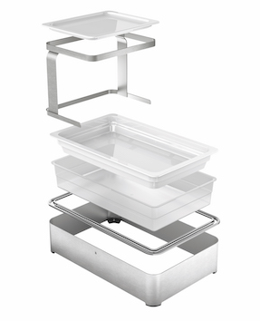

Further information:  proHeq GmbH  WMF Professional  Carl-Benz-Str. 10  75217 Birkenfeld  Tel. +49 7231 4885 0  Fax +49 7231 4885 83  wmf@press-n-relations.de  www.wmf-professional.de | Press and public relations:  WMF Press Office  c/o Press’n’Relations GmbH  Monika Nyendick  Magirusstraße 33 – D-89077 Ulm  Tel. +49 731 96287-30  Fax +49 731 96287-97  wmf@press-n-relations.de  www.press-n-relations.de

About the WMF Group
WMF Professional’s Hotel business unit is one of the leading providers of professional equipment for hotels and the catering industry. The key strength of this long-established brand is its innovative, painstakingly crafted and stylish all-in-one solutions covering every aspect of food and drink, from preparation to serving. The extensive product range includes cutlery and glassware, serving and buffet equipment and table decorations in every colour.

For more than 160 years, the brands that make up the WMF Group have stood for the best in cooking, drinking and dining. Every day, more than 100 million people around the world use products from WMF, Silit and Kaiser to prepare, cook, bake, eat and drink in their homes. And when they are not doing that, they are enjoying coffee specialties and foods prepared by the hotel and catering industry using WMF, Schaerer or HEPP products. Our employees are passionate about bringing people together, whether at home, on the move or at fine-dining establishments, in order to give them shared moments that are both precious and delicious. All this with products which have outstanding design, perfect functionality and excellent quality to make every culinary experience a real joy. Our business has a long tradition, having been founded in Geislingen an der Steige in 1853, and has been part of the French Groupe SEB since the end of 2016.

