Automated production of coronavirus vials
ZAHORANSKY receives large order for systems for the processing of vaccine containers

Todtnau, Germany – June 29, 2020. A US company has placed a major order with a value of 25 million euro for eleven automation lines and six removal units for vaccine containers (vials) with ZAHORANSKY AG. With a global research drive for a vaccine against COVID-19, the preparations to manufacture the ampules with vaccines are already in full swing. Already from August, ZAHORANSKY will supply the manufacturer of coated COP (cyclo olefin polymer) vaccine containers with the first automation lines required for production; others will gradually be delivered afterwards. The Z.SIROC, Z.MISTRAL, and Z.LODOS models are used for this purpose. To guarantee both continuous automation as well as consistent quality in the manufacturing process, a total of 120 cameras and 53 robots will be installed. As soon as the lines are fully assembled and put into operation, they will be able to process 600,000 vials per day. Michael Schmidt, Managing Director of ZAHORANSKY Automation & Molds GmbH, adds: “Handling COP containers for delicate vaccines is no easy matter. However, we managed to convince our client with our years of experience in integrating our lines into the production facilities of our customers, as well as with our ‘Made in Germany’ quality.”

Vaccines consist of compounds with high molecular weight. These have a sensitive reaction to, among other things, heavy metal particles in glass containers, which are created during the hardening process. This lowers the shelf life of the vaccine. Plastic vials made of COP (cyclo olefin polymer) are an alternative to glass. These are manufactured in an injection blow-molding process. They stand out with their high breakage resistance as well as glass-like transparency, but offer poorer oxygen tightness. Therefore, the US manufacturer uses an additional silicon dioxide nanocoating. This reinforces the oxygen barrier and also allows for low-temperature storage. As a result, the plastic container can be transported more securely compared to the glass alternative, and it has a longer shelf life – invaluable benefits when it comes to a vaccine in global demand.

The US company put its trust in ZAHORANSKY because it is the only company with the necessary cumulative experience to cover all aspects of the production process. Michael Schmidt explains in more details: “This project was, in many ways, challenging. We needed to cover a range of demands – starting with the integration of the injection blow-molding machine at the customer, through to seamless documentation as well as traceability (track & trace) with laser engraving and integration into the MES system, up to continuous camera controls using algorithms developed specifically for this application.” After full assembly of the automated production line, the eleven Z.SIROC automation lines take the COP vials from the injection blow-molding machine and transfer them to the Z.MISTRAL. Here, the vaccine containers are cooled and a laser engraves an individual marking. The Z.LODOS now removes the processed and checked parts and passes them on to the NEST/TUB for finishing with a nanocoating. The vials are constantly checked for quality by various cameras during all phases of production.

Image materials
You can find the image material in our media portal press-n-relations.amid-pr.com (search for “ZAHORANSKY-Coronavirus-Vials”). Of course, we will also gladly send you the files via e-mail.
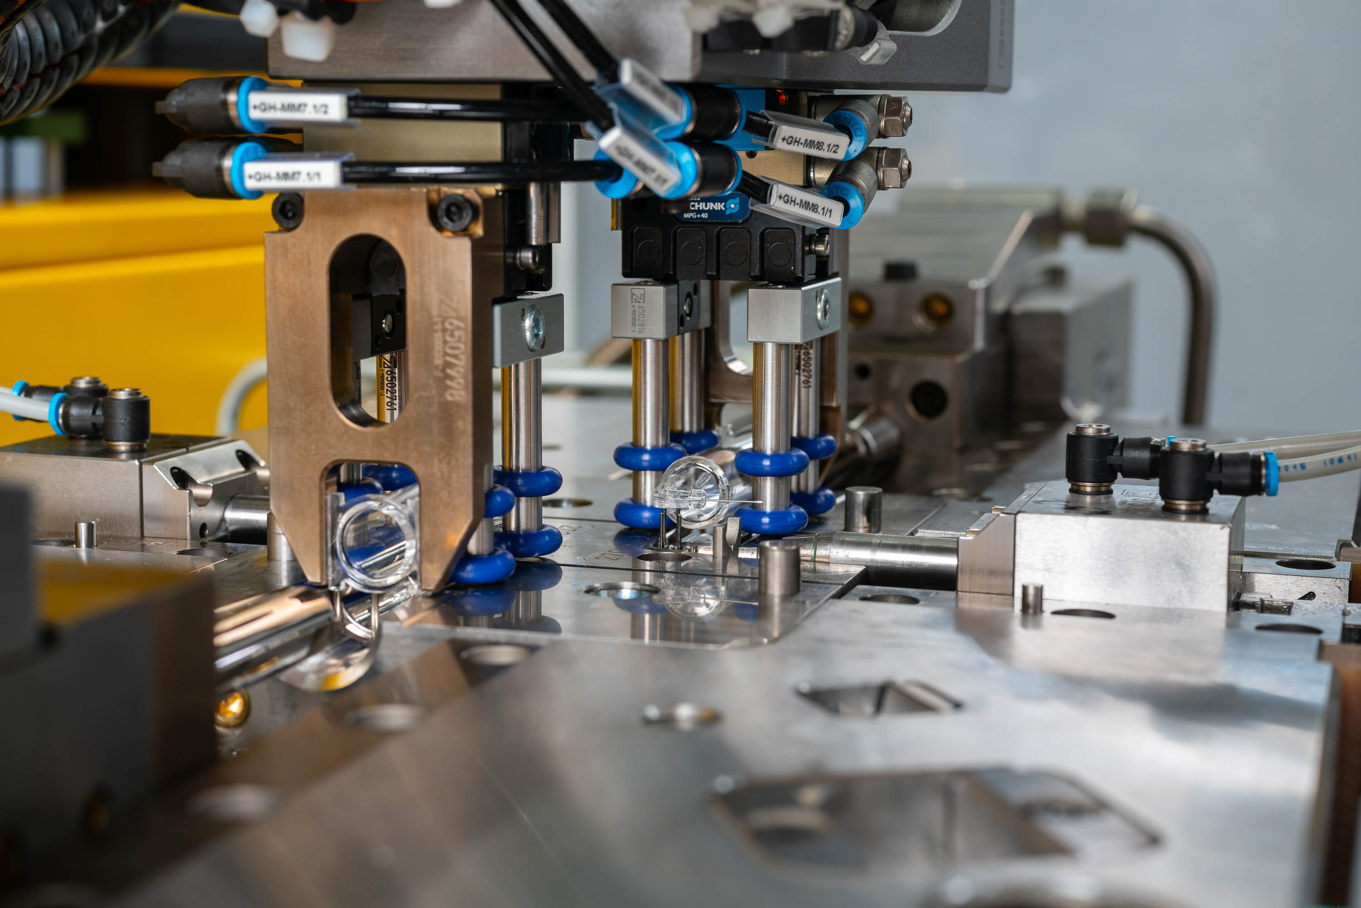 | 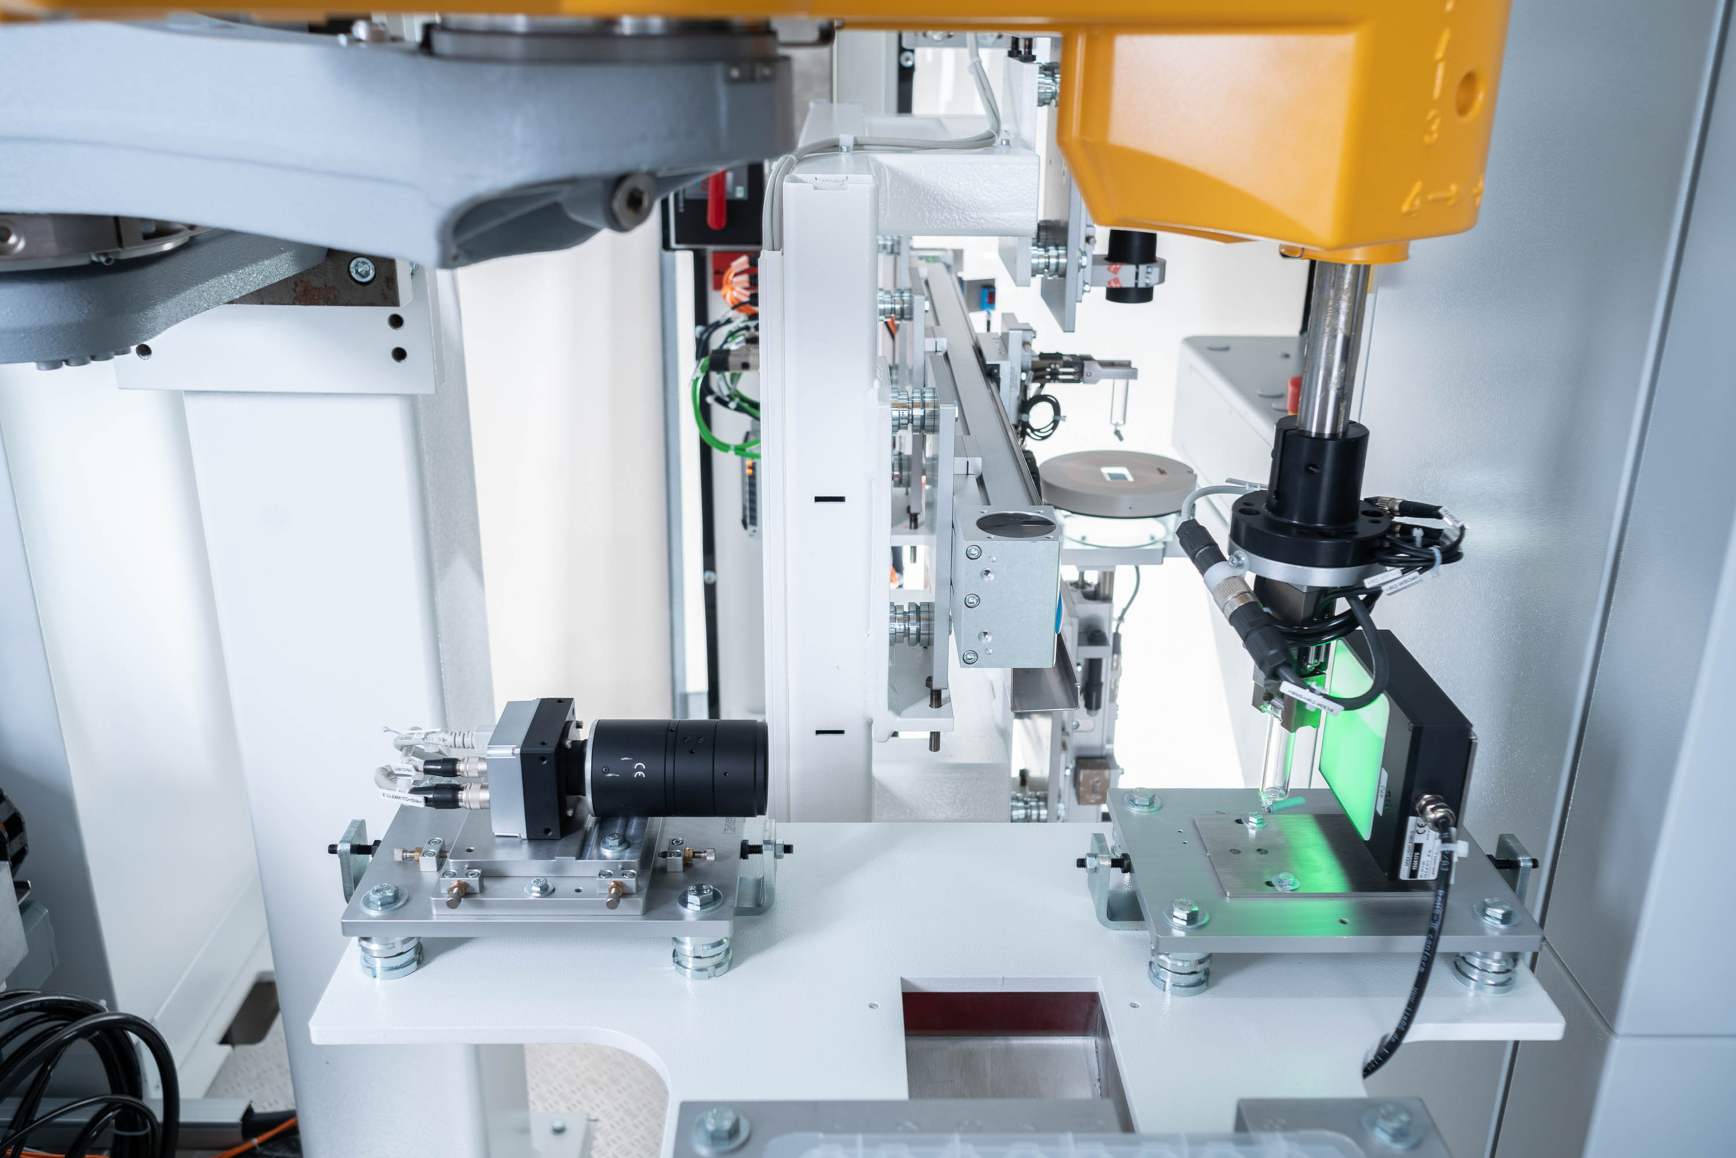
With the ZAHORANSKY automation systems, 600,000 coronavirus vials can be processed daily. (source: ZAHORANSKY) | To ensure quality, a total of 120 cameras are used in the ZAHORANSKY automation systems. (Source: ZAHORANSKY)

Further information:  ZAHORANSKY AG  Robert Dous, Head of Sales & Marketing  Anton-Zahoransky-Straße 1  D-79674 Todtnau-Geschwend  Tel.: +49 (0) 7671 997-0  Fax: +49 (0) 7671 997-299  E-Mail: robert.dous@zahoransky.com  https://www.zahoransky.com/  https://www.facebook.com/ZAHORANSKYGroup/  https://twitter.com/_ZAHORANSKY_  https://www.youtube.com/user/ZAHORANSKYGROUP  https://www.linkedin.com/company/zahoransky-group/ | Public Relations:  Press'n'Relations GmbH  Nataša Forstner, Thomas Seibold  Magirusstr. 33, 89077 Ulm  Tel. +49 (0) 731 96287-17 bzw. 19  Fax +49 (0) 731 96287-97  E-Mail: nfo@press-n-relations.de,  ts@press-n-relations.de  https://www.press-n-relations.de/
Background information
Since 1902, the ZAHORANSKY name has stood for reliability, precision, and sophisticated technology. The foundation of the company was laid by Anton Zahoransky, who produced the first devices and machines for automation and brush production in his small workshop in Todtnau.

Building on the experiences and skills gathered since then, ZAHORANSKY today operates as a full-service provider and technology partner for companies in the brush industry, medical technology, and additional industries. With injection-molding tools and mechanical engineering and automation technology, as well as packaging lines, ZAHORANSKY covers the full range of individual demands. This is what approx. 900 employees, of which 70 are trainees, work hard at every day at ten locations in Germany, Spain, China, India, Japan, Brazil, and the US.

The system-spanning ZAHORANSKY solutions cover the entire process chain: starting with the integration of packaging technology through handling up to the programming and robotics in the production of fully automated manufacturing and assembly lines. The ZAHORANSKY technologies and services are in high demand in the following industries: household and industrial brushes, oral care, medical technology, cosmetics, consumer goods, and packaging.

