ZAHORANSKY will be at FachPack – 24 to 26 September, Nuremberg – Hall 3A / 3A-509

Organical packaging
ZAHORANSKY adds industrially compostable blister pack option for packaging machines in the Z.PACK range.

Todtnau, 24 September 2019. At Stand 509 in Hall 3A of FachPack 2019, ZAHORANKSY will be demonstrating how efficiency and sustainability can be economically combined in packaging technology: the Z.PACK range of compact blister-packaging machines now offers an option for processing transparent PLA films. Jörg Philip Zimmermann, Head of Product Sales Packaging ZAHORANSKY, explains: “With this development, we are meeting the needs of companies that want to design their products, including their packaging, in an environmentally friendly manner – from recyclable cardboard packaging to industrially compostable PLA blister packs. There will be no loss of sealability, feel, or function.” In particular, the Z.PACK 4 and Z. PACK 5 models are excellent choices for companies seeking low investment costs and small space requirements. The machines are optimized for any batch size, and can package technical products such as stationery, tools, glue sticks, light bulbs, electrical parts, toilet cleaners, and the like just as reliable and sustainable as products in the cosmetics and personal hygiene sectors. The machines have a maximum forming area of 192 x 294 mm with a forming depth of up to 40 mm; an optional upgrade also allows deeper blisters to be produced. A maximum output of 20 cycles per minute can be achieved. The different models in the Z.PACK range can be individually configured according to customer requirements. They can be upgraded with expansion modules to provide additional functionality such as inserting leaflets, blind embossing, or visual monitoring.

High operator comfort
The various stations of the machines can be moved flexibly through the entire line with just a few simple steps and without the constraint of a mounting grid. This is thanks to the use of continuous guide rails, mounted on both sides along the entire chain length of the line. This means that even the heaviest stations, which weigh over half a metric ton, can be changed effortlessly by a single operator using just one finger. With the centralized spindle adjustment, Z.PACK machines also allow a simple and cost-efficient change over of the foil width. This can be adjusted along the entire chain length, and thus the entire machine, in a single step. These machines also make it easy to exchange format parts with toolless quick-changeover systems; depending on the format, the process can take as little as around 30 minutes.

Wide range of additional automation solutions
A large number of optional automation solutions are available for the feeding and end-of-line packaging areas of Z.PACK machines. For example, semi-automatic feeding systems can increase the system efficiency. The H105 pick & place handling system automatically places products in the correct orientation in the blister pack. The continuous, non-jerky operation of this feeding system results in a high level of ergonomic comfort for operators. It is also easy to retrofit this modular feeding system to existing machines.

Customer-specific system solutions from a single source
ZAHORANSKY takes a comprehensive approach to integrating packaging machines into fully interlinked, high performance production systems. The Automation & Molds division has extensive experience in the implementation of a wide variety of automation solutions, from a broad range of different product feeds to transport-compatible final packaging by external cartoning machines.

Images
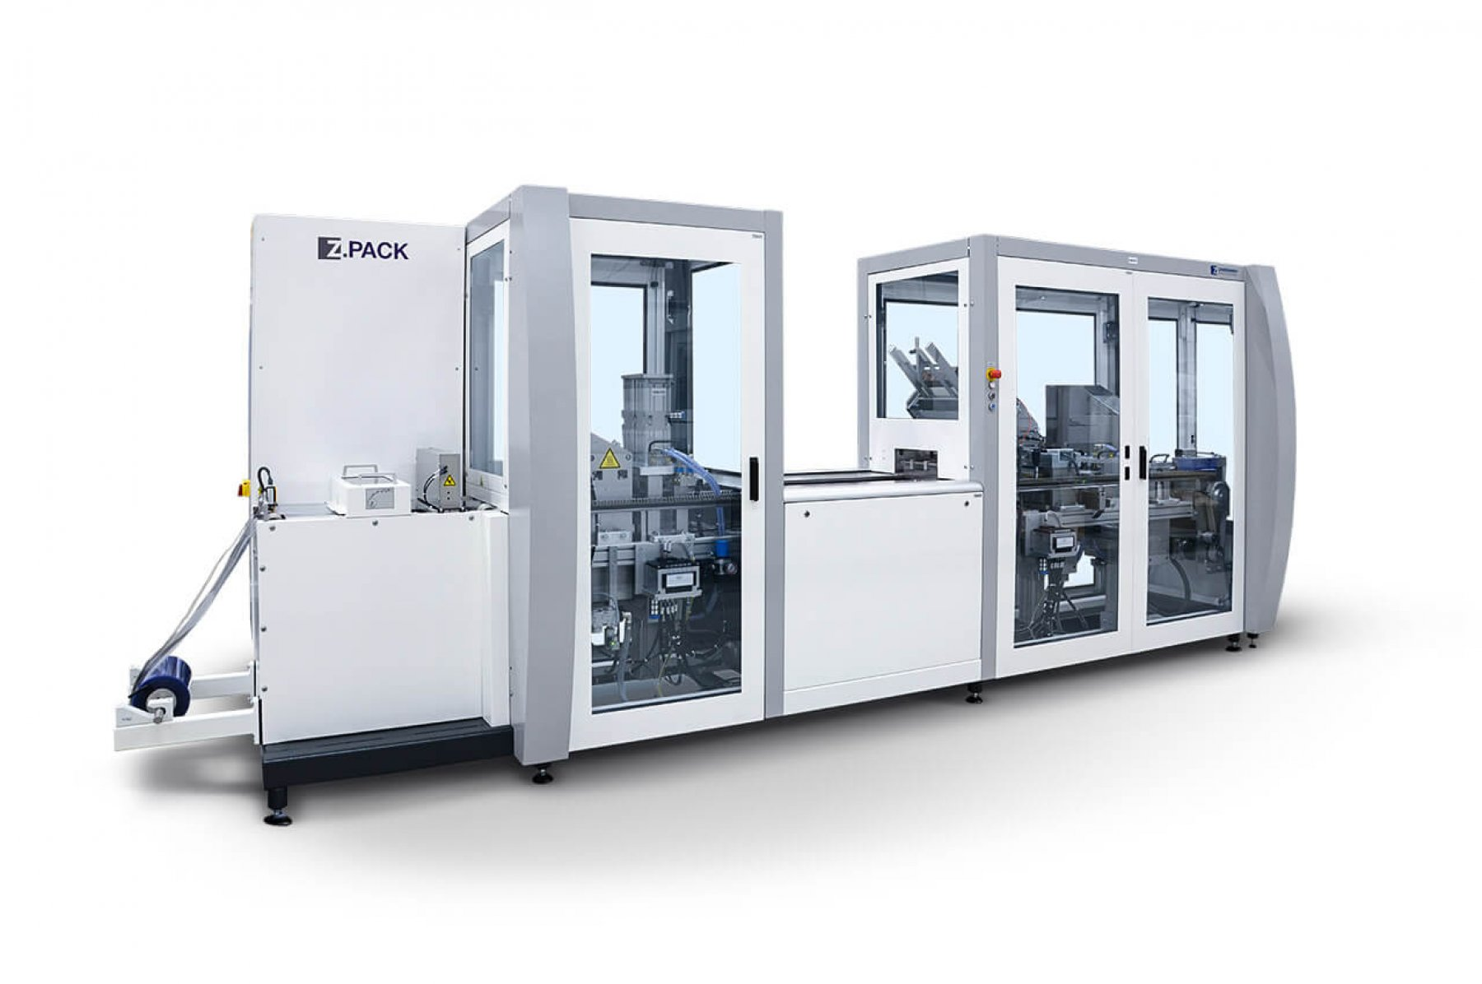
((Caption)) Packaging machines in the Z.PACK range can now handle industrially compostable PLA films.

These images can be obtained through our media portal: press-n-relations.amid-pr.com (use the search term “Zahoransky-FachPack-2019”). Of course, we would also be happy to send you the files by e-mail.

Further information:  ZAHORANSKY AG  Robert Dous, Head of Sales/Marketing  Anton-Zahoransky-Straße 1,  79674 Todtnau-Geschwend  Tel.: +49 (0) 7671 997-0  Fax: +49 (0) 7671 997-299  E-mail: robert.dous@zahoransky.com  www.zahoransky.com  https://www.facebook.com/ZAHORANSKYGroup/  https://twitter.com/_ZAHORANSKY_  https://www.youtube.com/user/ZAHORANSKYGROUP  https://www.linkedin.com/company/zahoransky-group/ | Press and Public Relations:  Press'n'Relations GmbH  Nataša Forstner, Thomas Seibold  Magirusstr. 33, 89077 Ulm  Tel. +49 (0) 731 96287-17 or 19  Fax +49 (0) 731 96287-97  E-mail: nfo@press-n-relations.de,  ts@press-n-relations.de  www.press-n-relations.de
Background information
ZAHORANSKY has been synonymous with reliability, precision, and sophisticated technology since 1902 already. The foundation for this reputation was laid by Anton Zahoransky in his small workshop in Todtnau, Germany, in which he produced the first devices and machines for automating brush production.

On the basis of the experiences and competences gained since then, ZAHORANSKY now operates as a full-service provider and technology partner for companies in the brush sector, medical technology, and other industries. With injection molds, machinery and automation technology, as well as packaging systems, ZAHORANSKY covers the full range of customer demands. This is what around 900 employees, of which 60 apprentices, work hard at every day at ten locations in Germany, Spain, China, India, Japan, Brazil, and the US.

The cross-system ZAHORANSKY solutions covers the entire process chain: Starting at the integration of packaging technology and handling up to the programming and robotics in the manufacturing of fully automated production and assembly systems. ZAHORANSKY technologies and services are in high demand in the following industries: household and industrial brushes, oral care, medical technology, cosmetics, consumer goods, and packaging.

