ZAHORANSKY at the K 2019 – October 16th to 23rd, Düsseldorf – Hall 1/Stand E70

The Z factor is included
New at ZAHORANSKY: a multi-component mold for injection molding/silicon applications and a laser inscription unit for soft plastics

Todtnau, September 2nd, 2019. At the K 2019, two ZAHORANSKY innovations containing our famous Z-factor are celebrated at Stand E70 in Hall 1. The Mold Construction business unit presents its new multi-component mold, the Z.WARP move, for 2K silicon applications, impressively demonstrating its benefits using the example of a 2K magnifying glass made from polybutylene terephthalate (PBT) and liquid silicon rubber (LSR): The magnifying glass is made of two 2K components, which are then also assembled inside the mold after the injection-molding process. This not only gives companies greater flexibility in the design and functioning of their products, it also allows them more efficient production in a single work cycle. The second innovation at the fair is presented by the Oral Care business unit: A laser unit makes it possible for the first time to add custom inscriptions to the soft and hard components of toothbrushes immediately before packaging. The most impressive element of the system is its speed: The inscription process takes less than a second. Due to the reduction in preparation effort compared to pad printing, the process is particularly suited for the smallest batches from a batch size of 1. The most innovative feature lies in the option to inscribe soft plastic components near the thumb as well as in the grip elements. In contrast with conventional laser processes, which generally only work with polypropylene hard plastics, no carbonization takes place. The surface smoothness remains virtually unchanged and is resistant against environmental influences such as abrasion by frequent use or the effects of liquids containing propanediol or ethanol.

With its appearance at the K 2019 fair, ZAHORANSKY once more proves its competence in implementing customer demands and mastering technical challenges. The multi-component mold Z.WARP move as well as the laser unit for soft plastics allow companies to design their products more flexibly and produce them more efficiently.

A detailed look at the Z.WARP move multi-component mold
Michael Schmidt, Managing Director ZAHORANSKY Automation & Molds GmbH, is delighted to see that the partnership with Edegs Formenbau GmbH bears its first fruits already in its first year: “With the Z.WARP move, we from now on add the option of silicon applications to our automation systems. To present an example of the possibilities of this technology, we will present a magnifying glass that has been produced with the new process at our fair stand: It combines conventional thermoplastic injection-molding technology with the benefits of highly transparent silicon and integrated mechanics.” Multi-component injection-molding products that contain silicon have special mechanical properties, which is why they are used in medical technology as well as increasingly in the automotive sector and other industries.

A detailed look at the Oral Care laser unit
Michael Soukup, Head of Product Sales Oral Care, presents two revolutions in the laser inscribing of toothbrushes at the fair stand – with a look to both production processes and design: “On the one hand, our new laser unit enables companies to customize their toothbrushes shortly before packaging. The second benefit lies in new design freedoms, only made possible by this laser unit: Pixels as small as 0.025 mm can be inscribed into the soft toothbrush components, for permanent inscription of detailed logos, graphics, and images.” The inscription takes place shortly before packaging, which massively cuts the time it takes to deliver an order. Producers need no longer wait with production until the order arrives, but can rather use stored, neutral models. The inscription process itself takes less than a second per toothbrush. In contrast with other processes, such as pad printing, this system is thus already economical from the smallest of batch sizes. With an automated ZAHORANSKY system, the production of individually inscribed toothbrushes for “professional” use (dental clinics, dental practices) is possible just as efficiently as for small niche markets or even customer-specific individual production. The special composition of the soft components was achieved using thermoplastic elastomers by Kraiburg with additives and color particles by Merck.

Images
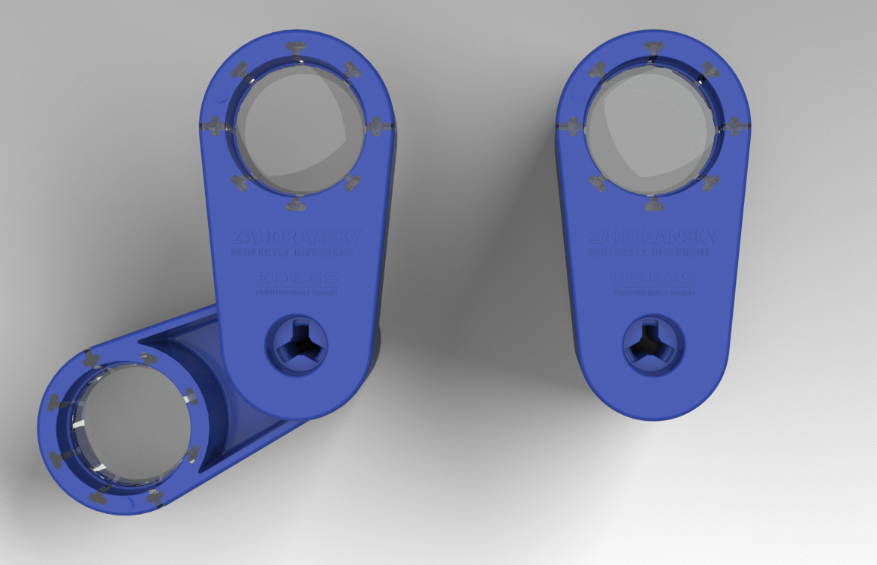 | 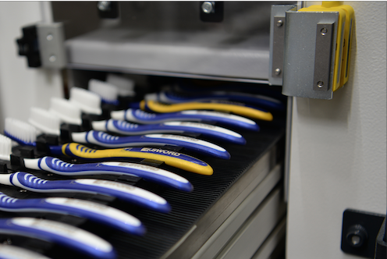
((BU)) The magnifying glass produced with the Z.WARP move unites injection-molding technology with highly transparent silicon and integrated mechanics. | ((BU)) With the new laser unit, production processes for toothbrushes are optimized and design options expanded.

You can find the image material in our media portal press-n-relations.amid-pr.com (search for: “Zahoransky K Messe 2019”). Of course, we will also gladly send you the files by e-mail.

Further information:  ZAHORANSKY AG  Robert Dous, Head of Sales/Marketing  Anton-Zahoransky-Straße 1  79674 Todtnau-Geschwend  Tel.: +49 (0) 7671 997-0  Fax: +49 (0) 7671 997-299  E-mail: robert.dous@zahoransky.com  www.zahoransky.com  https://www.facebook.com/ZAHORANSKYGroup/  https://twitter.com/_ZAHORANSKY_  https://www.youtube.com/user/ZAHORANSKYGROUP  https://www.linkedin.com/company/zahoransky-group/ | Press and Public Relations:  Press'n'Relations GmbH  Nataša Forstner, Thomas Seibold  Magirusstr. 33, 89077 Ulm  Tel. +49 (0) 731 96287-17 or 19  Fax +49 (0) 731 96287-97  E-mail: nfo@press-n-relations.de,  ts@press-n-relations.de  www.press-n-relations.de
Background information
ZAHORANSKY has been synonymous with reliability, precision, and sophisticated technology since 1902 already. The foundation for this reputation was laid by Anton Zahoransky in his small workshop in Todtnau, Germany, in which he produced the first devices and machines for automating brush production.

On the basis of the experiences and competences gained since then, ZAHORANSKY now operates as a full-service provider and technology partner for companies in the brush sector, medical technology, and other industries. With injection molds, machinery and automation technology, as well as packaging systems, ZAHORANSKY covers the full range of customer demands. This is what around 900 employees, of which 60 apprentices, work hard at every day at ten locations in Germany, Spain, China, India, Japan, Brazil, and the US.

The cross-system ZAHORANSKY solutions covers the entire process chain: Starting at the integration of packaging technology and handling up to the programming and robotics in the manufacturing of fully automated production and assembly systems. ZAHORANSKY technologies and services are in high demand in the following industries: household and industrial brushes, oral care, medical technology, cosmetics, consumer goods, and packaging.

