Dr. Bernd Stein to become new Chief Technical Officer at ZAHORANSKY AG

Todtnau, July 31st, 2020 – From August 1st, 2020, Dr. Bernd Stein will be appointed as a Board Member at ZAHORANSKY AG, responsible for technology and machinery. Gerhard Steinebrunner, who previously held this position, has decided to leave the company to take on a new career challenge.

Dr. Bernd Stein, 56 years old and an accomplished mechanical engineer, will be contributing many years of his industry experience to his position on the ZAHORANSKY AG Board. His most recent role was COO at Kiefel GmbH in Freilassing. Gerhard Enders, Chairman of the Supervisory Board at ZAHORANSKY AG, said, “We are delighted to welcome back Dr. Bernd Stein to the Board. He was previously on the Board at ZAHORANSKY AG from 2005 to 2013, so he already has extensive knowledge of our markets, clients, and products. I am therefore confident that he will settle into his new role seamlessly.” Board Member Ulrich Zahoransky added, “We have managed to consistently develop our position as the world’s leading supplier in our sector thanks to the advancement of our technologies and services. With Dr. Bernd Stein on board, we now have a seasoned expert to guide us on down this path of success.” Dr. Bernd Stein announced, “I am thrilled to be part of the ZAHORANSKY team again and by the prospect of working with the innovative staff to conquer our future challenges.”

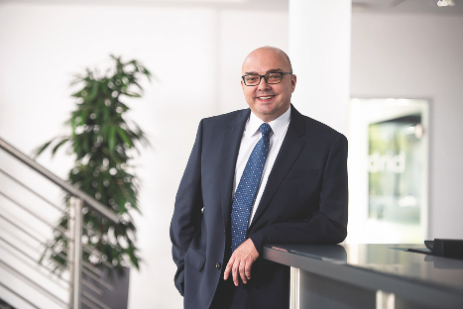

From August 1st, 2020, Dr. Bernd Stein will be a Board Member at ZAHORANSKY AG, responsible for technology and machines.

You can find the image material on our media portal press-n-relations.amid-pr.com (search term “ZAHORANSKY-Board-Dr-Bernd-Stein”). We will also be more than happy to email you the file.

Further information:  ZAHORANSKY AG  Robert Dous, Head of Sales and Marketing  Anton-Zahoransky-Straße 1  79674 Todtnau-Geschwend  Tel.: +49 (0) 7671 997-0  Fax: +49 (0) 7671 997-299  Email: robert.dous@zahoransky.com  https://www.zahoransky.com/  https://www.facebook.com/ZAHORANSKYGroup/  https://twitter.com/_ZAHORANSKY_  https://www.youtube.com/user/ZAHORANSKYGROUP  https://www.linkedin.com/company/zahoransky-group/ | Public relations:  Press'n'Relations GmbH  Nataša Forstner, Thomas Seibold  Magirusstr. 33, 89077 Ulm  Tel.: +49 (0) 731 96287-17 bzw. 19  Fax: +49 (0) 731 96287-97  Email: nfo@press-n-relations.de,  ts@press-n-relations.de  https://www.press-n-relations.de/
Background information
Since 1902, the ZAHORANSKY name has stood for reliability, precision, and sophisticated technology. The company was founded by Anton Zahoransky, who crafted the first devices and machines for automation and brush production in his small workshop in Todtnau.

Building on the experiences and skills gathered since then, ZAHORANSKY now operates as a full-service provider and technology partner for companies in the brush manufacture industry, medical technology, and other sectors. With injection-molding tools, mechanical engineering and automation technology, and packaging lines, ZAHORANSKY covers the full range of specific demands. This is what the roughly 900 employees, of whom 70 are trainees, always stand for across ten locations in Germany, Spain, China, India, Japan, Brazil, and the US.

The system-wide ZAHORANSKY solutions cover the entire process chain: starting with the integration of packaging technology to handling and the programming and robotics in producing fully automated manufacturing and assembly lines. The ZAHORANSKY technologies and services are in high demand in the following industries: household and industrial brushes, oral care, medical technology, cosmetics, consumer goods, and packaging.

