New micro-injection mold produces toothbrush tips for the Z.VAMP

Todtnau, 11 September 2020. When developing new machines and systems, ZAHORANSKY AG always aims to consistently optimize its production process. In doing so, both economic aspects and the production environment itself are considered equally. With its Micro-Injection Molding Machine, ZAHORANSKY now offers the ideal addition to the Z.VAMP — the specialist machine for toothbrush production which uses the 3D-TUFTING process. The compact Micro Mold from ZAHORANSKY can be placed directly next to the Z.VAMP in combination with a Micro-Injection Molding Machine, and produce the plastic head plates required for toothbrush production on site.

The Micro-Injection Molding Machine requires a minimum space of just under one square meter and can therefore be easily integrated into existing production environments. The head plate output is matched to the performance of the Z.VAMP, perfectly integrating the injection molding and production processes. A further advantage of the new micro-injection molding machine: the on-site and “just-in-time” production of the head plates reduces storage and possible transport costs.

Customization options thanks to the suction process method
The Z.VAMP is the ideal choice to produce toothbrushes with rigid design requirements for the filament, as it offers maximum customization options in terms of colors, shapes, and radii. For example, the angle of the bundles (up to 12°) and filament topography can be selected almost entirely. During the 3D-TUFTING process, the Z.VAMP fills plastic plates without metal anchors with up to 20,000 monofilaments in just one operation. The filaments, which are rounded in advance, are filled into the head plate via a suction process in freely configurable bundle sizes and then welded at the back. After the assembly and fixation of the equipped head plates in the body of the toothbrush, both parts are welded using ultrasonic technology.

ZAHORANSKY’s 3D-TUFTING process particularly shows its advantages in the production of toothbrushes with a full set of chemically sharpened filaments. Unlike conventional tamping technology, no scrap is present and no reworking is necessary due to offset filaments. This saves personnel costs, reduces waste, increases productivity, and lowers production costs. In addition, hybrid brushes that combine chemically sharpened and standard filaments can also be produced in just one process using the Z.VAMP. As a further example: when combining high and low bundles, the high-quality pre-rounding process achieves a filament rounding quality of up to 98 percent.

Image material
Printable image material can be found in our media portal press-n-relations.amid-pr.com (search term “Z.VAMP-Micro-Mold”) Of course, we can also send you the files by email.

  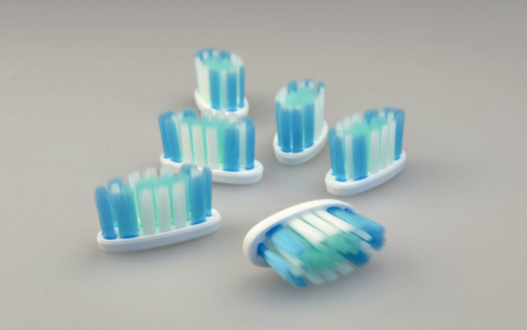 | 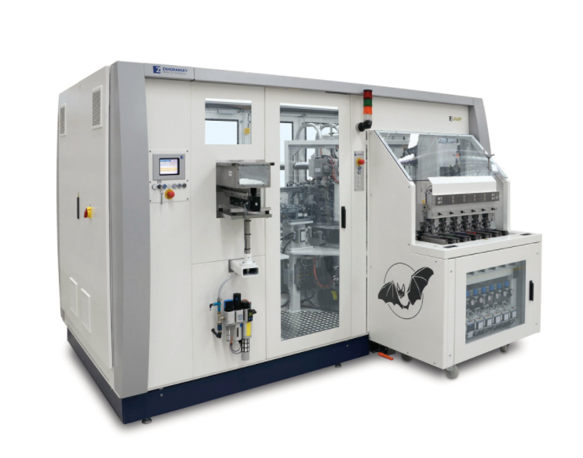
ZAHORANSKY is the specialist for head plates with chemically pointed filaments. | During the 3D-TUFTING process, the Z.VAMP fills plastic plates without metal anchors with up to 20,000 monofilaments.
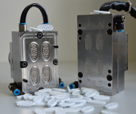 | 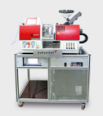
The ZAHORANSKY Micro-Mold weighs just 11 kg and utilizes little storage space and energy. | The Babyplast micro injection molding machine is placed directly next to the Z.VAMP and produces the head plates required for toothbrush production on-site.

Further information:  ZAHORANSKY AG  Robert Dous, Head of Marketing/Sales  Anton-Zahoransky-Straße 1  79674 Todtnau-Geschwend  Tel.: +49 (0) 7671 997-0  Fax: +49 (0) 7671 997-299  Email: robert.dous@zahoransky.com  www.zahoransky.com  https://www.facebook.com/ZAHORANSKYGroup/  https://twitter.com/_ZAHORANSKY_  https://www.youtube.com/user/ZAHORANSKYGROUP  https://www.linkedin.com/company/zahoransky-group/ | Press and public relations:  Press'n'Relations GmbH  Nataša Forstner, Thomas Seibold  Magirusstr. 33, 89077 Ulm  Tel. +49 (0) 731 96287-17 or 19  Fax +49 (0) 731 96287-97  Email: nfo@press-n-relations.de, ts@press-n-relations.de  www.press-n-relations.de
Background information
Since 1902, ZAHORANSKY has stood for reliability, precision, and sophisticated technology. Anton Zahoransky laid the foundation for this with his small workshop in Todtnau, where he produced the first devices and machines for the automation of brush production.

Based on the experience and expertise gained since then, ZAHORANSKY today presents itself as a full-range supplier and technology partner for companies in the brush industry, medical technology industry, and other sectors. ZAHORANSKY fully covers individual manufacturing requirements for injection molds, mechanical and automation engineering, and packaging systems. Around 900 employees, including 70 trainees, at ten locations in Germany, Spain, China, India, Japan, Brazil, and the USA are committed to our mission every day.

The cross-system solutions from ZAHORANSKY encompass the entire process chain: from the integration of packaging technology and handling, to programming and robotics in the manufacture of fully automated production and assembly systems. The technologies and services of ZAHORANSKY are in demand in the following industries: household and industrial brushes, oral care, medical technology, cosmetics, consumer goods, and packaging.

