ZAHORANSKY introduces new apps for contactless support and direct spare parts orders
Direct access to machine and spare parts service with ZPARE and ZOLVE

Todtnau, Germany 16 March 2021. ZAHORANSKY has created two new apps – ZPARE and ZOLVE – to offer its customers the option of placing orders for spare parts directly on the app and, in case of technical questions, to connect its customers to an online ZAHORANSKY expert. This direct line to the machine and spare parts service team decreases any downtime in production and reduces the potential for errors during maintenance and repair work. The ZPARE app enables the secure, fast, and automatic recognition and ordering of spare parts exclusively with the smartphone's camera function. The photographed product identification number is recognized in the app by means of integrated artificial intelligence. It then appears in a selection list for review, and, after selecting the quantity, can be sent directly to the ZAHORANSKY spare parts service team with just one click. In addition to this – or for troubleshooting and general maintenance work – the new ZOLVE app offers the option of connecting to a ZAHORANSKY service expert online via live video and audio streaming. This means that support is available directly on the machine and the customer can carry out repairs or maintenance processes on their own with expert instructions.

Artur Seger, the Head of After Sales at ZAHORANSKY, adds: “For manufacturing companies, all periods of non-productivity, regardless of whether they are planned or not, must be kept as short as possible. Our two new apps are digitally providing an enormous boost to this requirement.” The apps also promote compliance with the corona-related contact restrictions currently in force almost all over the world: significantly faster support and the elimination of travel expenses make up for the drawbacks of this currently only virtual, not physical, on-site visit.

The two ZAHORANSKY apps, ZPARE and ZOLVE, are available for Android and iOS systems (smartphone and tablet). To ensure the worldwide supply of spare parts, ZPARE offers support in the following languages: English, German, Spanish, Chinese, Portuguese, Japanese. The ZOLVE app also offers live translation in 20 languages. To ensure comprehensive support, we offer high-resolution image quality in connection with the transmission of additional documents and information. Additional ZAHORANSKY experts can be reached when required. You receive a final report in a PDF format, which can be archived with images and notes, after the maintenance work has been completed. Both apps require an internet connection.

You can find more information on the ZPARE app and its benefits here:
https://youtu.be/gpDqdOqLN1Q

You can find more information on the ZOLVE app and its benefits here:
https://youtu.be/dzbL1gCpqFs

Image material
You can find the image material in our media portal press-n-relations.amid-pr.com (search term "ZAHORANSKY ZOLVE ZPARE"). We are also more than happy to email you the files.
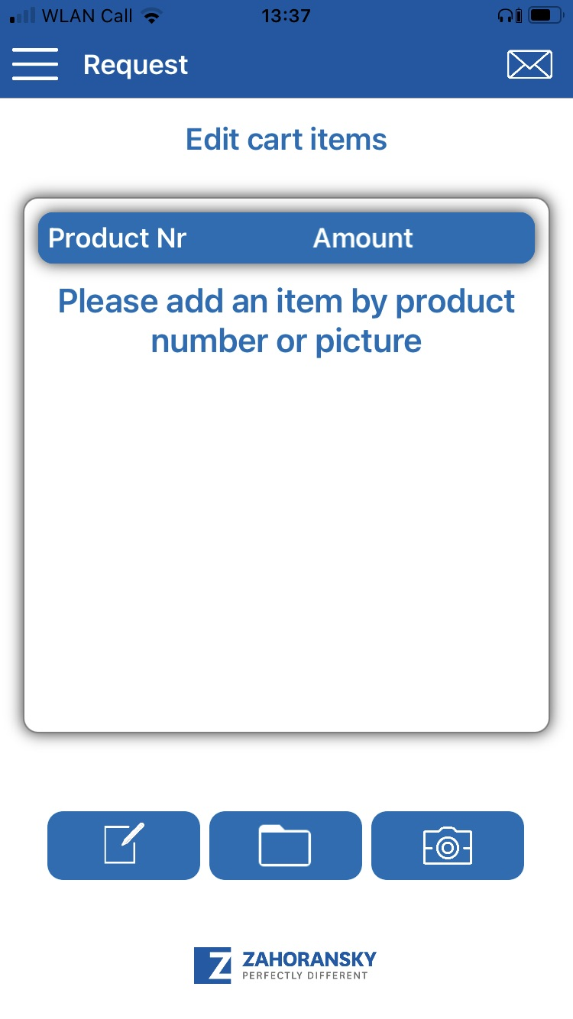 | 
ZPARE from ZAHORANSKY simplifies spare parts ordering | With ZOLVE from ZAHORANSKY, service experts can be called in online

Further information:  ZAHORANSKY AG  Robert Dous, Head of Sales and Marketing  Anton-Zahoransky-Straße 1  79674 Todtnau-Geschwend  Tel.: +49 (0) 7671 997-0  Fax: +49 (0) 7671 997-299  E-mail: robert.dous@zahoransky.com  www.zahoransky.com | Public relations:  Press'n'Relations GmbH  Nataša Forstner, Thomas Seibold  Magirusstr. 33, 89077 Ulm  Tel. +49 (0) 731 96287-17 or -19  Fax +49 (0) 731 96287-97  E-mail: nfo@press-n-relations.de, ts@press-n-relations.de  www.press-n-relations.de
Background information
Since 1902, ZAHORANSKY has stood for reliability, precision, and sophisticated technology. Anton Zahoransky laid the foundation with his small workshop in Todtnau, where he produced the first devices and machines for the automation of brush production.

Based on the experience and expertise gained since then, ZAHORANSKY today presents itself as a full-range supplier and technology partner for companies in the brush industry, medical technology industry, and other sectors. ZAHORANSKY fully covers individual manufacturing requirements for injection molds, mechanical and automation engineering, and packaging systems. Around 900 employees, including 70 trainees, at ten locations in Germany, Spain, China, India, Japan, Brazil, and the USA are committed to our mission every day.

The cross-system solutions from ZAHORANSKY encompass the entire process chain: from the integration of packaging technology and handling, to programming and robotics in the manufacture of fully automated production and assembly systems. The technologies and services of ZAHORANSKY are in demand in the following industries: household and industrial brushes, oral care, medical technology, cosmetics, consumer goods, and packaging.

