ZAHORANSKY Group acquires dialysis division
of FLG Medizintechnik GmbH

Todtnau, January 18, 2021. On January 1st, 2021 the ZAHORANSKY Group acquired the dialysis division of its long-standing partner FLG Automation AG, taking a decisive step in consolidating its position in the field of medical technology. The complete lines for dialysis filter manufacturing from FLG perfectly complement the available know-how and existing portfolio of ZAHORANSKY concerning machines and installations for medical-technical products, as well as primary pharmaceutical packaging. Here too, ZAHORANSKY offers the "one-stop shopping" experience its customers already know from brush production. In the future, this concept will also cover the installations for the production of dialyzers, the necessary injection molds for all parts, as well as the packaging machines. The ZAHORANSKY range will comprise turn-key production systems for the manufacturing of dialyzers, also covering the quality checks that are indispensable in medical technology. The acquisition of the dialysis division was made possible as part of the succession plan for FLG founder, Lüdger Grünewald.

Ulrich Zahoransky comments as follows: "We have already been cooperating with FLG for many years. Real friendships have developed between our companies over time, also at a personal level. This makes me all the more delighted to have found a solution that works for both parties, creating a classic win-win situation." To ensure a seamless transition period, all requests by FLG customers and interested parties will be forwarded to ZAHORANSKY and answered by the same from January 1st. The lion's share of service and support activities can from now on be assumed through VPN remote services, with ZAHORANSKY benefiting from the support of the team at FLG. Lüdger Grünewald will also be available to the ZAHORANSKY Group in the coming years, as a consultant: "I am already delighted by even more intensive collaboration in future, as well as by the opportunity to put my extensive know-how to great use."

With its global sales and service subsidiaries in the US, India, China, Japan, and Brazil, ZAHORANSKY will also be able to provide competent customer support for these systems on a great number of key markets in the near future. The medical technology activities of the corporate group are bundled in ZAHORANSKY Automation & Molds GmbH in Freiburg.

A success story: Medical technology by ZAHORANSKY
Over the past fifteen years, ZAHORANSKY developed its activities in medical technology – parallel to its traditional line of business, injection molds and machines for brush production. Besides automatic lines for the production of suitable primary packaging, the company above all made a name for itself with machines for the production of staked-needle syringes, plastic syringes with a molded-over needle. The needles are not glued onto the syringe, but rather molded over the syringe in a fully automatic process, benefiting both their stability and material compatibility while allowing for an efficient production process. With the acquisition of FLG production lines for dialyzers, ZAHORANSKY is now adding great competence to this field of business. The company achieves one of its most significant successes in this field at the beginning of 2020: US company SiO2 placed a major order with ZAHORANSKY at this time of initially 25 million euro for eleven automation lines and six removal units for corona vaccine vials. Over the course of the year, the order was extended to an overall scope of 48 million euro. As part of the US government project "Operation Warp Speed", 300 million corona vaccine doses should be available by the beginning of the year. In spite of extremely short delivery times, ZAHORANSKY managed to meet the order in time and the machines were punctually put into operation with the customer.

Image material
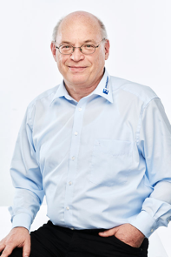 | 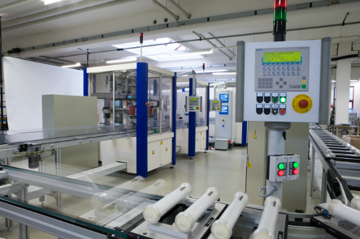
 | Assembly station with dialysis filters
  Ulrich Zahoransky, Managing Director at ZAHORANSKY

You can find the image in our media portal press-n-relations.amid-pr.com (search term "ZAHORANSKY FLG"). We are also more than happy to email you the files.

Further information:  ZAHORANSKY AG  Robert Dous, Head of Sales/Marketing  Anton-Zahoransky-Straße 1  79674 Todtnau-Geschwend  Tel.: +49 (0) 7671 997-0  Fax: +49 (0) 7671 997-299  E-mail: robert.dous@zahoransky.com  https://www.zahoransky.com/  https://www.facebook.com/ZAHORANSKYGroup/  https://twitter.com/_ZAHORANSKY_  https://www.youtube.com/user/ZAHORANSKYGROUP  https://www.linkedin.com/company/zahoransky-group/ | Press and Public Relations:  Press'n'Relations GmbH  Nataša Forstner, Thomas Seibold  Magirusstr. 33, 89077 Ulm  Tel. +49 (0) 731 96287-17 or 19  Fax +49 (0) 731 96287-97  E-mail: nfo@press-n-relations.de,  ts@press-n-relations.de  https://www.press-n-relations.de/

Background information
ZAHORANSKY has been synonymous with reliability, precision, and sophisticated technology since 1902. Anton Zahoransky laid the foundation with his small workshop in Todtnau, in which he manufactured the first devices and machines for the automation of brush production.

Using the experiences and skills gained since the company founding, ZAHORANSKY now operates as a full-service provider and technology partner for companies in the brush industry, medical technology, and other industries. With injection molds, machine engineering, and automation technology, as well as packaging lines, ZAHORANSKY covers the whole range of customer requirements. This is what around 900 employees – of which 70 are trainees – work hard for each and every day at ten locations in Germany, Spain, China, India, Japan, Brazil, and the US.

The system-spanning solutions of ZAHORANSKY cover the entire process chain: from the integration of packaging technology to handling up to programming and robotics in the manufacturing of fully automated production and assembly lines. The ZAHORANSKY technologies and services are in high demand in the following industries: household and industrial brushes, oral care, medical technology, cosmetics, consumer goods, and packaging.

