Z.PARD MT for fully automated brush production
Four-station twin machine ensures greater output and process reliability in the production of household and hygiene brushes

Todtnau, 10. November 2023 – High output combined with reliability and flexibility - the Z.PARD from ZAHORANSKY has proven itself for many years as a high-performance machine for the economical production of household and hygiene brushes. With the Z.PARD MT, ZAHORANSKY now offers the industry a further development for fully automated brush production. Compared to the manually operated model, the four-station machine includes an in- and outfeed handling as well as the trimming unit in addition to the drilling and tufting unit. This means that the operator only must place the brush bodies on the infeed belt for storage. The Z.PARD MT takes care of all further steps, from removal and transfer to the drilling unit by an industrial robot to dispensing the finished "ready-for-sale" brushes into a storage container. A consistently high output thanks to maximum production speed, optimum capacity planning and a small footprint are just as much in favor of the MT variant as the reduction in the workload of the machine operators. In the particularly price-sensitive mass market for household and hygiene brushes, customers benefit from even lower unit costs with higher product quality and process reliability thanks to the high degree of automation of the Z.PARD MT.

With the Z.PARD MT, ZAHORANSKY is further expanding its range of fully automated machines for brush production. This gives manufacturers of household and hygiene brushes even more flexibility to choose a solution that is precisely tailored to the individual requirements of their company. Like the manually operated Z.PARD model, the MT version is characterized by high performance, reliability and precision. The high degree of automation also increases efficiency and process reliability and enables the Z.PARD MT to produce at full speed. The "no-human-touch" operation also leads to even higher product quality due to the elimination of sources of error and at the same time increases work safety and comfort, as all quality-relevant production steps run without interaction by an employee.

Increased automation to counter the shortage of skilled workers
Another advantage: in times of a global shortage of skilled workers, operation is possible with less staff. After selecting the desired model on the touchscreen, the operator simply has to place the brush bodies on the infeed belt for storage instead of inserting them into the carousel's clamping system as with the manually operated version. In the Z.PARD MT, an integrated industrial robot removes the brush body from the belt and inserts it into the clamping unit of the twin carousel. In the next step, the holes are drilled at a speed of up to 25,000rpm. In the next step the brush handles get tufted at a speed of up to 2x 600 tufts per minute, trimmed directly in the machine and dispensed into a storage container as a 'ready-for-sale' product. This means that only one machine operator is required to operate and monitor the Z.PARD MT. While the machine is working, the operator can also carry out other tasks such as labeling, packaging, etc. To further relieve employees, the Z.PARD MT can also be supplemented with automatic filament feeding system and a labeling device. Last but not least, the Z.PARD MT scores points for its smaller footprint, as no additional trimming machine is required.

Simple and quick adjustments
The Z.PARD MT is ideal for the production of household products such as brooms, hand brushes, scrubbing brushes as well as dishwashing, toilet, bath and wire brushes. Accordingly, both wooden and plastic handles with a brush length of up to 400 mm (optionally up to 600 mm) can be processed. The machine is also flexible when it comes to filament types: in addition to natural fibers and natural hair, plastic and wire filaments can also be processed. Depending on the brush model, the machine is available for processing filament lengths of up to 260 mm or 320 mm (unfolded). The Z.PARD MT is also impressive when it comes to converting to other brush models: The quick-change system enables sample specific components, such as carriages or tufting tools, to be replaced in a very short time. In addition, parts such as the quick-change plate or the tufting tool are compatible with other household machines, this saving the investment budget. The desired models are programmed and visualized directly on the machine using the smart ZMI 4.0 machine control system. The models can be visualized at any time to get a direct impression of the final product.

Focus on ergonomics and work safety
Like all ZAHORANSKY machines, the Z.PARD MT is particularly user-friendly thanks to its ergonomic design and also increases work safety. Recesses at the bottom of the machine for optimum accessibility and easy-to-open doors contribute to this, as does an additional emergency stop switch directly on the machine. Furthermore, an LED bar with traffic light function visualizes the operating status.
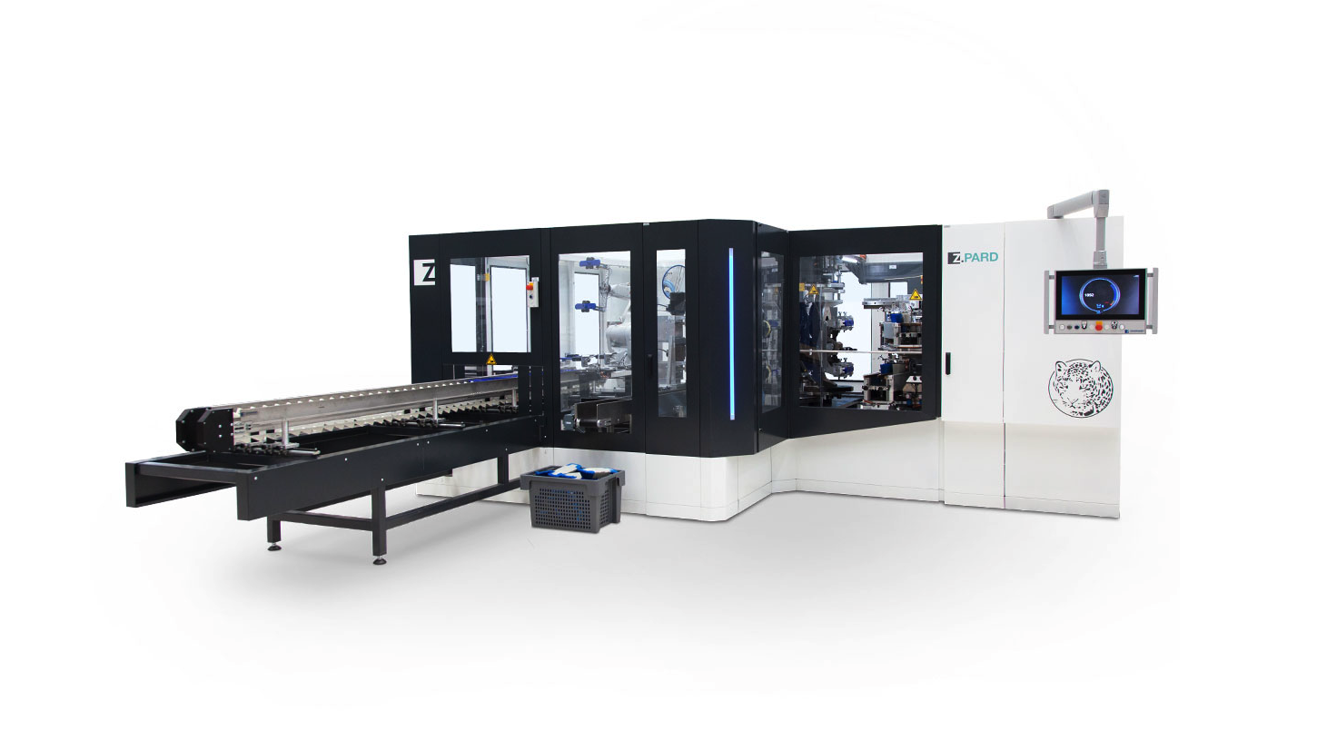

Images
You can find the image material in our media portal press-n-relations.amid-pr.com (search term "ZAHORANSKY Z.PARD MT"). We will of course also be happy to send you the file by e-mail.

Further information:  ZAHORANSKY AG  Robert Dous, Managing Director of ZAHORANSKY Automation & Molds and Chief Sales Officer of ZAHORANSKY GROUP  Anton-Zahoransky-Strasse 1  79674 Todtnau-Geschwend  Phone: +49 (0) 7671 997-0  Email: robert.dous@zahoransky.com  www.zahoransky.com | Press and public relations:  Press'n'Relations GmbH  Nataša Forstner  Magirusstr. 33, 89077 Ulm  Phone: +49 731 146 156-77  Email: nfo@press-n-relations.de,  www.press-n-relations.de

Background information
The name ZAHORANSKY has stood for reliability, precision, and sophisticated technology since 1902. The foundation for this was laid by Anton Zahoransky in his small workshop in Todtnau, where he manufactured the first devices and machines for automated brush production.

Thanks to the experience and expertise gained since then, ZAHORANSKY is now a full-range supplier and technology partner for companies in the brush industry, medical technology, and other sectors. With injection molds, mechanical engineering, automation technology, and packaging systems, ZAHORANSKY can provide comprehensive services for individual requirements. Approximately 900 employees, including 70 trainees, work to achieve this every day at ten locations in Germany, Spain, China, India, Japan, Brazil, and the United States.

ZAHORANSKY’s multi-system solutions cover the entire process chain: from integrating packaging technology and handling, to programming and robotics in the manufacture of fully automated production and assembly systems. ZAHORANSKY's technologies and services are widely used in the following industries: household and industrial brushes, oral care, medical technology, cosmetics, consumer goods, and packaging.

