Change of Executive Board at ZAHORANSKY AG
ZAHORANSKY realigns Executive Board with Dr.-Ing. Heinrich Sielemann and Ric Nachtmann

Todtnau, October 7, 2024 – As part of the strategic development of the ZAHORANSKY Group initiated in 2023, the upcoming generational change in the Executive Board, due to age, will also take place at the end of 2024. Ulrich Zahoransky (70) would like to move to the Supervisory Board after a transition period. Winfried Ebner (63) will also step down from the company's Executive Board and will advise the new Chief Technology Officer, particularly in the areas of technology and patent issues. He will remain Managing Director of the subsidiary ZAHORANSKY Automation & Molds GmbH.

On December 1, 2024, Dr.-Ing. Heinrich Sielemann will be appointed to the Executive Board for the Technical Division. Ric Nachtmann will join the company as Chief Financial Officer on 1 January 2025.

With the aim of remaining an innovation leader in the future in the areas of oral care, brushes & brooms, and medical technology, and to optimally serve market and customer requirements, ZAHORANSKY AG initiated a comprehensive strategic development in 2023 to position the Group for the future. ‘The challenges for our industries and our company are not getting any smaller. In order to counter these in a timely manner with targeted measures, we are consistently driving the development of our company forward and, in doing so, have proactively initiated the future-oriented positioning of our company together with a consulting firm,’ says Ulrich Zahoransky. The company sees particular potential in the medical technology business unit, which will be expanded more intensively. This benefits from the company's many years of experience in the fields of machine and mould construction, plastics technology, and automation. In addition, the company aims to further strengthen and expand its position as a market and innovation leader for moulds and tufting machines for oral care and brushes & brooms.

‘We also want to give additional impetus to the further development of our company by realigning the Executive Board,’ says Ulrich Zahoransky. With his strategic foresight, he himself has played a decisive role in shaping the company's successful development over the last 36 years and is handing over the baton to the new board at his own request. One milestone of his personal success story is, among other things, the establishment of the medical technology division. During the realignment, the Supervisory Board has also decided to no longer organize the Executive Board according to the product areas in the future. Instead, ZAHORANSKY is now placing a duo at the top of the ZAHORANSKY Group with Dr.-Ing. Heinrich Sielemann as Chief Technical Officer and Ric Nachtmann as Chief Financial Officer.

‘We are pleased to have found two experienced executives in Dr Heinrich Sielemann and Ric Nachtmann who will lead the ZAHORANSKY Group out of a challenging phase and into a successful future,’ says Wolfgang Weber, Chairman of the Supervisory Board. Ulrich Zahoransky adds: ‘With the appointment of Dr Heinrich Sielemann and Ric Nachtmann, we for the first time have an executive board that does not include any members of our family – that is a major change. Nevertheless, we want to remain a family business and, as a family, we fully support our company.’

About the new Executive Board members
Dr Heinrich Sielemann was most recently President of the IWK Group, a manufacturer and system provider of tube filling and packaging lines with a focus on the pharmaceutical, medical technology and cosmetics industries. He has a 28-year career in the field of mechanical and plant engineering, during which he held various management positions, including Chief Technology Officer, Vice President Engineering & Technology and Managing Director of Technology. Born in Dortmund, Nachtmann graduated from the Technical University of Dortmund with a degree in process engineering (chemical engineering), where he also completed his doctorate.

Before joining ZAHORANSKY, Ric Nachtmann was Chief Finance Officer of the ProMinent Group in Heidelberg, a manufacturer of components and systems for metering technology and water treatment. The business graduate completed his studies at the Technical University in Berlin and has over 20 years of experience in finance and controlling. During his professional career, Nachtmann has held various management positions, including Finance Director and CFO.

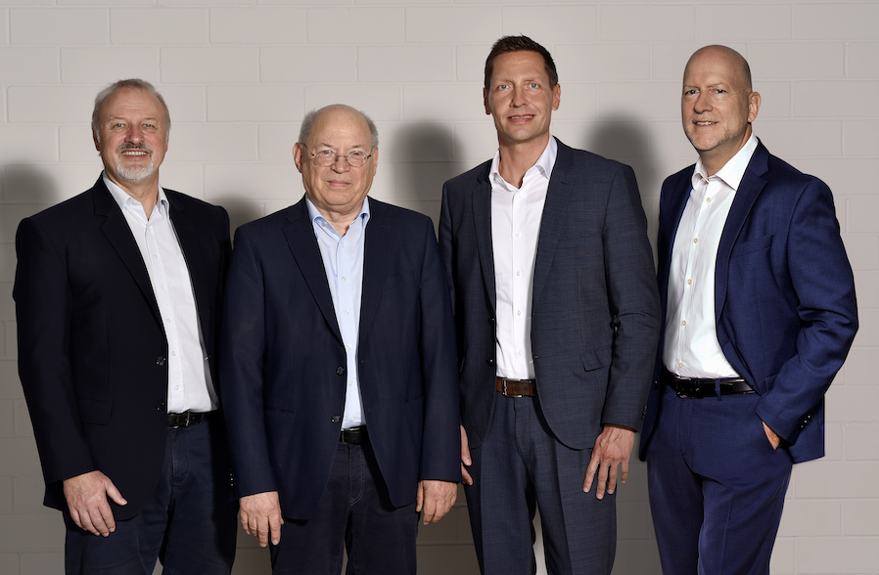

From left: Chairman of the Supervisory Board Wolfgang Weber, Member of the Executive Board Ulrich Zahoransky, Ric Nachtmann, Dr Heinrich Sielemann

Image material
You can find the image material in our media portal press-n-relations.amid-pr.com (search term ‘Zahoransky-Vorstand’). We would also be happy to send you the file by email.

Furter information:  ZAHORANSKY AG  Ulrich Zahoransky, Vorstand  Anton-Zahoransky-Straße 1  79674 Todtnau-Geschwend  Tel.: +49 (0) 7671 997-0  E-Mail: info@zahoransky.com  www.zahoransky.com | Public relations:  Press'n'Relations GmbH  Nataša Forstner  Magirusstr. 33, 89077 Ulm  Tel. +49 731 146 156-77  E-Mail: nfo@press-n-relations.de  www.press-n-relations.de

Background information
The name ZAHORANSKY has stood for reliability, precision, and sophisticated technology since 1902. The foundation for this was laid by Anton Zahoransky in his small workshop in Todtnau, where he manufactured the first devices and machines for automated brush production.

Thanks to the experience and expertise gained since then, ZAHORANSKY is now a full-range supplier and technology partner for companies in the brush industry, medical technology, and other sectors. With injection molds, mechanical engineering, automation technology, and packaging systems, ZAHORANSKY can provide comprehensive services for individual requirements. Approximately 900 employees, including 70 trainees, work to achieve this every day at ten locations in Germany, Spain, China, India, Japan, Brazil, and the United States.

ZAHORANSKY’s multi-system solutions cover the entire process chain: from integrating packaging technology and handling, to programming and robotics in the manufacture of fully automated production and assembly systems. ZAHORANSKY's technologies and services are widely used in the following industries: household and industrial brushes, oral care, medical technology, cosmetics, consumer goods, and packaging.

