Z.PUMA: Maximum performance and flexibility
New ZAHORANSKY machine impresses with efficiency and ergonomic design

Todtnau, 12.09.2023 - With the new Z.PUMA, ZAHORANSKY is expanding its portfolio with a machine for brooms and brushes that sets new standards in terms of output and flexibility. The heart of the machine is the tufting tool, which can process diverse filament types with an unfolded length of up to 320 millimeters at up to 1,100 tufts per minute - and is outstandingly quiet. From brooms and toilet brushes to robust wire brushes, all standard household products can be produced highly efficiently thanks to the modular design with easily interchangeable patterns and frames. Pattern changes can be carried out in less than a minute per station. However, the Z.PUMA not only excels in terms of performance: thanks to its ergonomic design, it offers a new level of user-friendliness and work safety. In addition to recesses at the bottom of the machine for better accessibility and an additional emergency stop switch, the well thought-out design of the machine and the visualization of the operating status via LED bar with traffic light function and, last but not least, the modern ZMI 4.0 machine control system also contribute to this. Depending on the desired production quantity, the Z.PUMA is available as a "single tufting machine" or "twin tufting machine".

While the machine with one tufting tool has three clamping stations and two drilling units, the "twin machine" is equipped with two tamping tools, six clamping stations and three drilling units. In this way, the output of the machine can be effectively increased. In addition, double clamping is optionally possible for the production of brooms, which increases the output by approximately 20 percent. In both cases, production is semi-automatic, which means that both the feeding of the brush bodies (made of wood or plastic) and the removal of the stuffed brushes are carried out manually. The drilling and tufting, on the other hand, are fully automatic and take place with the highest precision within the plant. Finally, the brooms and brushes only have to be given their final shape with a trimming machine such as the Z.FOX.

Old and new strengths
As a consequent further development of the extremely popular Z.LION, the Z.PUMA adopts many of its strengths and builds on them. For example, while the Z.LION operates with a standard stroke of 70 millimeters and more stroke was previously only possible at the expense of production speed, the Z.PUMA is designed for full speed at 100 millimeters stroke. In terms of flexibility, the new machine also exceeds the already high initial level. In terms of operation, the new machine also plays to its strengths. Among other things, it features the innovative ZMI 4.0 machine control system and its ergonomic design allows users to stand closer to the machine. Easy-to-open doors at the front, an additional emergency stop switch directly on the machine instead of just on the operating display, and additional LEDs in the interior that indicate whether all drilling machines are at a standstill also ensure maximum safety.

Z.LION and NANKU
Companies that want to convert or expand their production to the new equipment can save themselves some unnecessary new purchases. Frames and sample parts of the Z.LION are compatible with the Z.PUMA without additional effort and can continue to be used. In addition, inexpensive adapters are offered for the previous tufting tools. However, the Z.LION will also remain available after the market launch of the Z.PUMA. ZAHORANSKY's most successful machine - and best-selling brush production line worldwide - was already a milestone in the industry when it was launched ten years ago and continues to enjoy great popularity. With the NANKU, which is manufactured at the ZAHORANSKY plant in Coimbatore, India, an alternative is also available for this market segment that offers an impressive price/performance ratio. Although the inexpensive machine is not as flexible as the Z.PUMA or Z.LION and can only produce brooms and brushes in certain sizes, it shines here with comparably high performance.

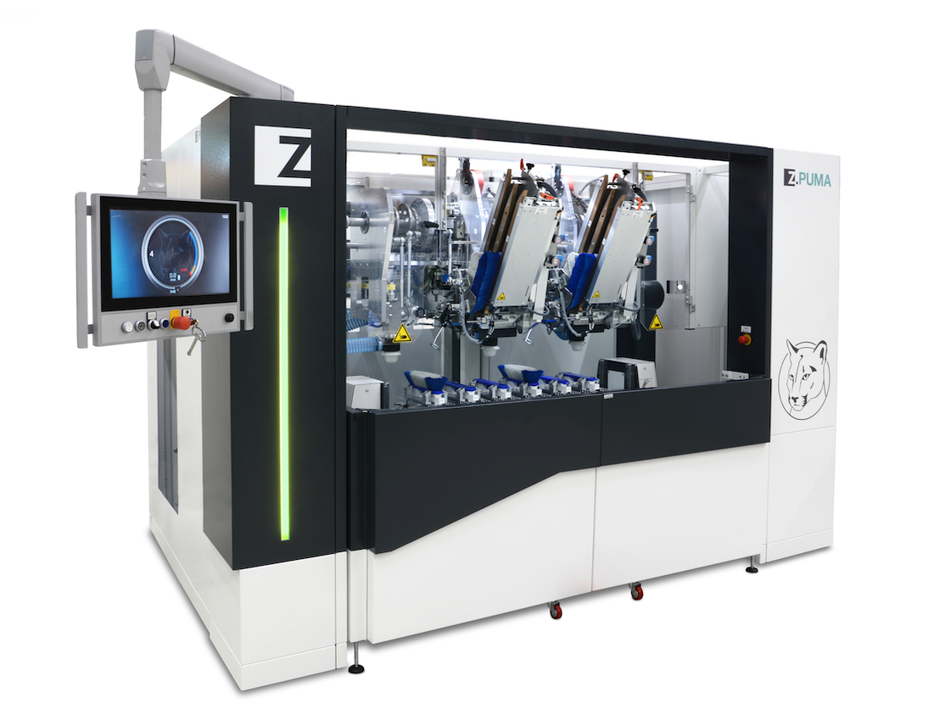

Image material
You will find the image material in our media portal press-n-relations.amid-pr.com (search term "ZAHORANSKY-Z.PUMA"). Of course, we will also be happy to send you the file by e-mail.

Further information:  ZAHORANSKY AG  Robert Dous, Managing Director of ZAHORANSKY Automation & Molds and Chief Sales Officer of ZAHORANSKY GROUP  Anton-Zahoransky-Strasse 1  79674 Todtnau-Geschwend  Phone: +49 (0) 7671 997-0  Email: robert.dous@zahoransky.com  www.zahoransky.com | Press and public relations:  Press'n'Relations GmbH  Nataša Forstner  Magirusstr. 33, 89077 Ulm  Phone: +49 (0) 731 96287-17  Email: nfo@press-n-relations.de,  www.press-n-relations.de

Background information
The name ZAHORANSKY has stood for reliability, precision, and sophisticated technology since 1902. The foundation for this was laid by Anton Zahoransky in his small workshop in Todtnau, where he manufactured the first devices and machines for automated brush production.

Thanks to the experience and expertise gained since then, ZAHORANSKY is now a full-range supplier and technology partner for companies in the brush industry, medical technology, and other sectors. With injection molds, mechanical engineering, automation technology, and packaging systems, ZAHORANSKY can provide comprehensive services for individual requirements. Approximately 900 employees, including 70 trainees, work to achieve this every day at ten locations in Germany, Spain, China, India, Japan, Brazil, and the United States.

ZAHORANSKY’s multi-system solutions cover the entire process chain: from integrating packaging technology and handling, to programming and robotics in the manufacture of fully automated production and assembly systems. ZAHORANSKY's technologies and services are widely used in the following industries: household and industrial brushes, oral care, medical technology, cosmetics, consumer goods, and packaging.

