The new Z.SCORP from ZAHORANSKY
Fully automated production of technical brushes thanks to integrated trimming unit

Todtnau, 12.07.2023 - New standards in terms of output, flexibility and automation in the production of disc or cylindrical brushes - this is what the new Z.SCORP production line from ZAHORANSKY stands for. Thanks to the integrated trimming unit, the compact machine design enables fully automatic production of technical brushes directly after the tufting process. Compared to the usual combination of a drilling and tufting machine with a trimming machine, this saves space in the production hall and significantly increases both efficiency and process reliability. Full automation ensures up to 30 percent higher output compared to conventional brush production and effectively prevents operator errors and quality fluctuations. The Z.SCORP also shows its strengths in flexible and fast changeover to other brush types. Both the trimming and drilling units and the brush length can be adapted to produce different brush designs in just a few steps. The programming and visualization of the desired trimming contours and brush designs is then carried out directly on the machine via the smart ZMI 4.0 machine control system. In addition, the Z.SCORP is currently the only machine on the market that can be converted for the fully automated production of disc brushes as well as cylindrical brushes thanks to the simple changeover option of the carriage and the infeed system.

Efficiency through automation
As a so-called 3-station, 5-axis carousel, the Z.SCORP offers maximum productivity in the field of technical brushes. The machine is configured to produce disc or cylindrical brushes depending on the customer's requirements but can be retooled by the customer at any time if necessary - for example, to expand the product portfolio. The highly efficient and safe manufacturing process is as follow: Brush bodies made of plastic or wood are first fed into the system either manually or fully automated by robot. Then the machine drills the necessary holes with high precision, and diameters of up to 8.5 millimeters, and tufts them. Plastic and wire filaments as well as natural fiber and natural hair with an unfolded length of up to 260 or 320 millimeters can be used. With up to 600 tufts per minute and the option of using up to three different colored filaments simultaneously, the Z.SCORP is extremely productive. The brushes are trimmed directly afterwards. The integrated trimming unit works with precision to the millimeter according to the stored contours and brush designs. Cylindrical brushes can be produced up to a maximum length of 600 mm and a diameter of up to 320 mm, and disc brushes up to a maximum diameter of 610 mm and a total height of 170 mm.

Quick and easy adaptations
If the machine should produce a different brush model, the changeover is extremely quick and uncomplicated. Thanks to the ergonomic operating concept with easy accessibility and the highest safety standards, necessary adjustments to the trimming unit can be made in under 3 minutes without tools. This alone saves around 15 minutes of downtime in production. Corresponding adjustments to the brush length and the drilling unit can also be made in just a few steps. Adjusting the trimming contours is just as easy. These can be programmed easily and flexibly in less than a minute via the ZMI 4.0 machine control system. The brush can be visualized at any time to get a direct impression of the final product. The finished design is then stored in the system and can be retrieved at any time. The final removal of the finished brushes is either manual or fully automatic. However, efficiency and well-thought-out design play a major role in the machine not only in the manufacturing processes. For clear visualization of the current operating status, the machine it has vertical LED bars with a traffic light function that allow operators to see directly whether material is missing, there is a problem, or everything is running normally.

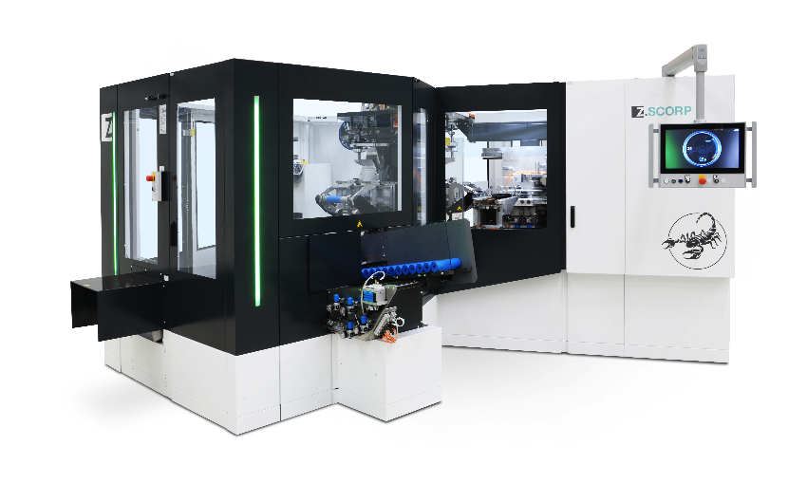

Image material
Image material can be found in our media portal press-n-relations.amid-pr.com (search term “ZAHORANSKY-Z.SCORP“). Of course, we would also be happy to send you the files by email.

Further information:  ZAHORANSKY AG  Robert Dous, Managing Director of ZAHORANSKY Automation & Molds and Chief Sales Officer of ZAHORANSKY GROUP  Anton-Zahoransky-Strasse 1  79674 Todtnau-Geschwend  Phone: +49 (0) 7671 997-0  Email: robert.dous@zahoransky.com  www.zahoransky.com | Press and public relations:  Press'n'Relations GmbH  Nataša Forstner  Magirusstr. 33, 89077 Ulm  Phone: +49 (0) 731 96287-17  Email: nfo@press-n-relations.de,  www.press-n-relations.de

Background information
The name ZAHORANSKY has stood for reliability, precision, and sophisticated technology since 1902. The foundation for this was laid by Anton Zahoransky in his small workshop in Todtnau, where he manufactured the first devices and machines for automated brush production.

Thanks to the experience and expertise gained since then, ZAHORANSKY is now a full-range supplier and technology partner for companies in the brush industry, medical technology, and other sectors. With injection molds, mechanical engineering, automation technology, and packaging systems, ZAHORANSKY can provide comprehensive services for individual requirements. Approximately 900 employees, including 70 trainees, work to achieve this every day at ten locations in Germany, Spain, China, India, Japan, Brazil, and the United States.

ZAHORANSKY’s multi-system solutions cover the entire process chain: from integrating packaging technology and handling, to programming and robotics in the manufacture of fully automated production and assembly systems. ZAHORANSKY's technologies and services are widely used in the following industries: household and industrial brushes, oral care, medical technology, cosmetics, consumer goods, and packaging.

