ZAHORANSKY Repositions Sales and Marketing
Focus on swifter time-to-market and holistic service approach – Robert Dous in new position

Freiburg, February 2, 2022. ZAHORANSKY is repositioning itself in sales and marketing and is merging the sales divisions “Oral Care/Broom & Brush Mechanical Engineering” and “Automation & Molds/Medical Technology”, which up until now have operated independently. This opens up synergies in development, sales and production. This development enables the strength of the global sales and production network across all ZAHORANSKY locations to be used even more consistently. The person responsible for this restructuring is Robert Dous, who has held a new position in relation to this since January: As the Managing Director of ZAHORANSKY Automation & Molds GmbH and the Chief Sales Officer of the ZAHORANSKY GROUP, he is now responsible for the global sales, marketing and service activities of all ZAHORANSKY products and locations. He is also responsible for managing the branches in the USA, Mexico, Brazil, India, Japan and China.

Two-pronged sales approach
In future, ZAHORANSKY will pursue a two-pronged sales approach. There will be divisions specifically for standard manual or automated brush production machines, packaging machines, automation modules as well as injection molds. These teams are controlled locally and are characterized by their special customer proximity and flexibility on account of their regional presence. An agile interdisciplinary organization approach is used for the project business in the division of tailor-made production solutions with a high degree of interlinking and automation in the areas of personal care, medical technology and industrial automation. Upgrading and expanding the key account management enables ZAHORANSKY to even better meet the requirements of global market leaders.

Expansion of the medical technology division
Medical technology is also a high priority in the future product strategy. This business division is being further expanded with production solutions for the manufacture of in-vitro diagnostics, drug delivery and primary packaging. Specifically, this involves dialyzers, vaccine containers, prefilled plastic syringes, pipette tips, blood collection tubes, inhalers and many other medical technology products.

Carefree all-in-one service
When it comes to customer care, ZAHORANSKY consistently relies on the perks of digitization using the global sales organization with Sales & Service branches. A 360-degree carefree service approach, based on remote monitoring & alerting of production processes, as well as preventive maintenance, increases the production output of the machines and minimizes scheduled downtimes.

Robert Dous vita
Robert Dous has been with ZAHORANSKY for almost 14 years and was previously responsible for sales, marketing and service as well as product management for machines and systems concerning the production of brushes, including toothbrushes, interdental brushes, household brushes, technical brushes and cosmetic brushes such as those used for mascara. As of January 2022, as the Managing Director of ZAHORANSKY Automation & Molds GmbH and the Chief Sales Officer of the ZAHORANSKY GROUP, he is now responsible for global sales, marketing and service activities of all ZAHORANSKY products and locations. He is also responsible for managing the branches in the USA, Mexico, Brazil, India, Japan and China.

Image
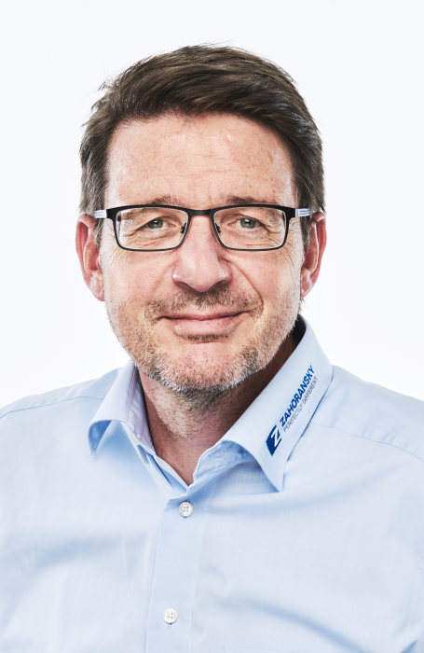
Robert Dous, Managing Director ZAHORANSKY Automation & Molds and Chief Sales Officer ZAHORANSKY GROUP

You can find the image in our media portal press-n-relations.amid-pr.com (search term "Robert Dous"). We are also more than happy to email you the file.

Further information:  ZAHORANSKY AG  Robert Dous, Robert Dous, Managing Director ZAHORANSKY Automation & Molds und Chief Sales Officer ZAHORANSKY GROUP  Anton-Zahoransky-Straße 1  DE-79674 Todtnau-Geschwend  Tel.: +49 (0) 7671 997-0  Fax: +49 (0) 7671 997-299  E-mail: robert.dous@zahoransky.com  https://www.zahoransky.com/  https://www.facebook.com/ZAHORANSKYGroup/  https://twitter.com/_ZAHORANSKY_  https://www.youtube.com/user/ZAHORANSKYGROUP  https://www.linkedin.com/company/zahoransky-group/ | Press and Public Relations:  Press'n'Relations GmbH  Nataša Forstner, Thomas Seibold  Magirusstr. 33, DE-89077 Ulm  Tel. +49 (0) 731 96287-17 or 19  Fax +49 (0) 731 96287-97  E-mail: nfo@press-n-relations.de,  ts@press-n-relations.de  https://www.press-n-relations.de/

Background information
ZAHORANSKY has been synonymous with reliability, precision, and sophisticated technology since 1902. Anton Zahoransky laid the foundation with his small workshop in Todtnau, in which he manufactured the first devices and machines for the automation of brush production.

Using the experiences and skills gained since the company founding, ZAHORANSKY now operates as a full-service provider and technology partner for companies in the brush industry, medical technology, and other industries. With injection molds, machine engineering, and automation technology, as well as packaging lines, ZAHORANSKY covers the whole range of customer requirements. This is what around 900 employees – of which 70 are trainees – work hard for each and every day at ten locations in Germany, Spain, China, India, Japan, Brazil, and the US.

The system-spanning solutions of ZAHORANSKY cover the entire process chain: from the integration of packaging technology to handling up to programming and robotics in the manufacturing of fully automated production and assembly lines. The ZAHORANSKY technologies and services are in high demand in the following industries: household and industrial brushes, oral care, medical technology, cosmetics, consumer goods, and packaging.

